Sandeep Ved

Customer Success Manager Architect, IBM Singapore

IBM Cloud Pak For Data 4.5

Data Virtualization Hands on Lab

Table of Contents

Data Virtualization Lab 3

Access Your Cluster 3

Service Provisioning 3

**Data Virtualization (DV)** 4

**DB2 (db2oltp)** 5

**Jupyter Notebook** 6

**PostgreSQL** 7

Manage Users Access 7

Db2 data loading 10

Check DB2 Connection Details 15

Setting up Data Virtualization 17

**Task 1: Create a project** 17

**Task 2: Add a connection to your Db2 data source** 19

**Task 3: Add a connection to a PostgreSQL data source** 22

**Task 4: Add tables to your virtualized data** 24

**Task 5: Join and Publish virtualized data to project** 27

Next steps 34

**Analyze the data in a notebook** 34

**Visualize the data with a dashboard** 36

Appendix 40

**DB2 Instance Provisioning** 40

# **Data Virtualization Lab**

## Access Your Cluster

1. Find out the OpenShift cluster Details as per the Given Cluster URL and credential provided.
2. Open the **Chrome/Firefox** Browser in **Incognito or Private mode** to Open the Cloud pak for Data Web Console.
3. Login to Web Console using the ID and credentials provided.

## Service Provisioning

This lab requires the Data Virtualisation service as well as a Db2 service to prepare the data source.

1. Navigate back to CP4D Web Console Home Page.

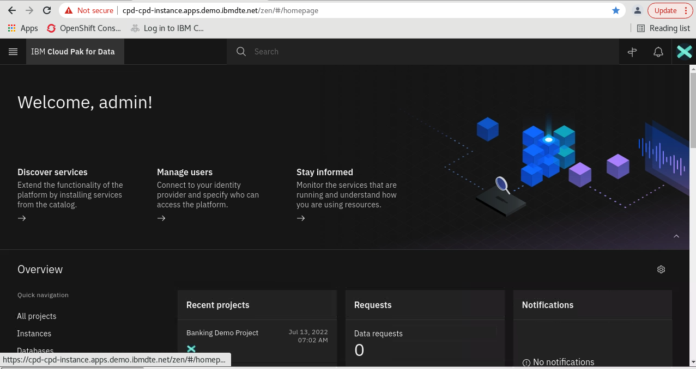

1. Review all the Menu Items. Click on **Services -> Instances** to check the status of all instances.

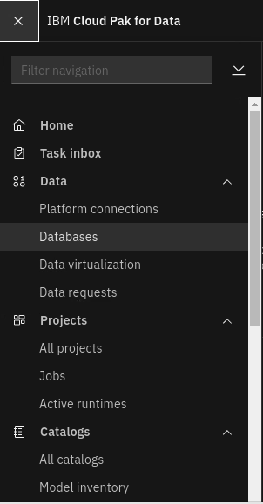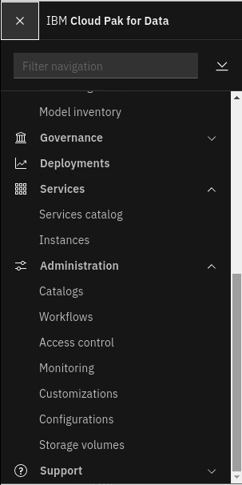

1. Review the currently provided instanced and its status. The status for all currently procured instances should be **green**.

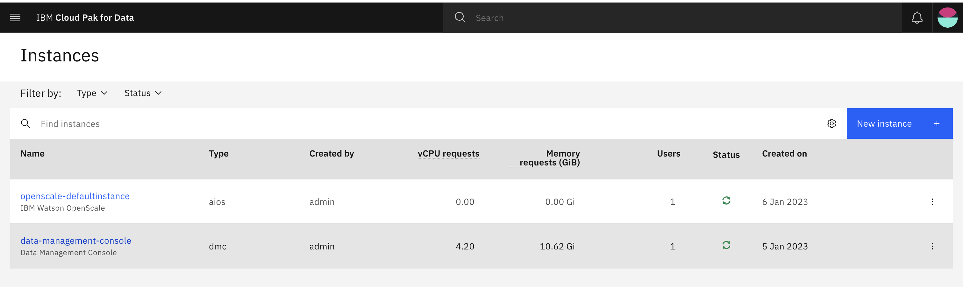

1. For the Lab, you need to create instances of Data Virtualization Instance (dv) and DB2 (db2oltp) services. The Data Management Console (dmc) service should already be enabled.
2. Click **New Instance +** Button to see what all services are already enabled and to create instance of dv and db2oltp. Review the status for all services. You will see that many services like Watson Studio or Cognos Dashboard are already enabled.

### **Data Virtualization (DV)**

1. Select Data Virtualization Services.

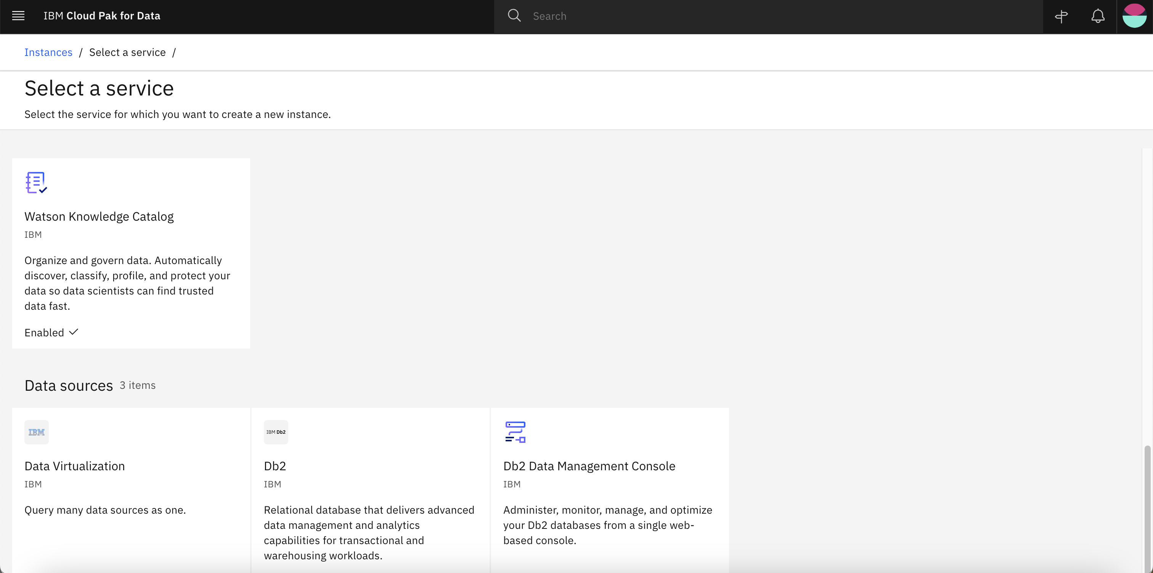

1. Click on the new Instance button and proceed the instructions.

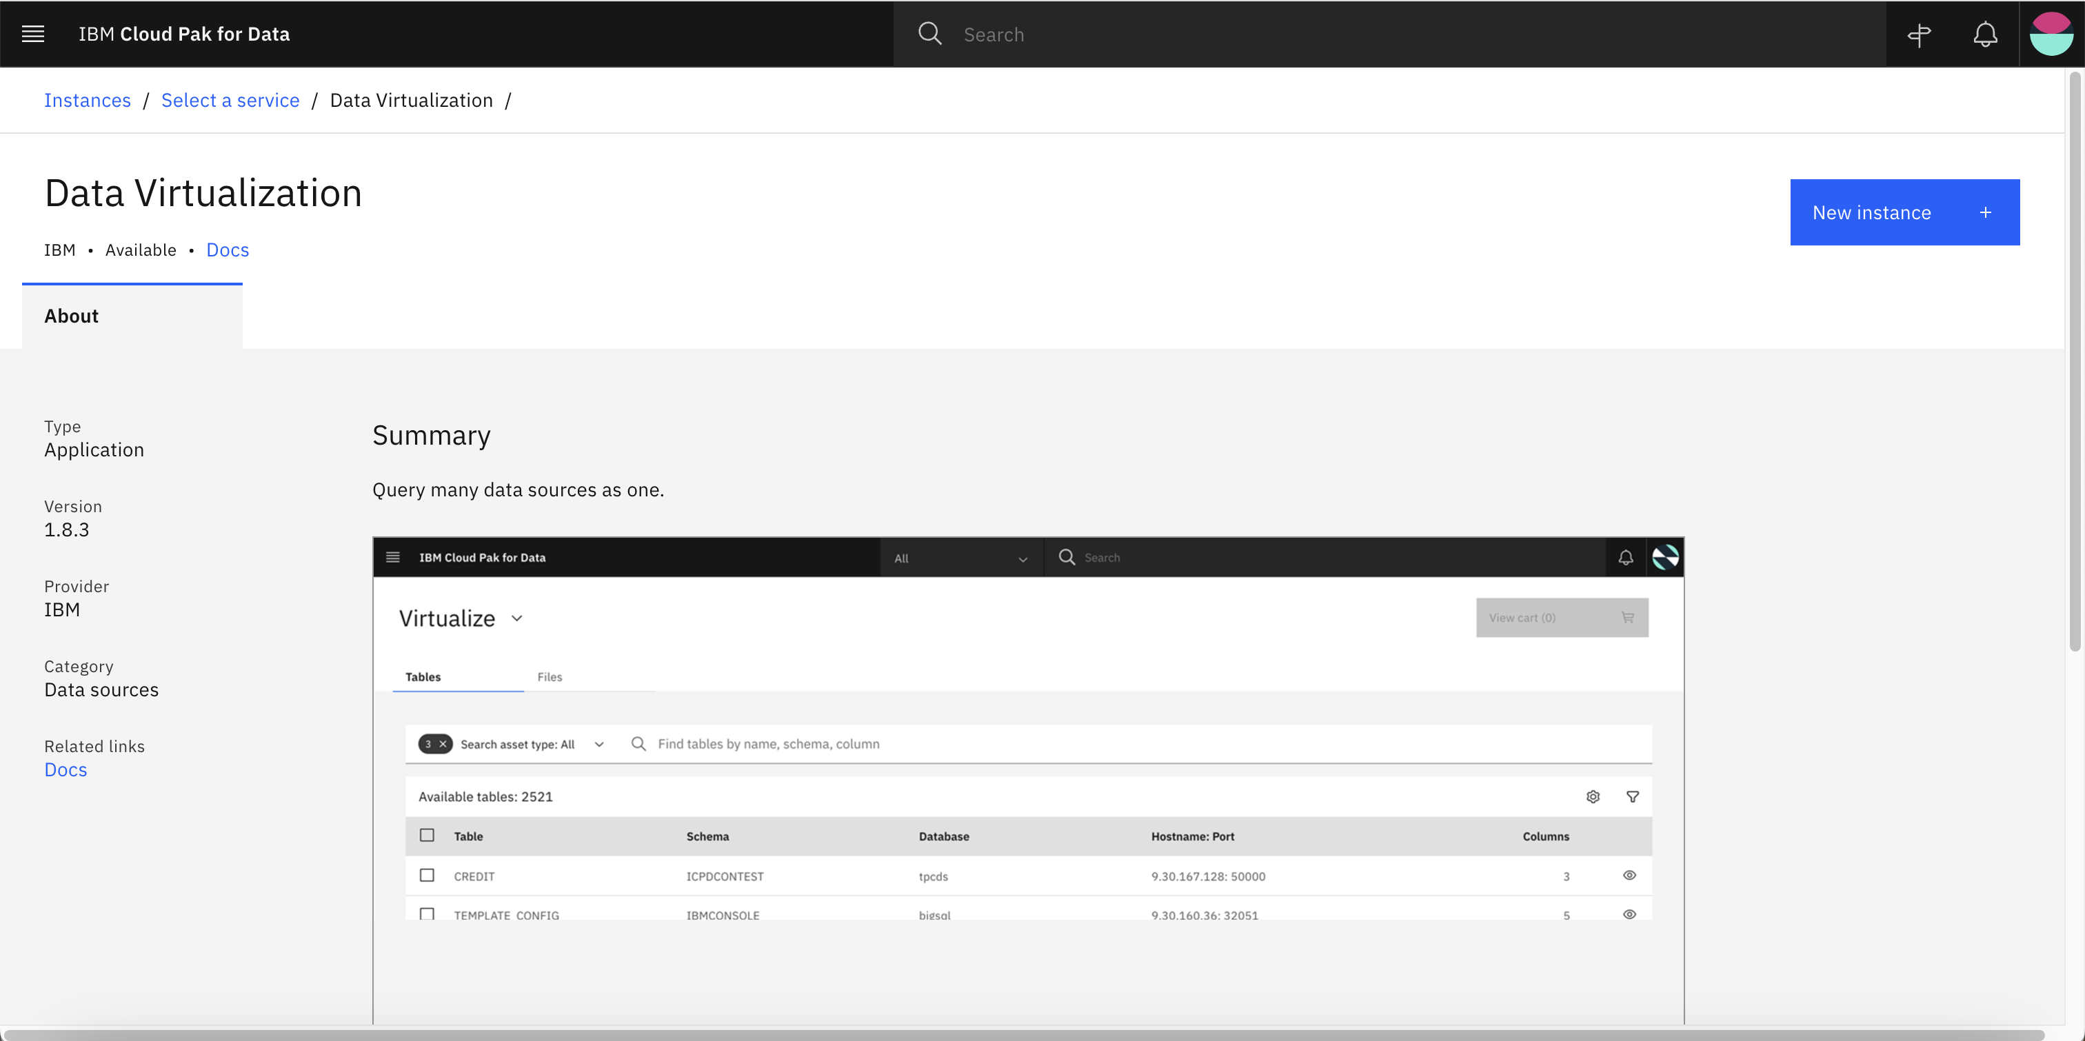

### **DB2 (db2oltp)**

1. Select DB2 Services.



1. Click on the new Instance button and proceed the instructions. Refer to **appendix** to see the complete procedure for reference.

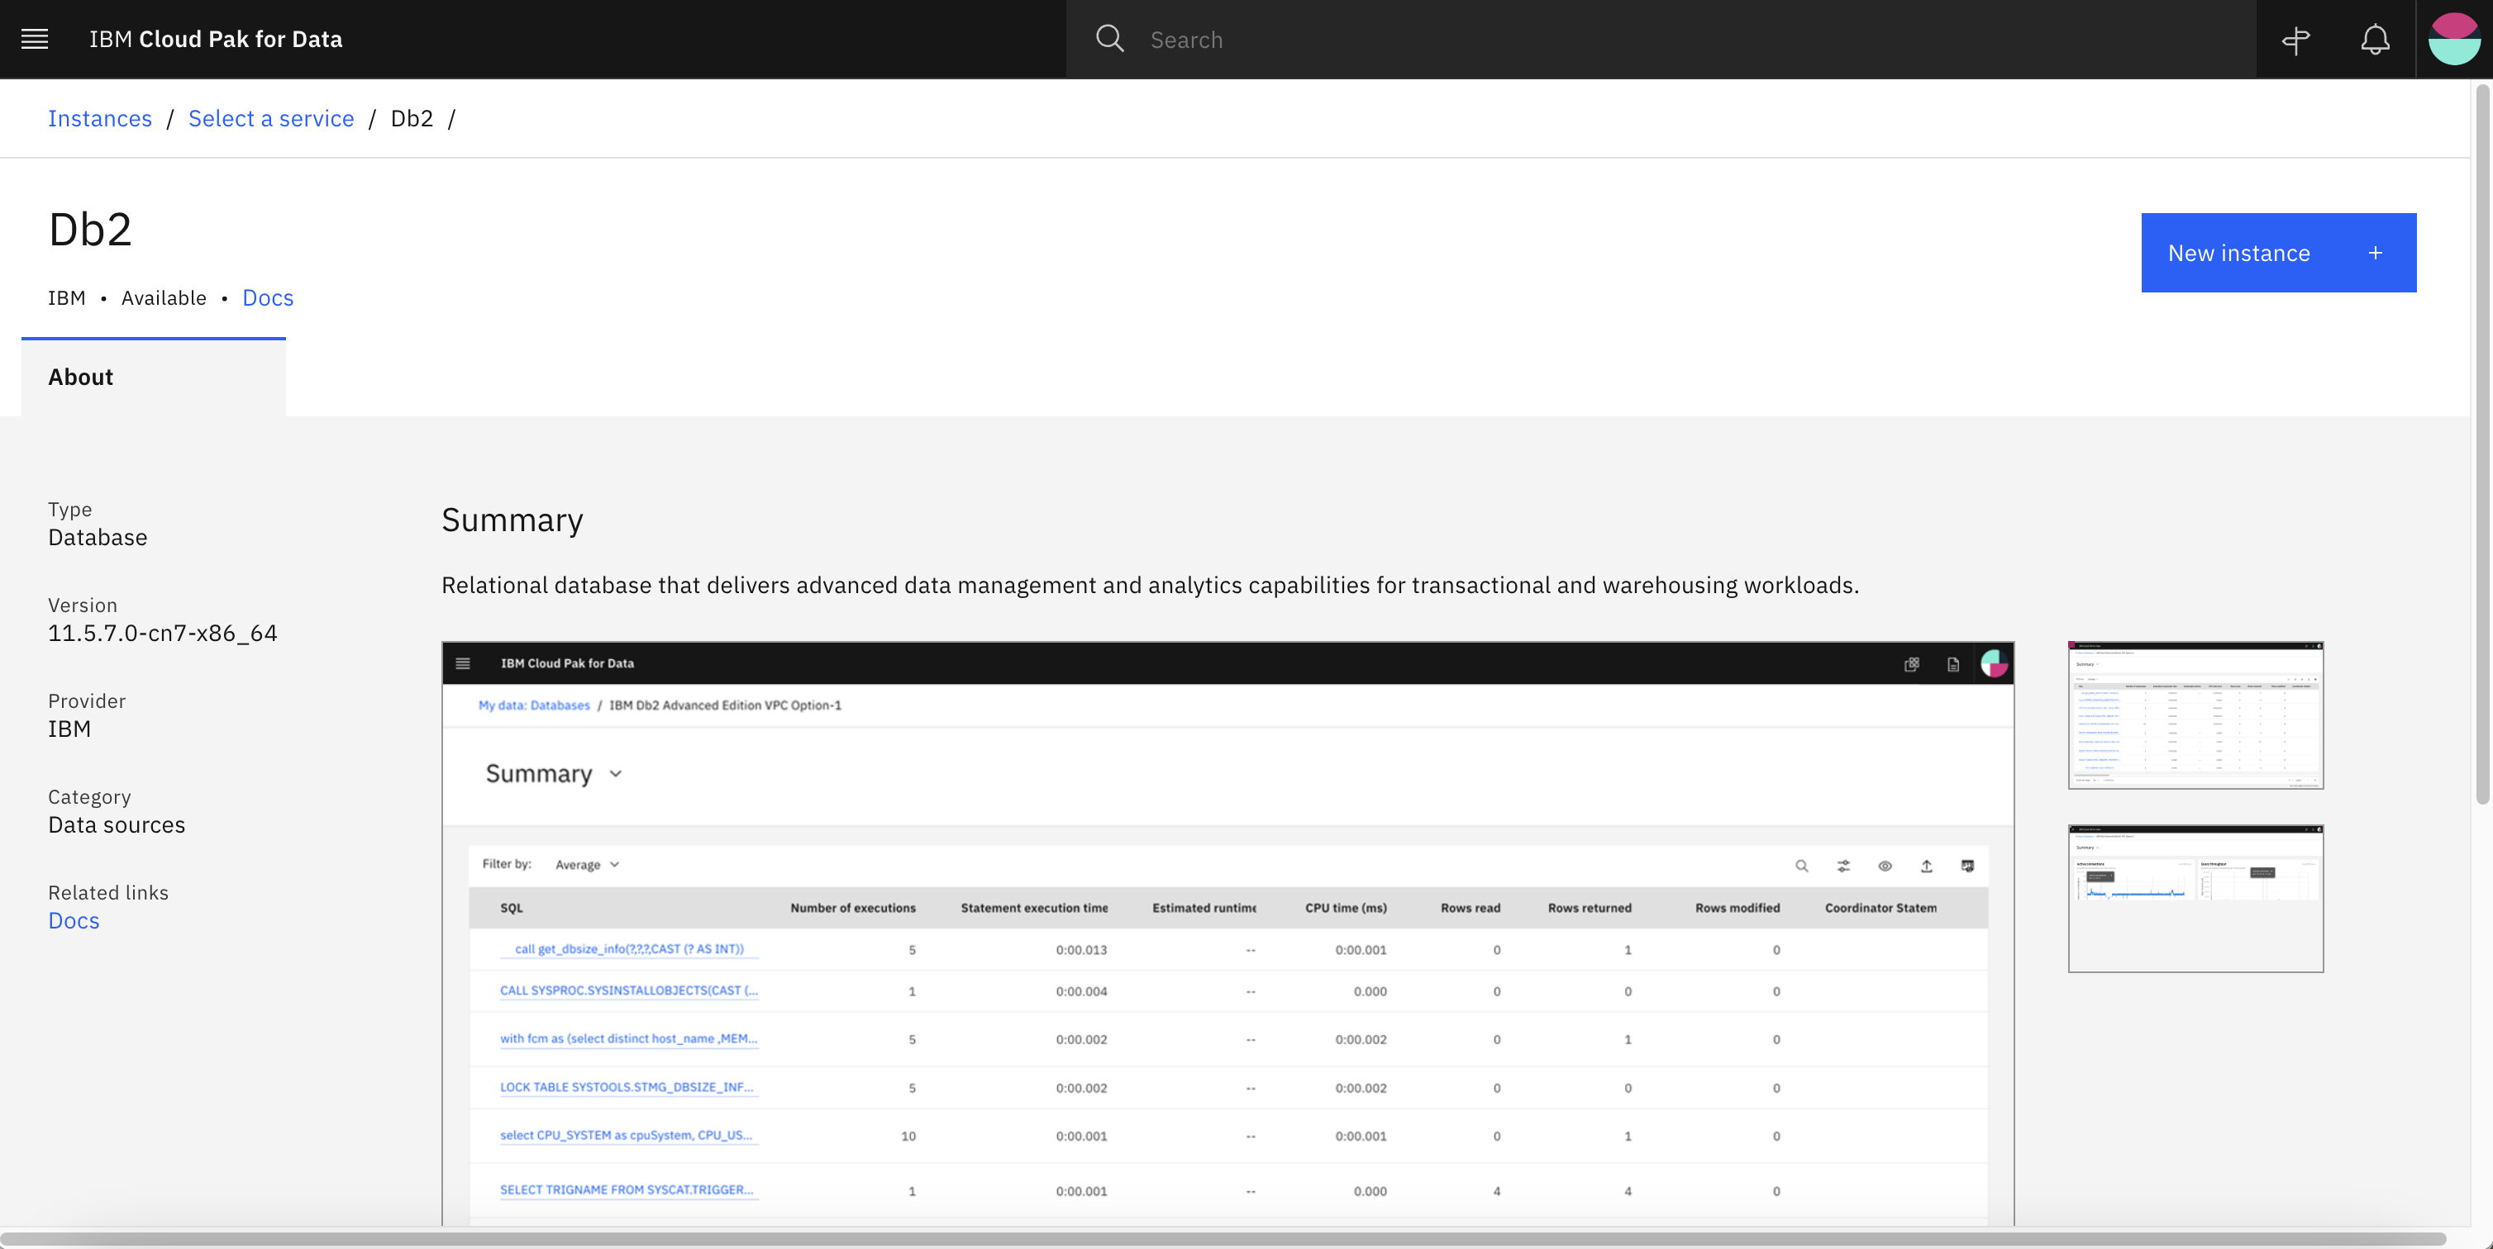

### **Jupyter Notebook**

1. Navigate to Menu -> Services -> Service Catalogue.
2. You can click on Jupyter Notebook and deploy the notebook.

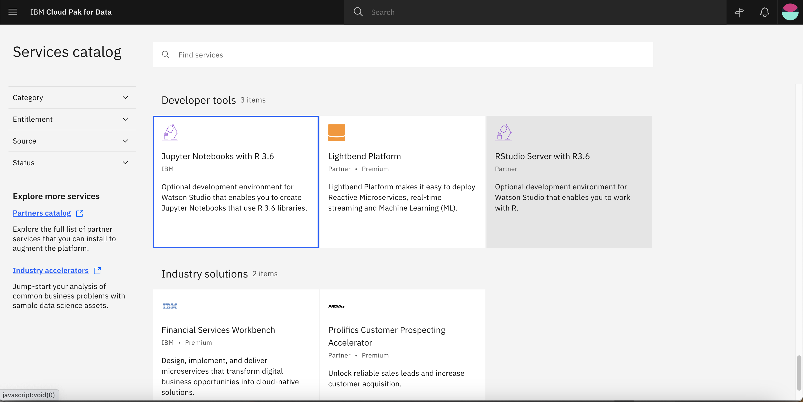

1. Click on Deploy button and continue the instructions

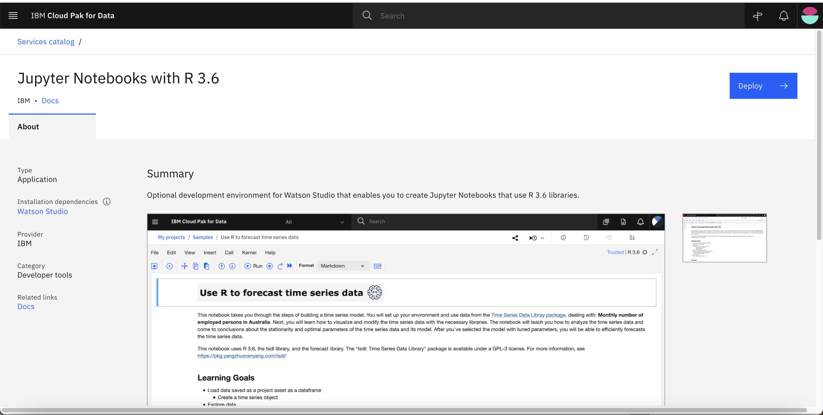

### **PostgreSQL**

1. An external PostgreSQL DB database has been already prepared for the lab with the following connection details.

* Database Name: vlyawtap
* Host Name: tiny.db.elephantsql.com
* Port: 5432
* User Name: vlyawtap
* Password: fXt4TyCB_W0d0LCaCaPF7MbLKWLpti60

## Manage Users Access

1. Navigate to CP4D Console Home Page. Go to Menu -> Services -> Instances.

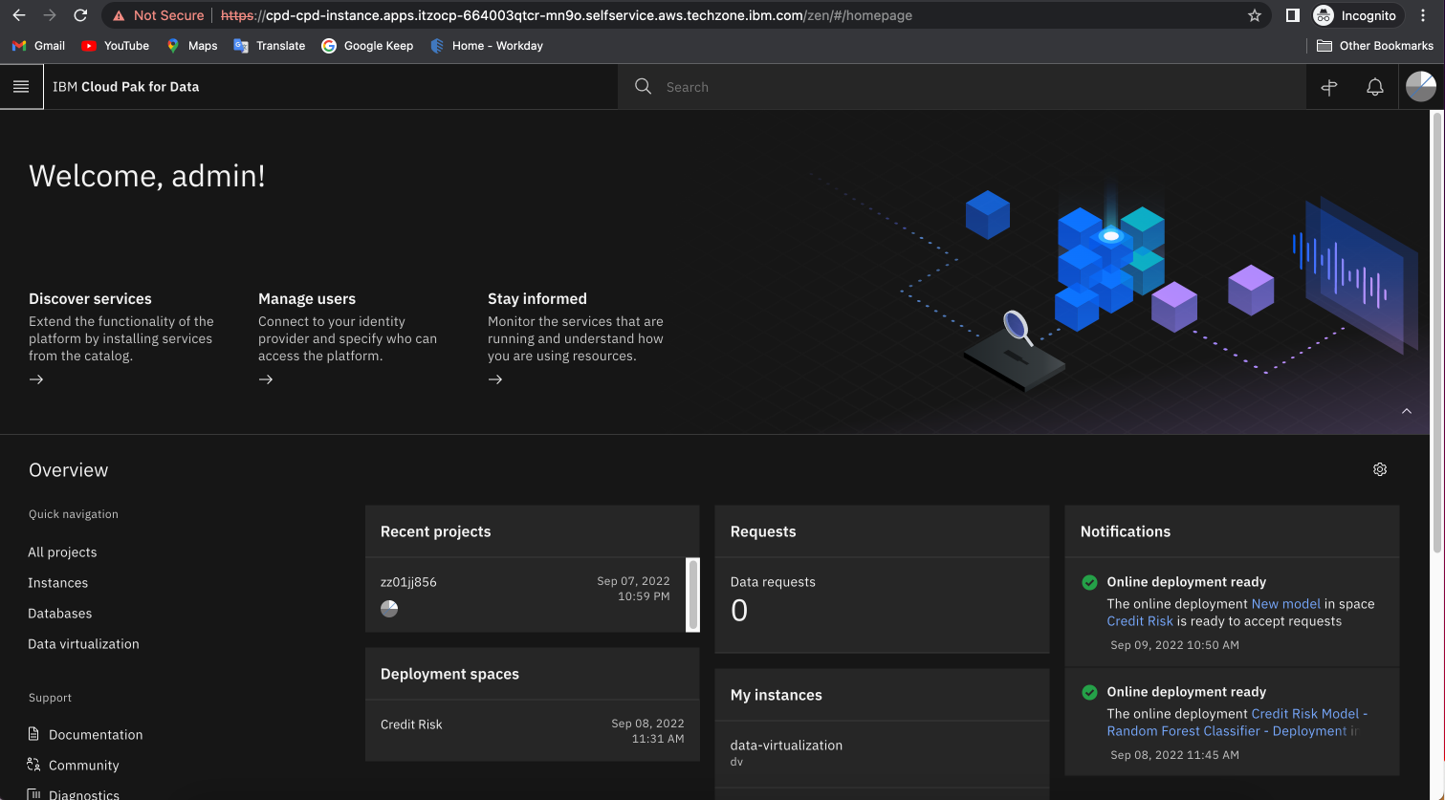

1. For the Db2 instance, and select **Manage Access**.

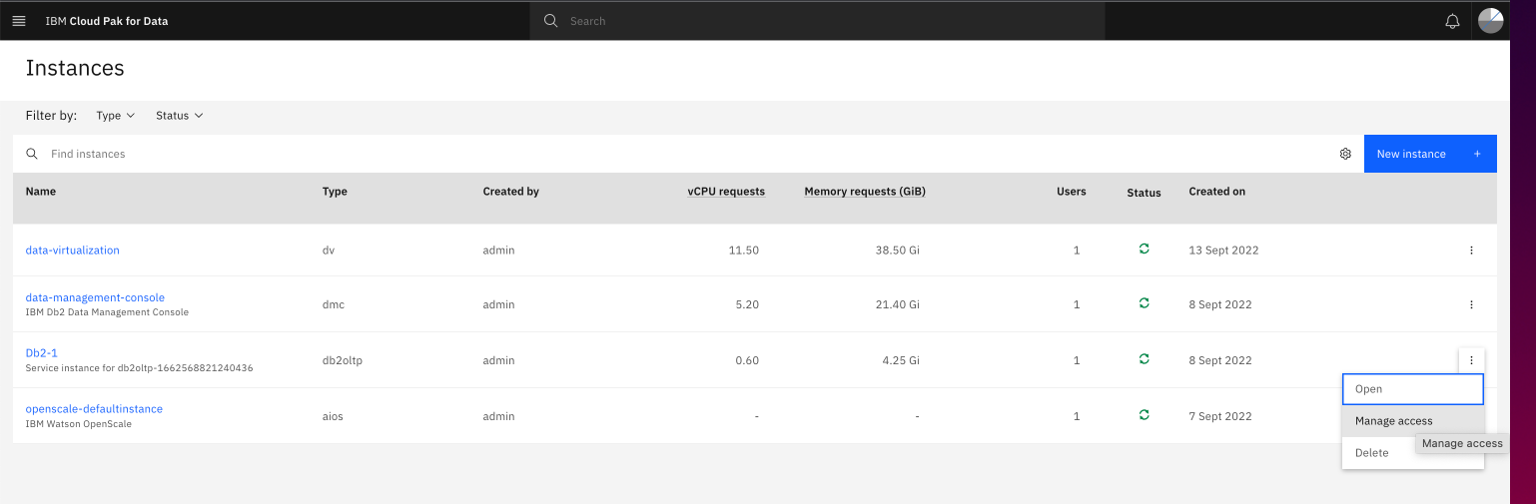

1. Review the users with Access to DB2.

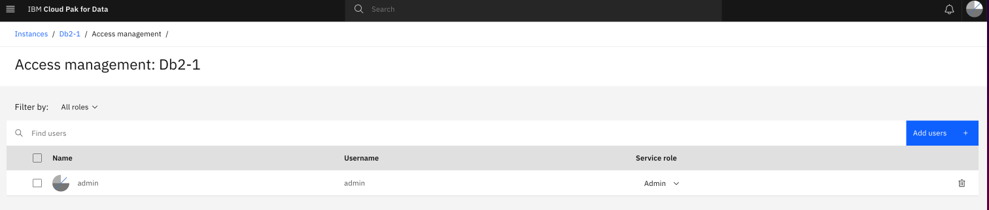

1. You may add new team members users by clicking on **Add User+** button for them to have access to manage DB2 Services.

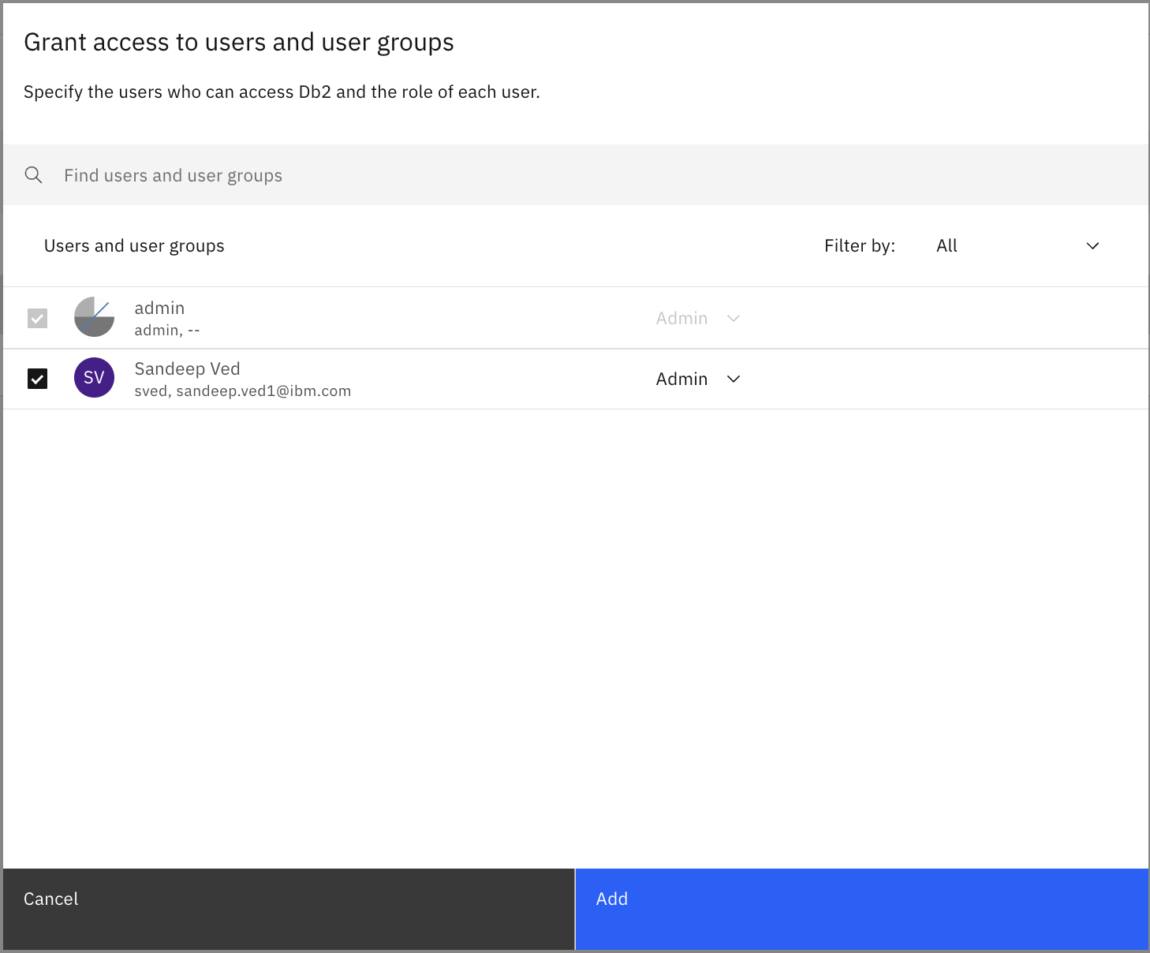

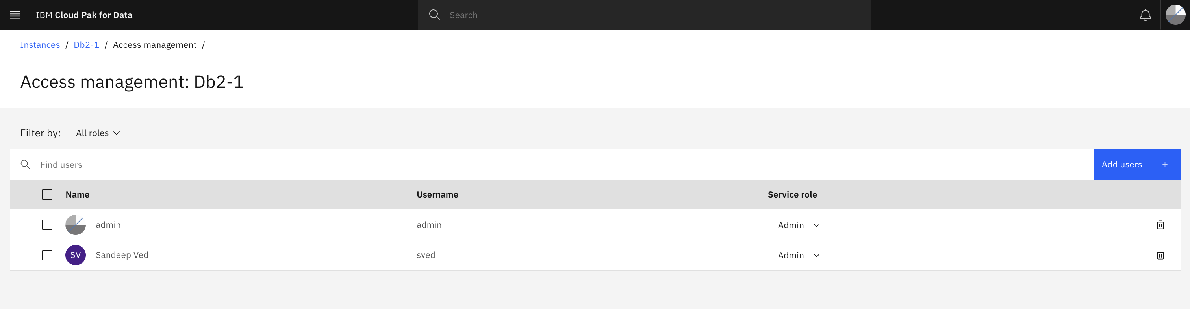

1. 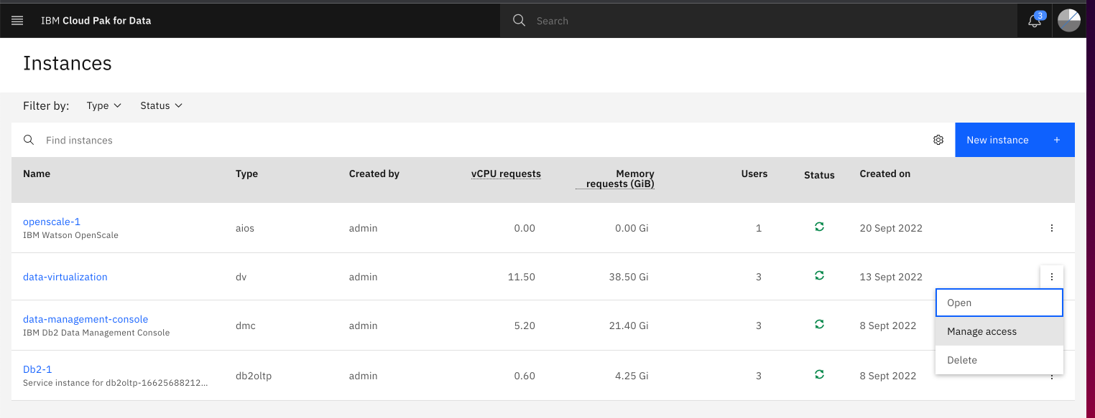Similarly assign access to new team members to the data virtualization instance as well.

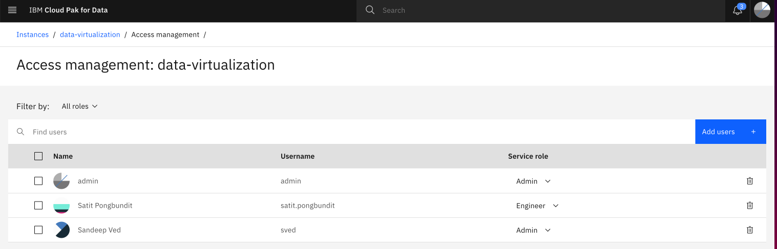

1. Similarly assign access to new users to the data management console instance as well.

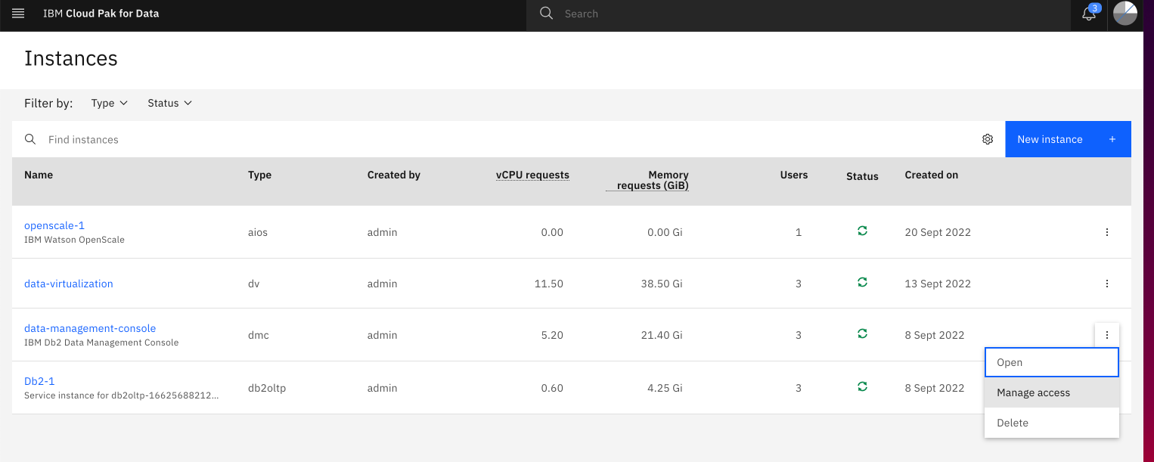

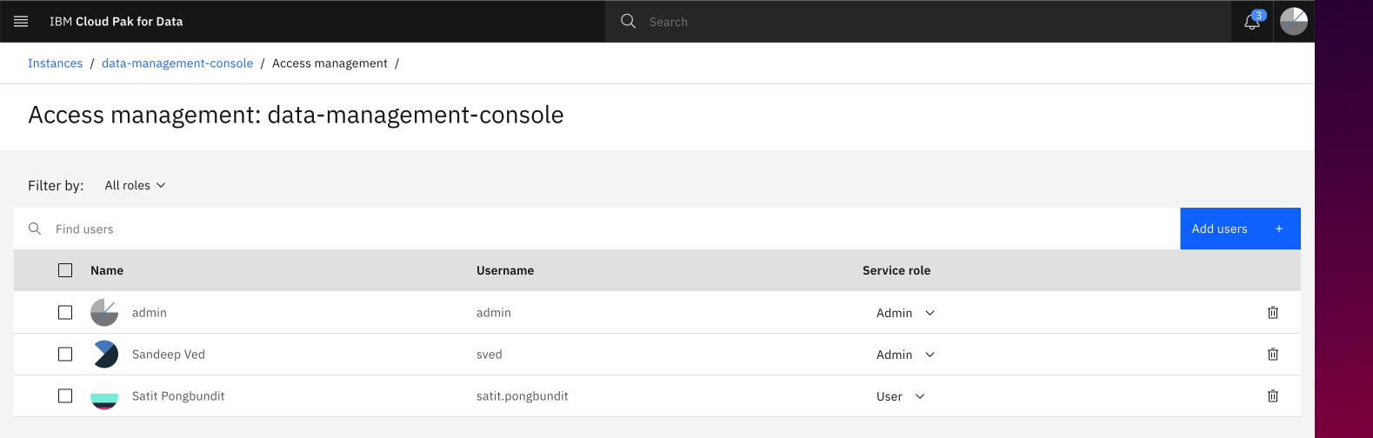

**Db2 data loading**

The data sets you will use in this tutorial are available in the Practicum Github. You need to load those data sets into Db2.

1. Access these two data sets in the GitHub, and download them to your local machine:
   * **Customers data set -> customers.csv** (To upload data in DB2 Database)
   * **Sales data set -> sales.csv** (For Reference only, as its already loaded in PostgreSQL DB)
2. Navigate to **Data -> Databases.**

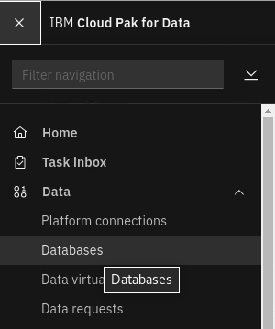

1. Click on **Open Database**

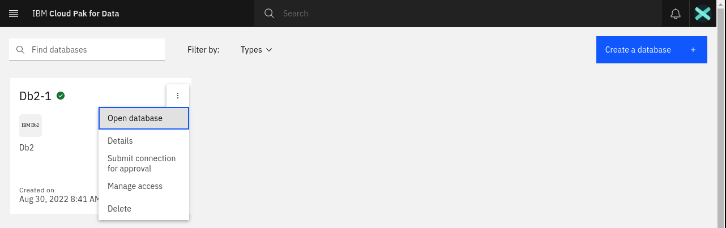

1. You will see the DB2 Database Summary. Click on the Summary Drop Down.

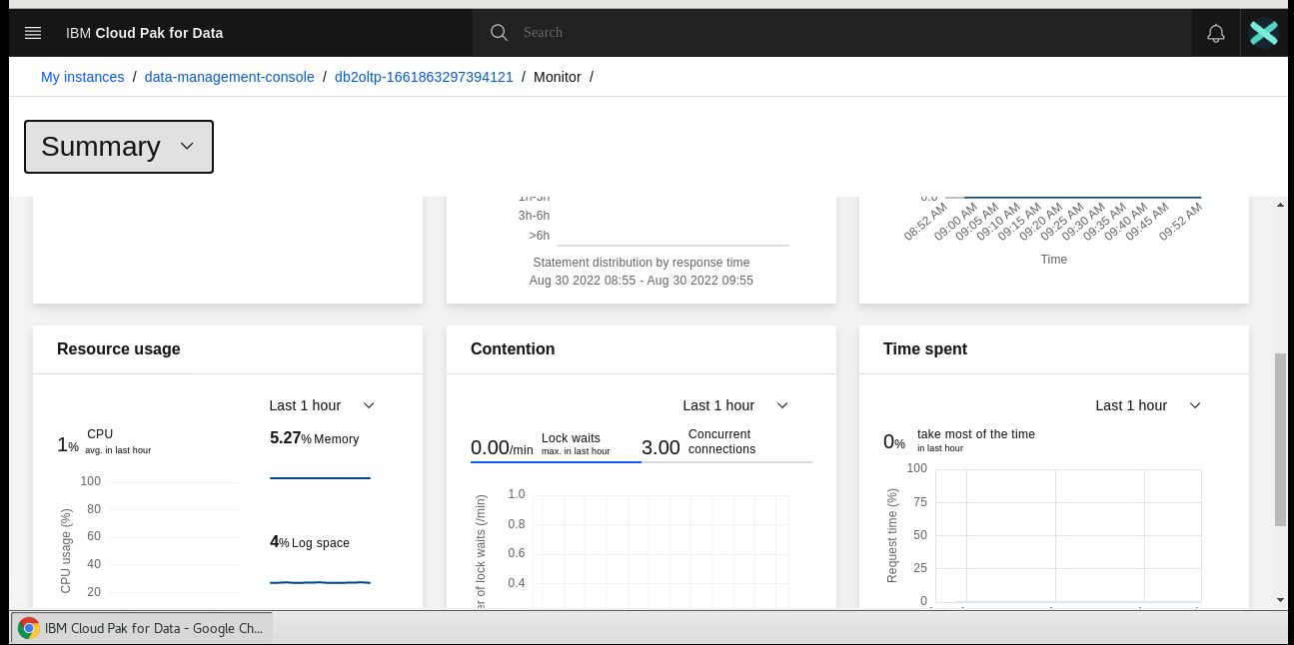

1. Under the Summary Drop down, click on **Load -> Load Data.**

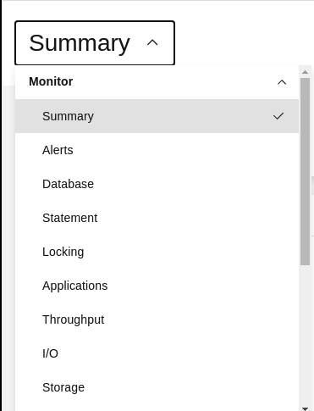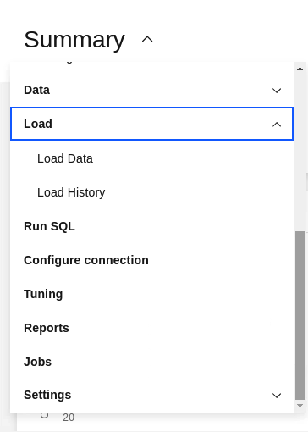

1. The DB2 Load Data Page will appear. Select or Drag the **customers.csv** file from your local machine into the File Selection panel in the Db2 console.

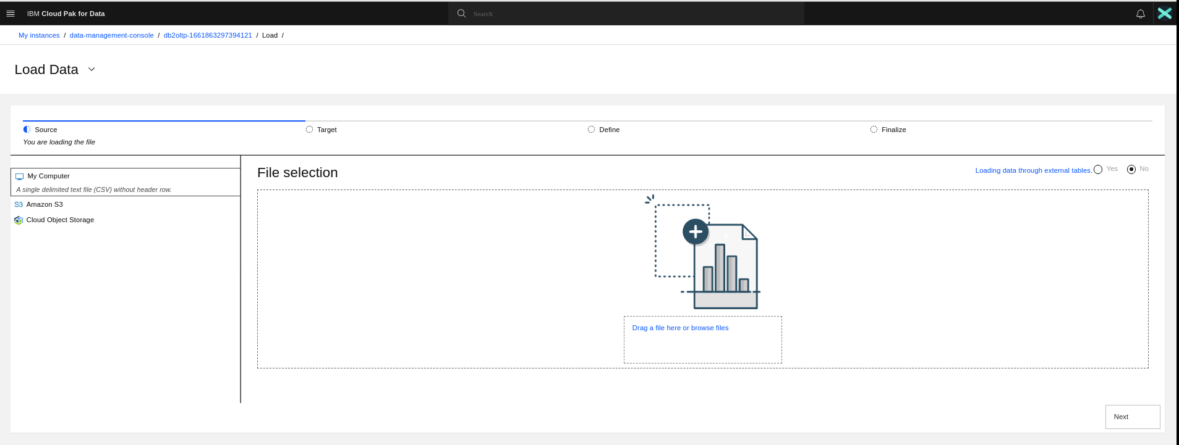

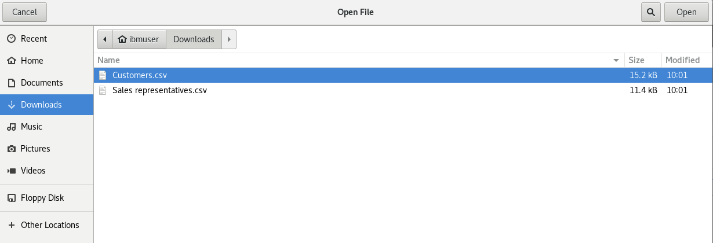

1. Click **Next**.

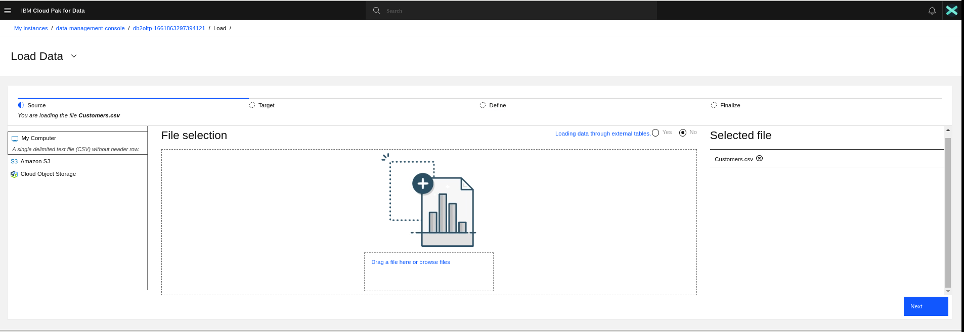

1. Click **New Schema+.**

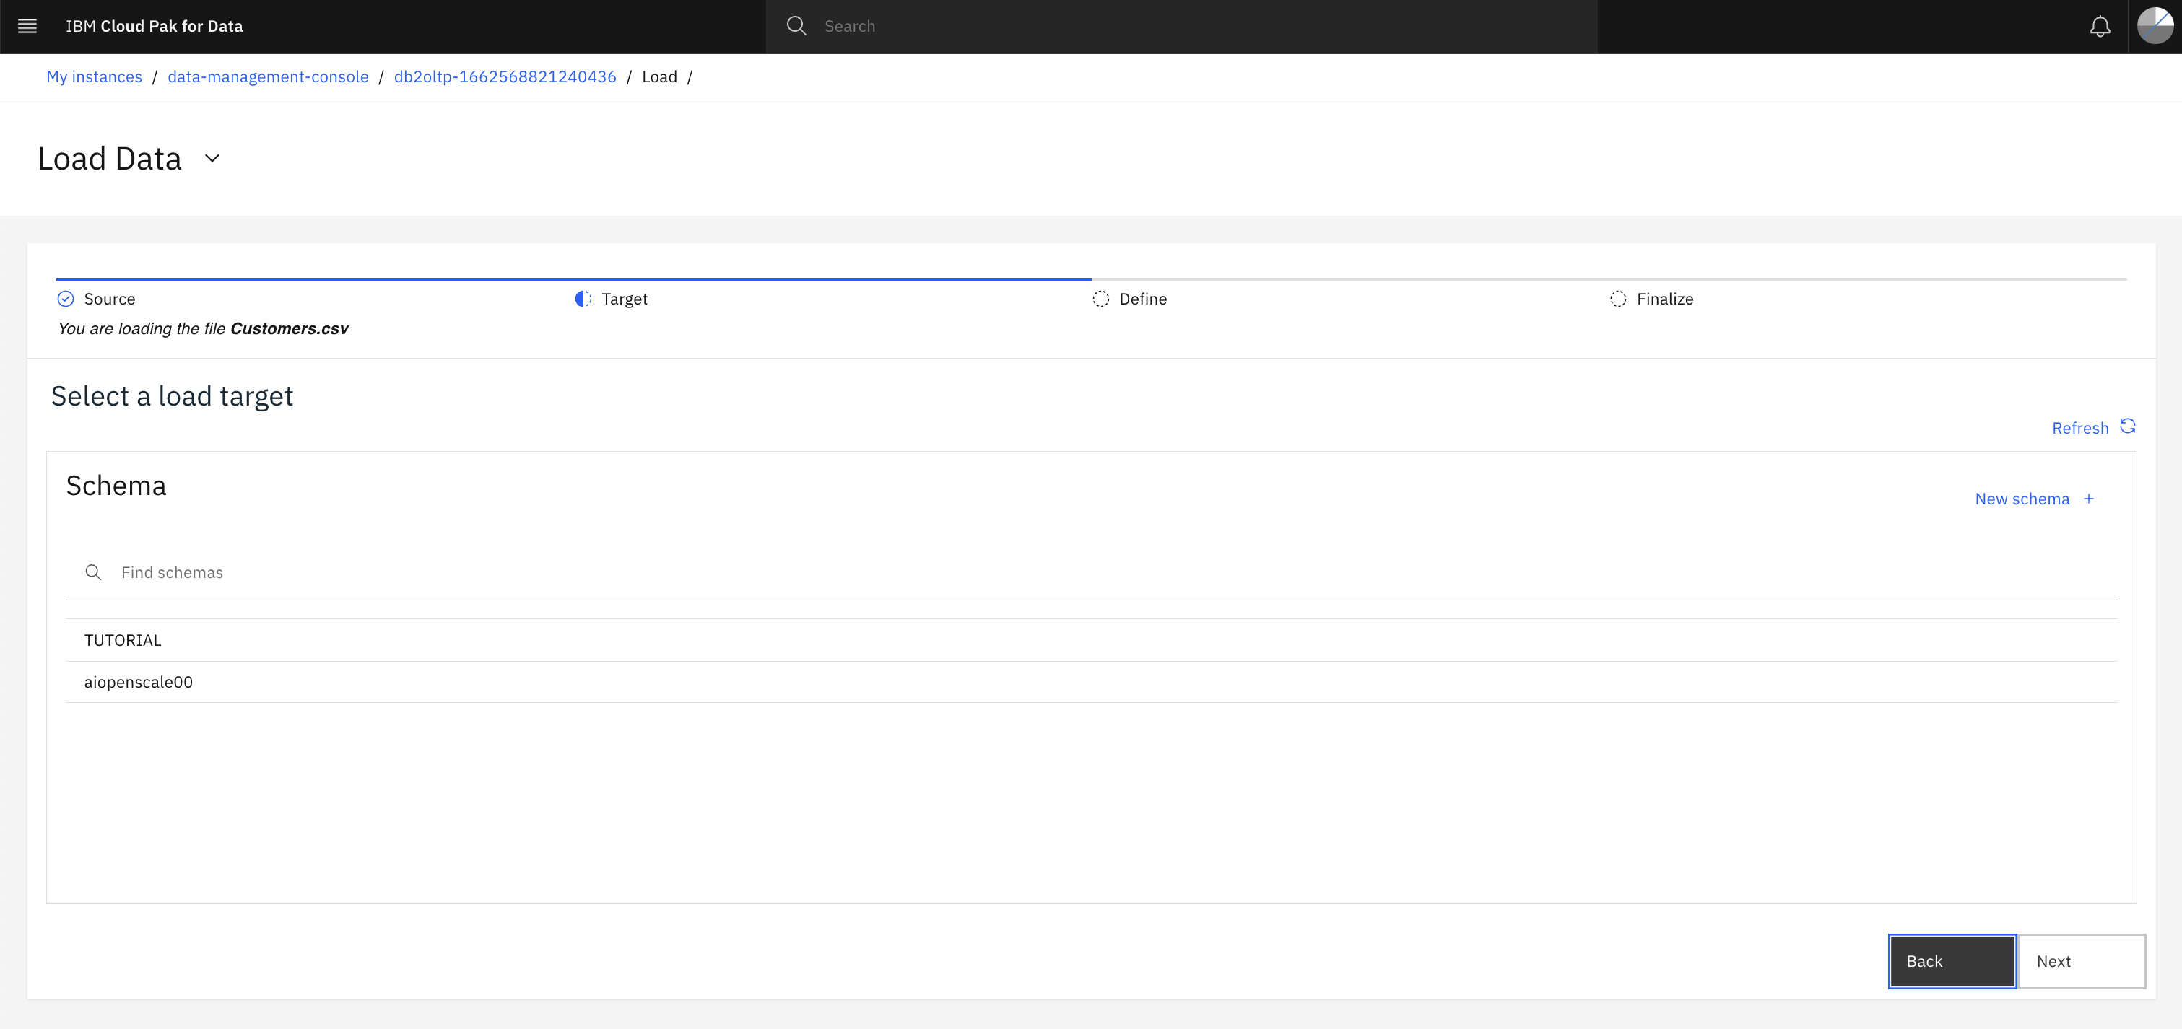

1. Enter a suitable name, eg. IBMADMIN. Click **Create.**

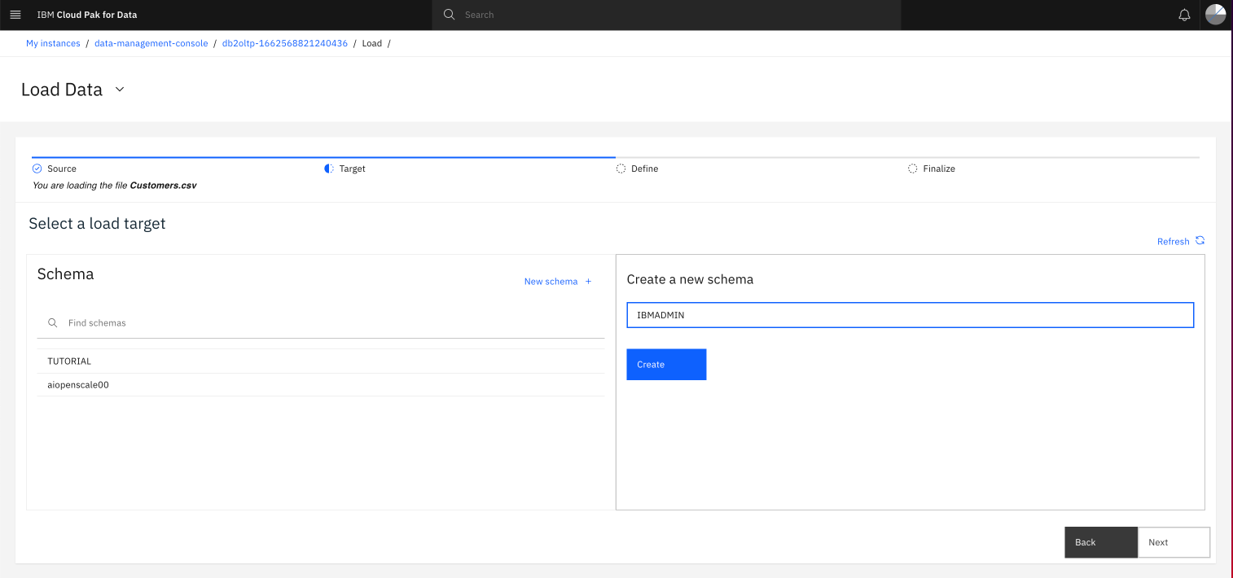

1. Click **New table +**.

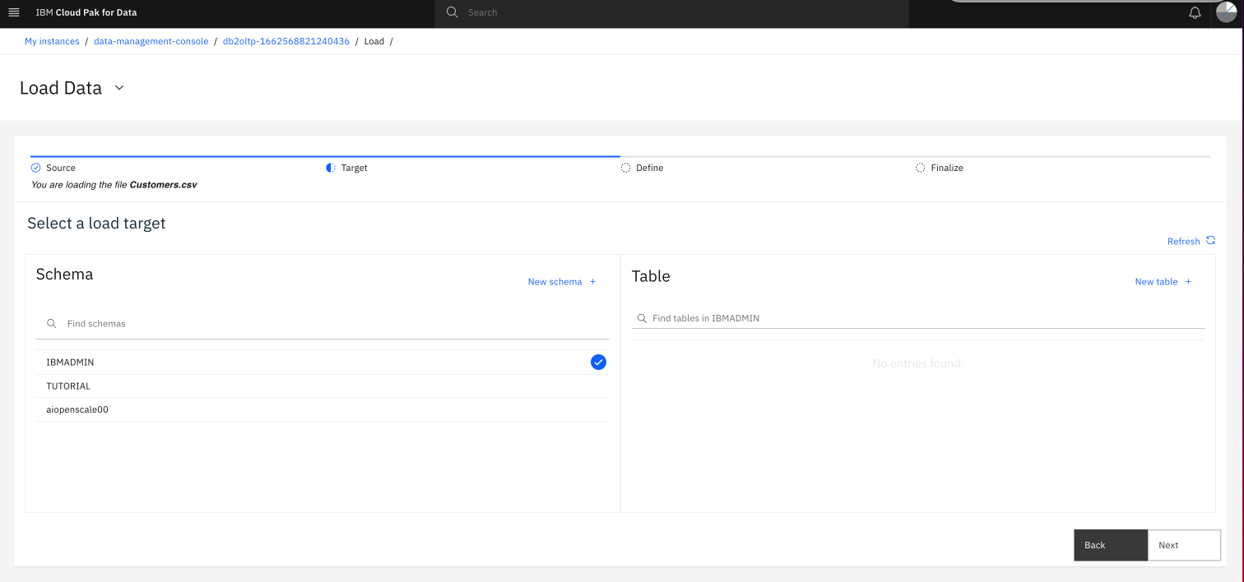

1. Type **customers** for the table name, and click **Create**.

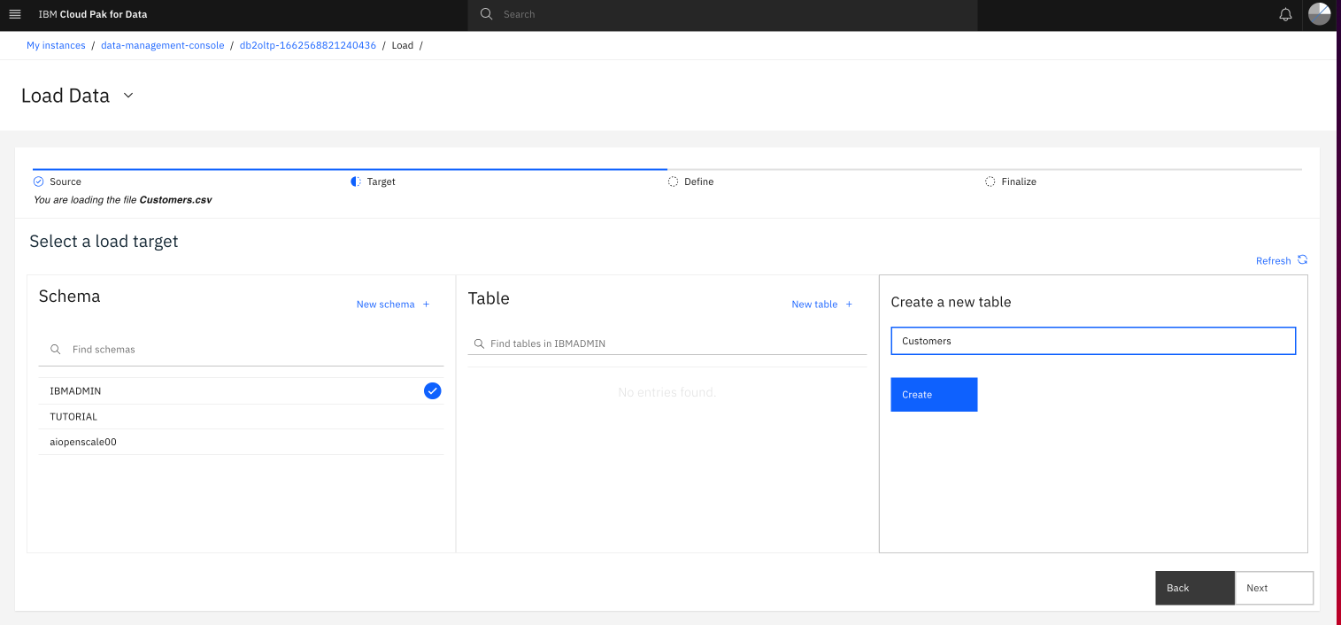

1. Click **Next** to continue.

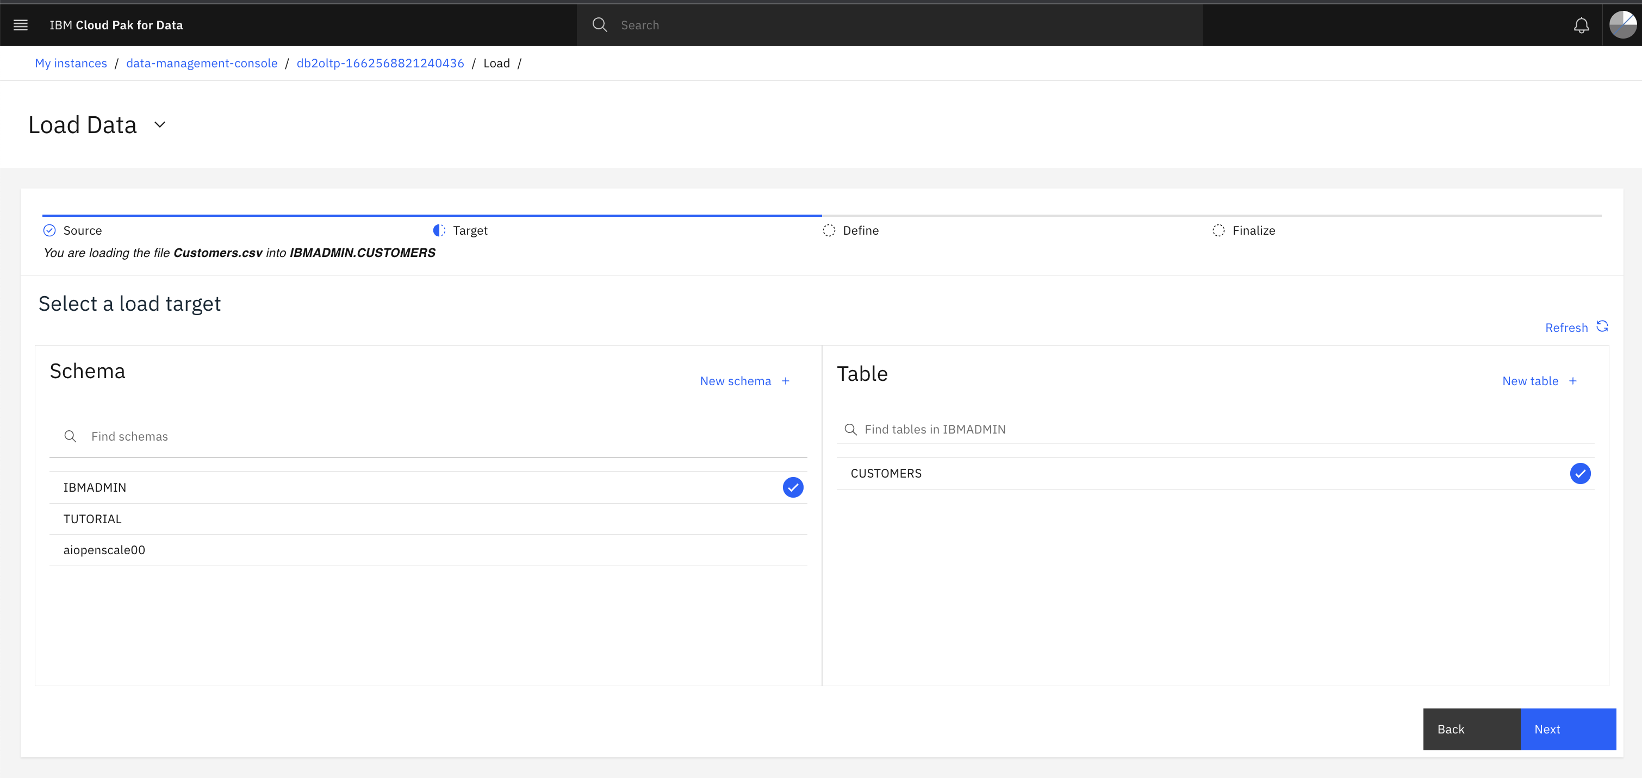

1. Review the data to be loaded, and click **Next**.

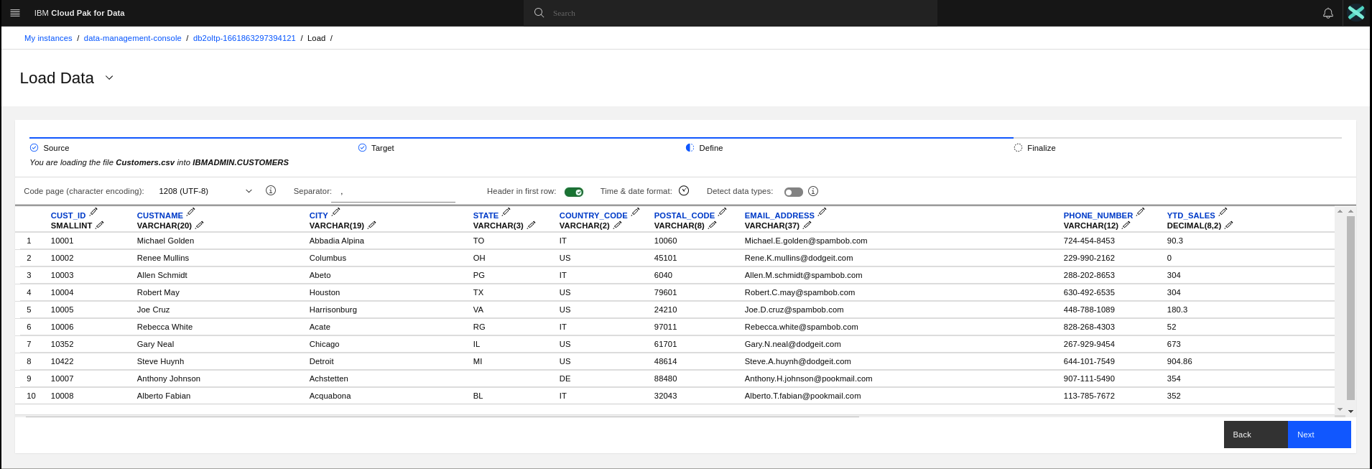

1. Review the summary, and click **Begin Load**.

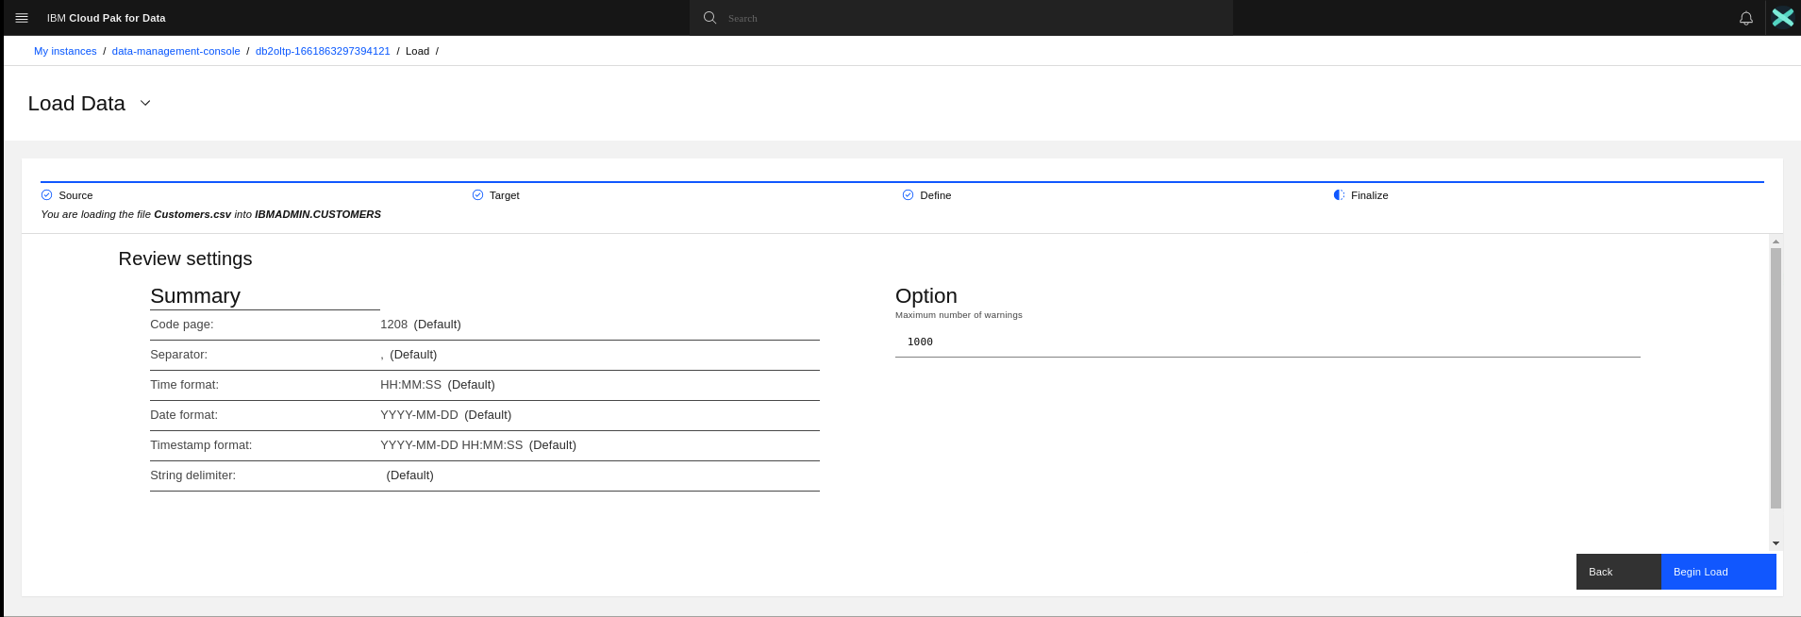

1. Verify that the load is successful. Click **View Table.**

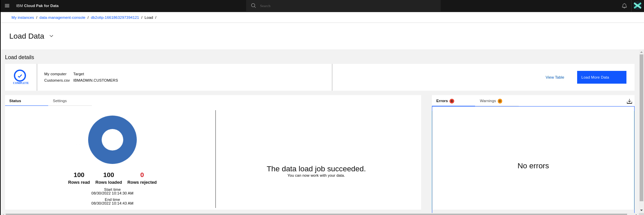

1. Table details will appear.

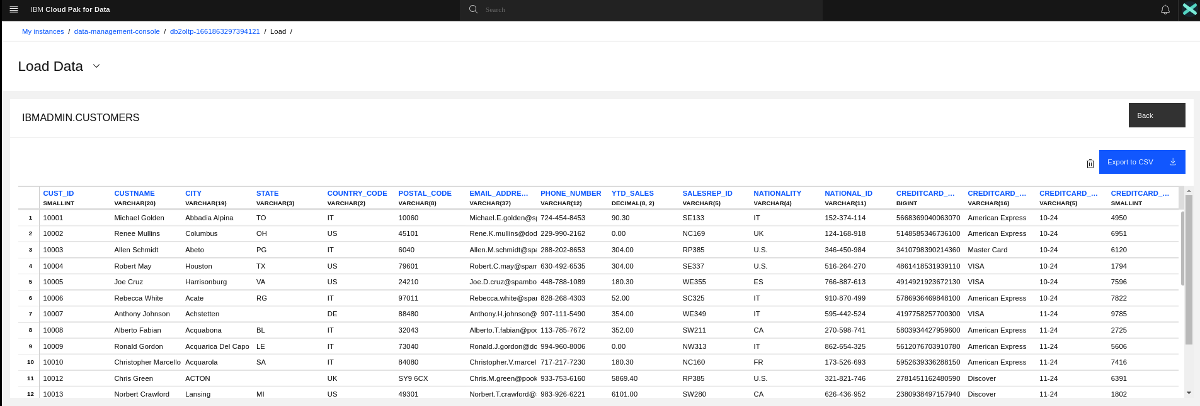

1. ~~Repeat steps 5-10 to load the~~**~~sales.csv~~**~~data set into the same schema with the table name sales.~~*<not needed as same table is uploaded and available from PostgreSQL DB>*

**Check DB2 Connection Details**

1. Navigate back to **Data -> Databases** from the main navigation menu.

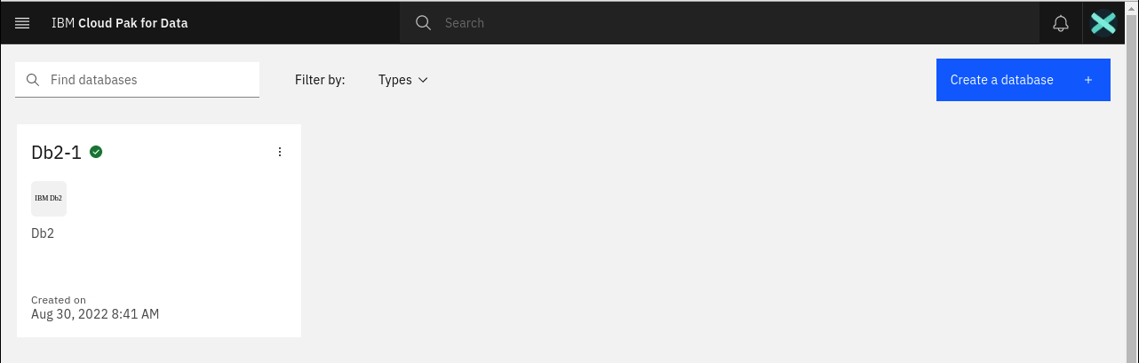

1. Click on Details .

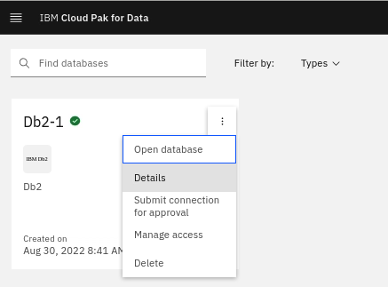

1. Note down the connection details for this DB instance like hostname, Database Name, Port (non SSL & SSL). You can use the admin user id credential to connect to the database later.

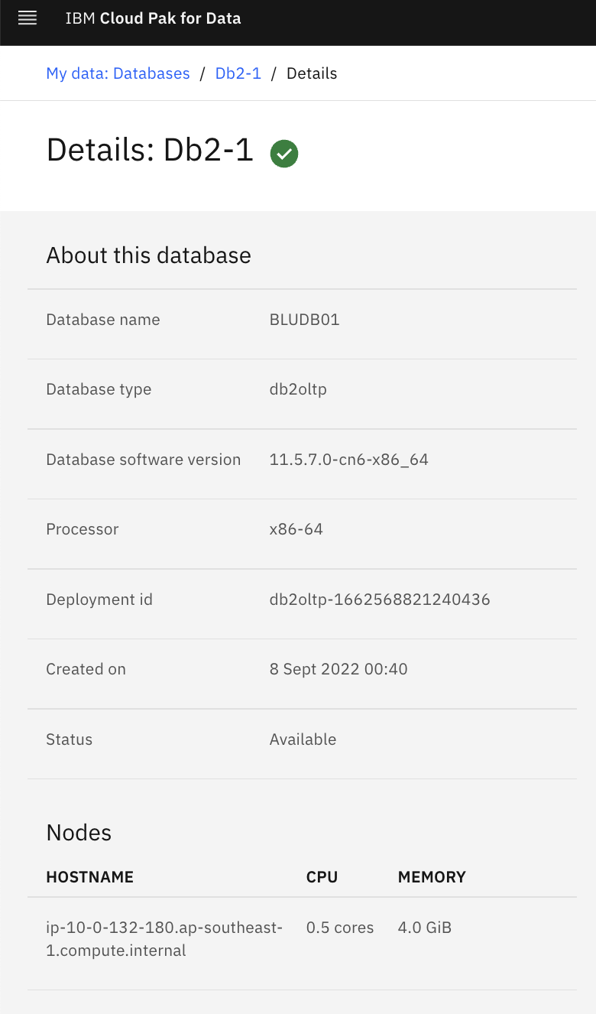 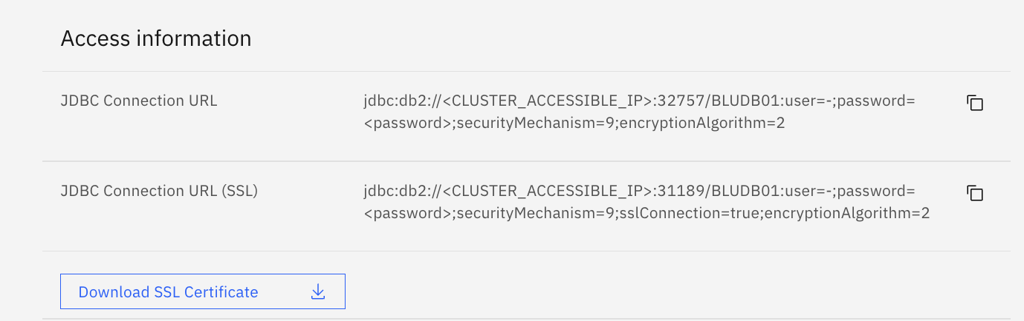

1. Again open the DB2 Database and Open the Summary Menu and select **Run SQL.**

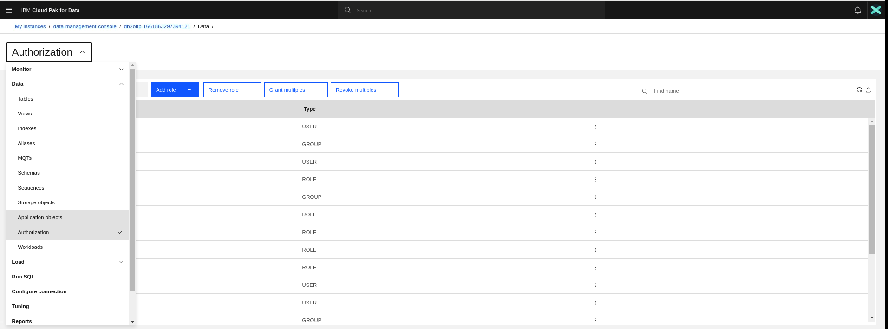

1. You can use the SQL interface to update the DB2 database as usual.

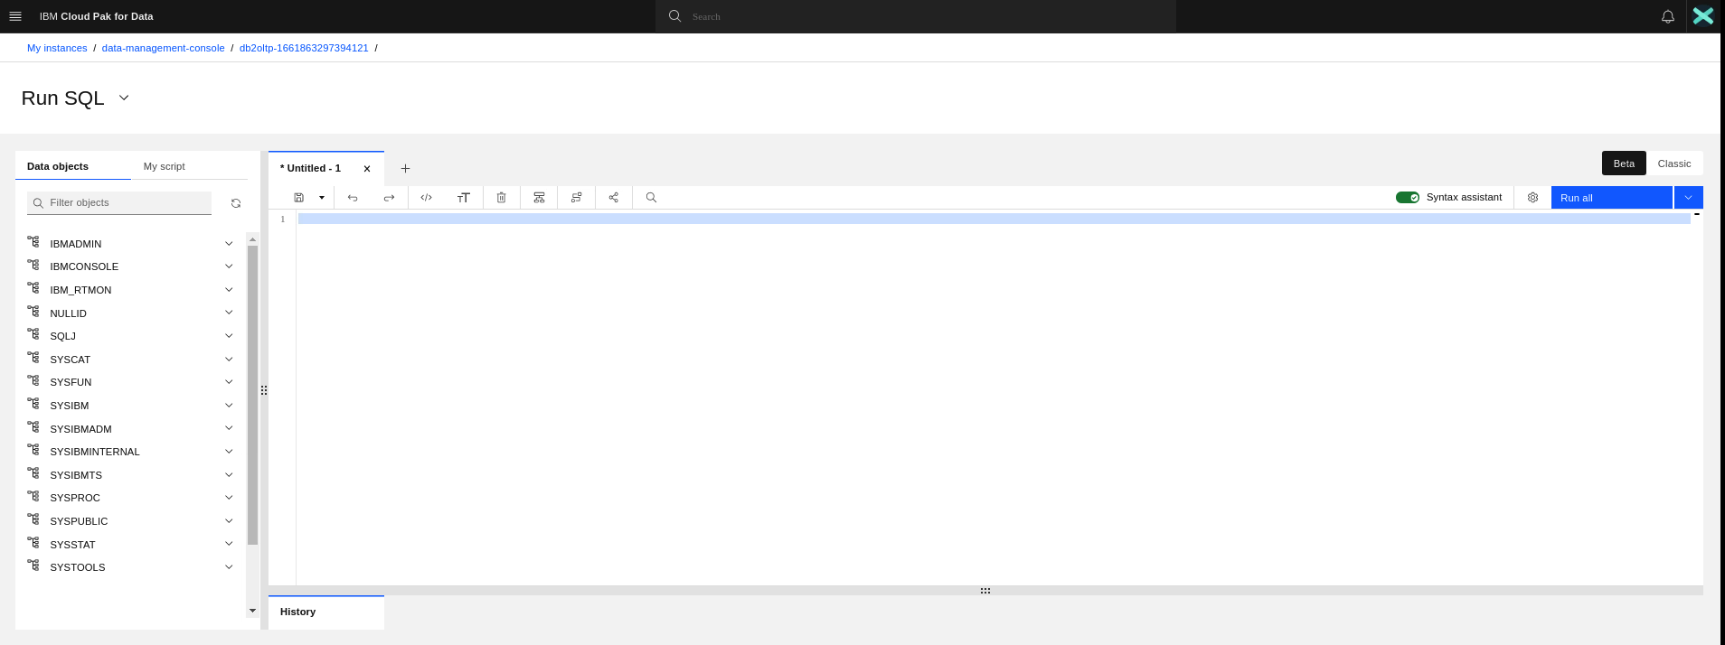

1. For example you can run below commands to grant full access to the database to newly created users.

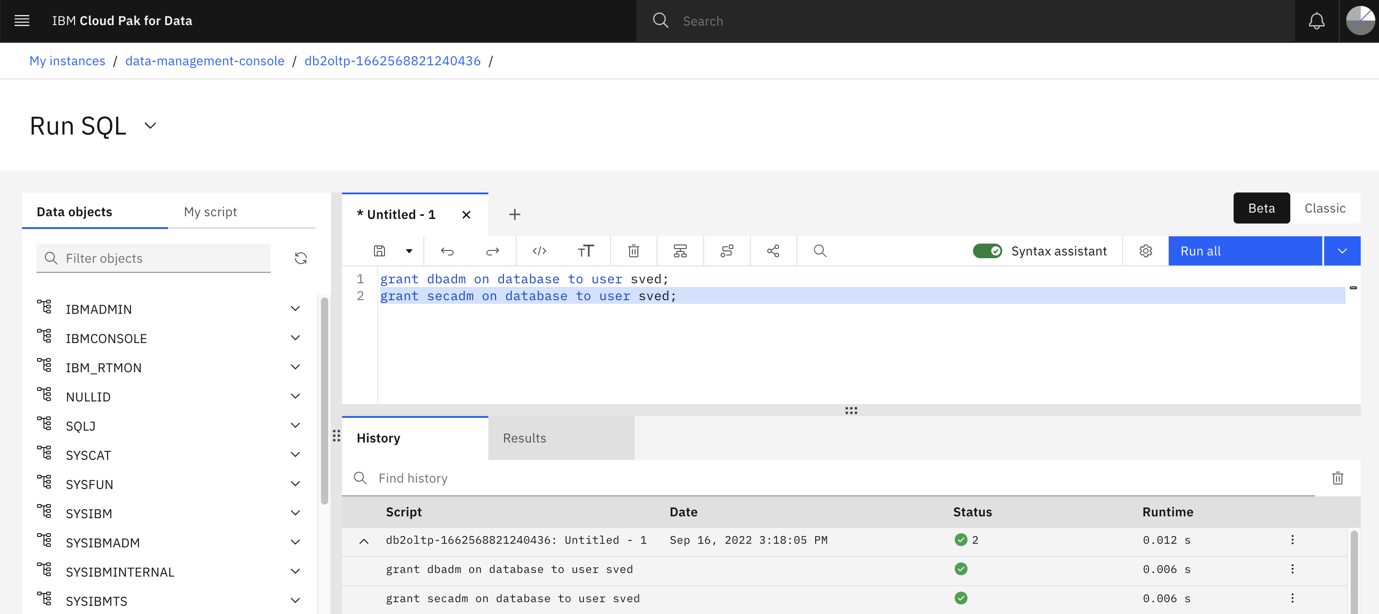

**Setting up Data Virtualization**

You can use **Data Virtualization** to create a virtual table to segment or combine data from one or more tables. **Data Virtualization** connects multiple data sources into a single self-balancing collection of data sources or databases. Refer this link for more details -> <https://www.ibm.com/docs/en/cloud-paks/cp-data/4.5.x?topic=data-virtualizing>

### **Task 1: Create a project**

You need a project to store the virtualized data.

1. Login to CPD Platform. Click on the Hamburger Icon on the top left.
2. Select **View all Projects**. Alternatively All Projects can be accessed from Home Page under Overview Section.
3. If you have an existing project and want to reuse it, open it. If you don't have an existing project or want to use fresh new project, click **New project** on your **Projects** page.

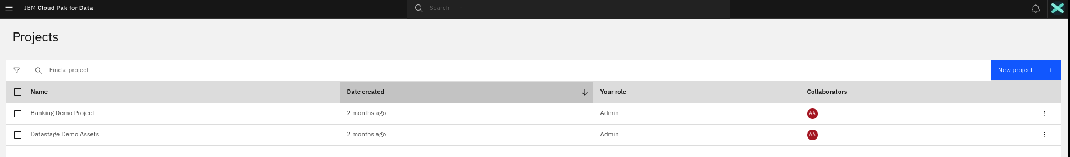

1. Select **Create an empty project**.

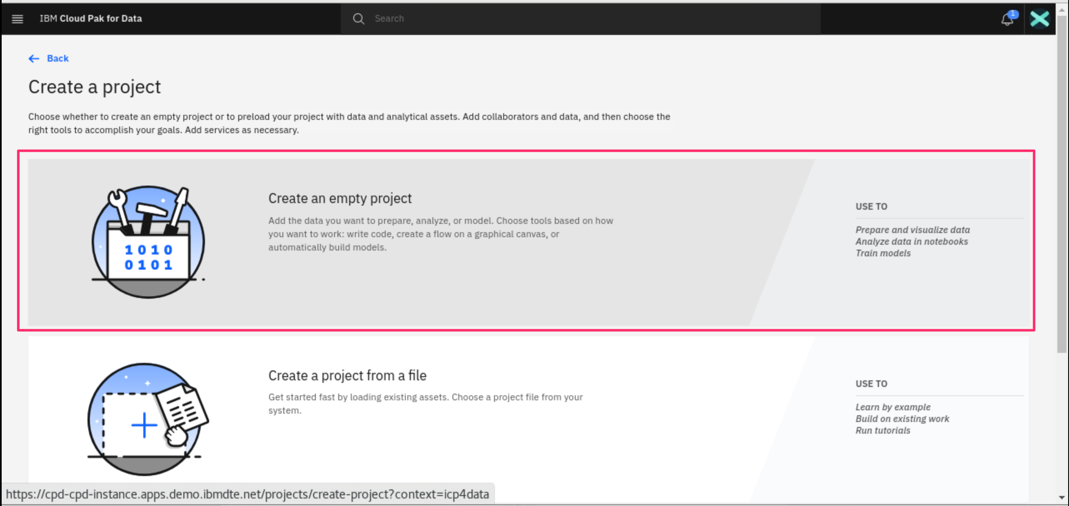

1. On the **Create a project** screen, add a name and optional description for the project. Click **Create**.

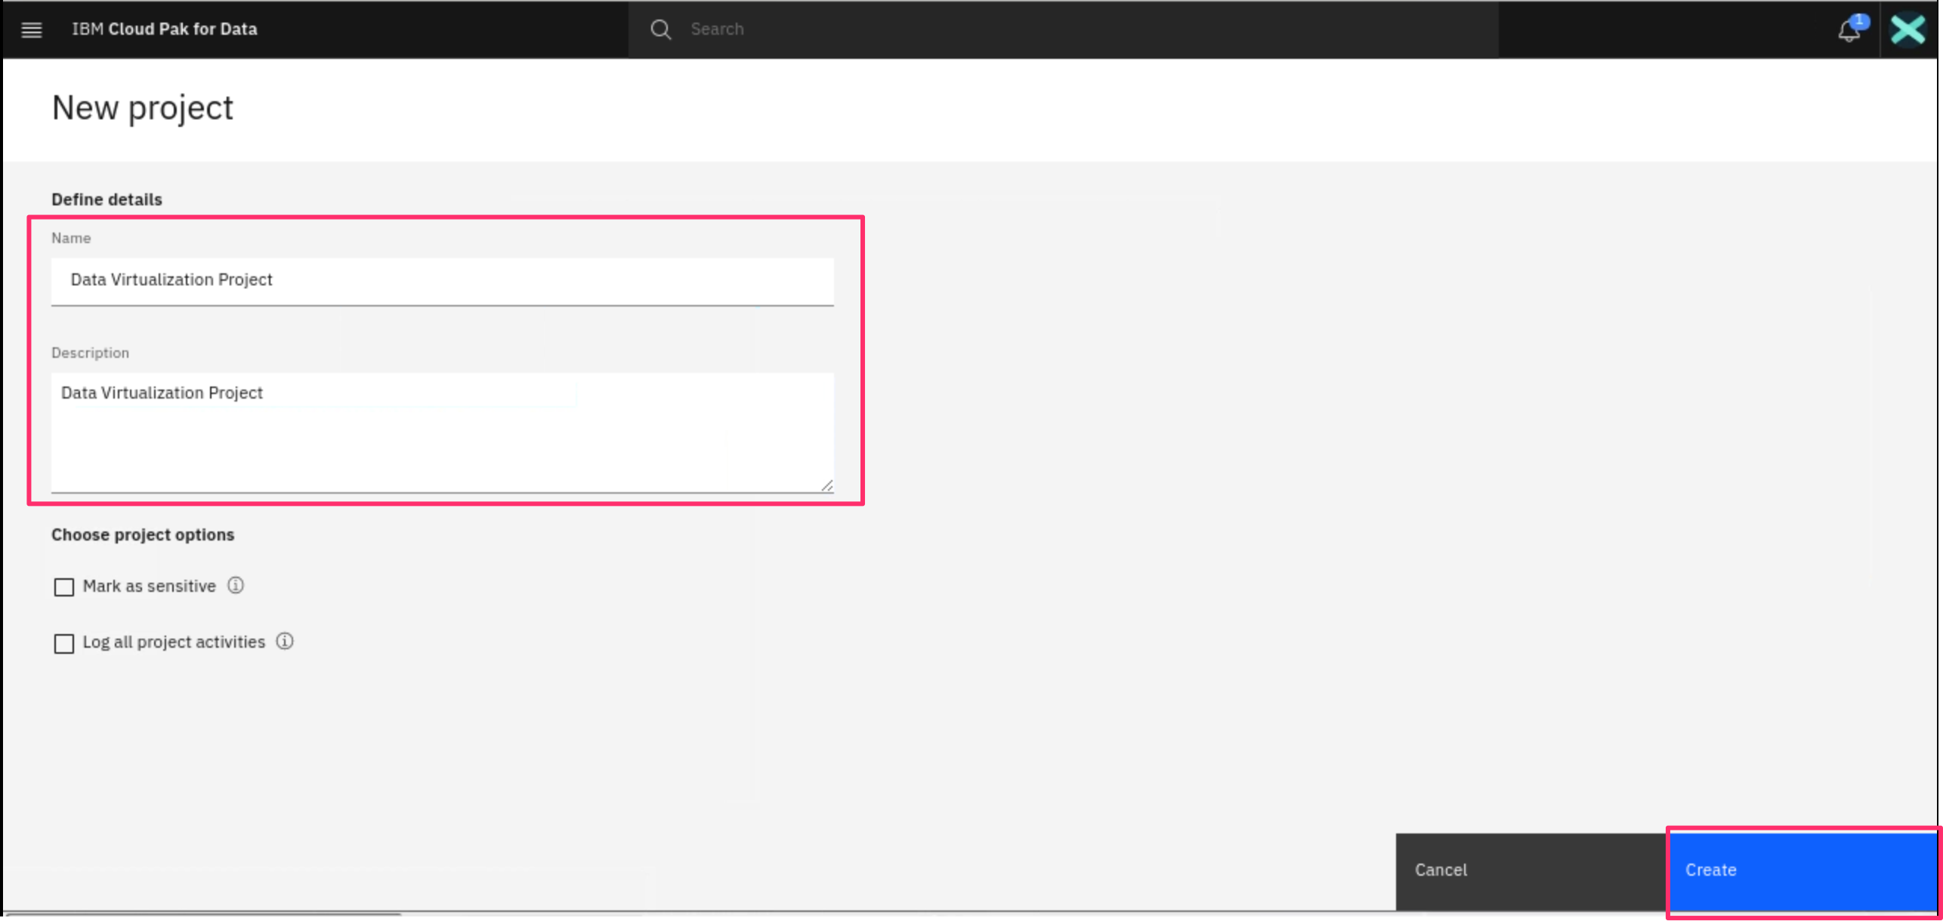

1. The Project will be created successfully.

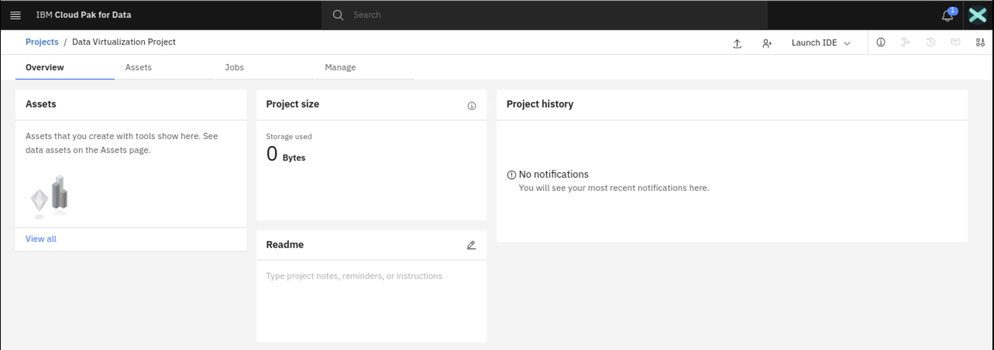

### **Task 2: Add a connection to your Db2 data source**

Before you can virtualize the data, you need create a connection to the data source.

1. From the main navigation menu, select **Data** > **Data virtualization**.

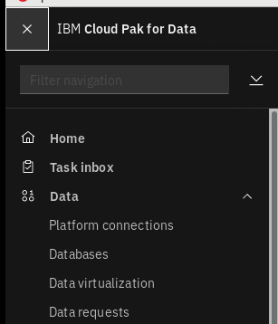

1. If opening for the first time, the Data Virtualization component may start to get initialized. Just wait until its fully deployed and Next screen appears.

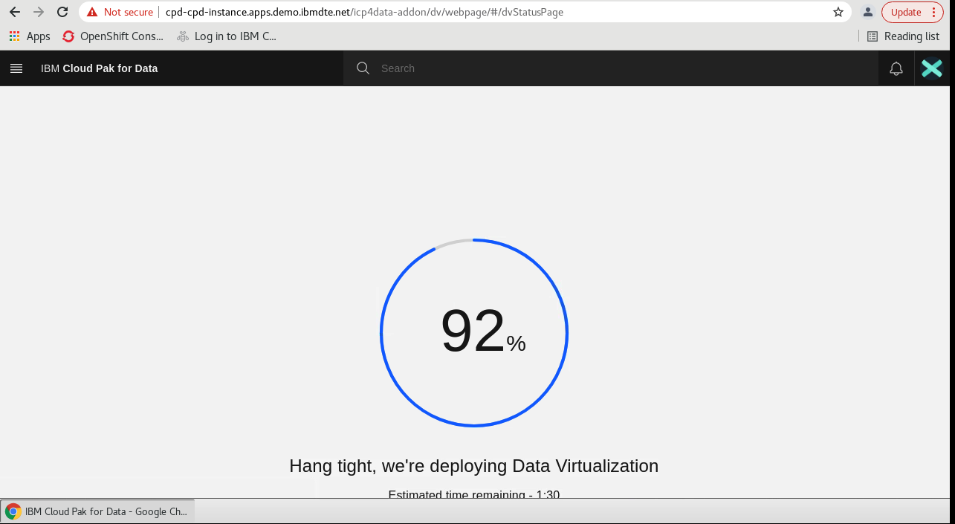

1. After initial initialization, the Data Virtualization Data Sources Page appears.

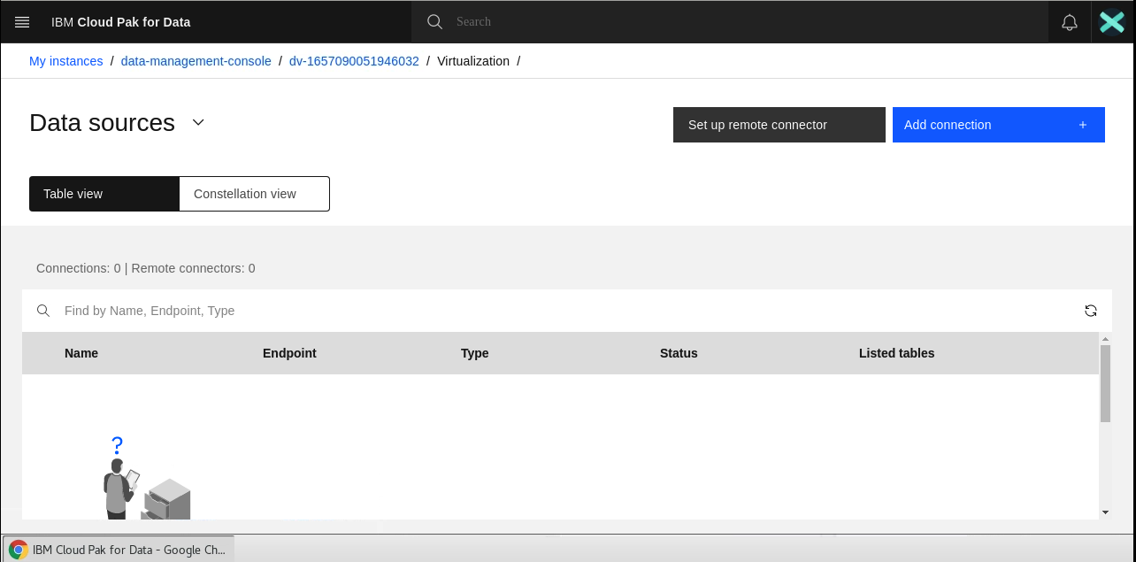

1. Click **Add connection > New connection**.

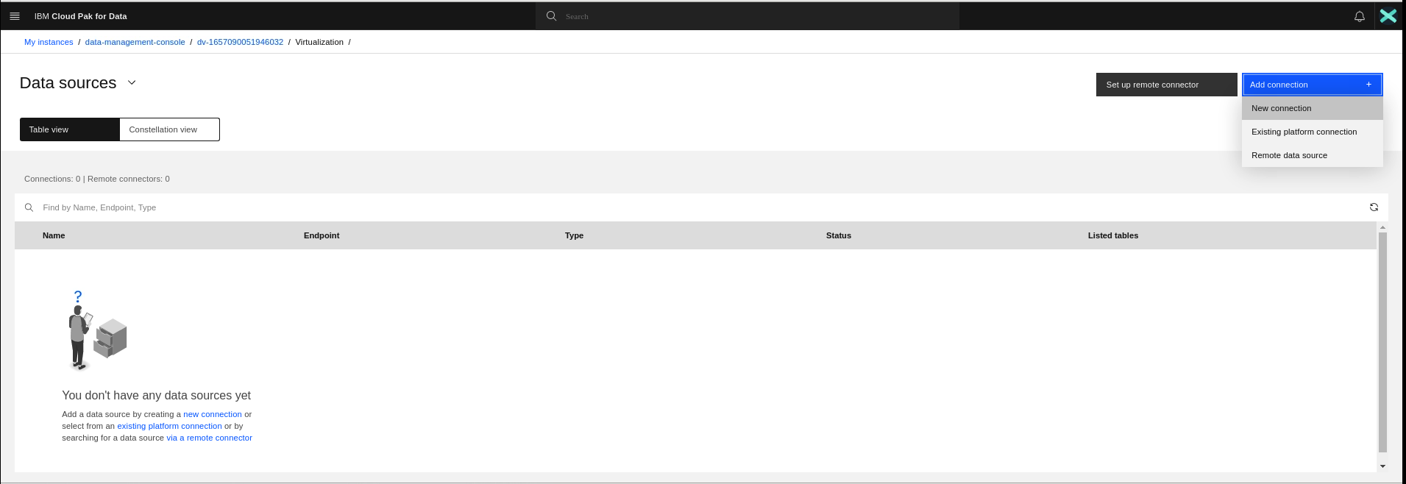

1. Select **IBM Db2**. Click **Select**.

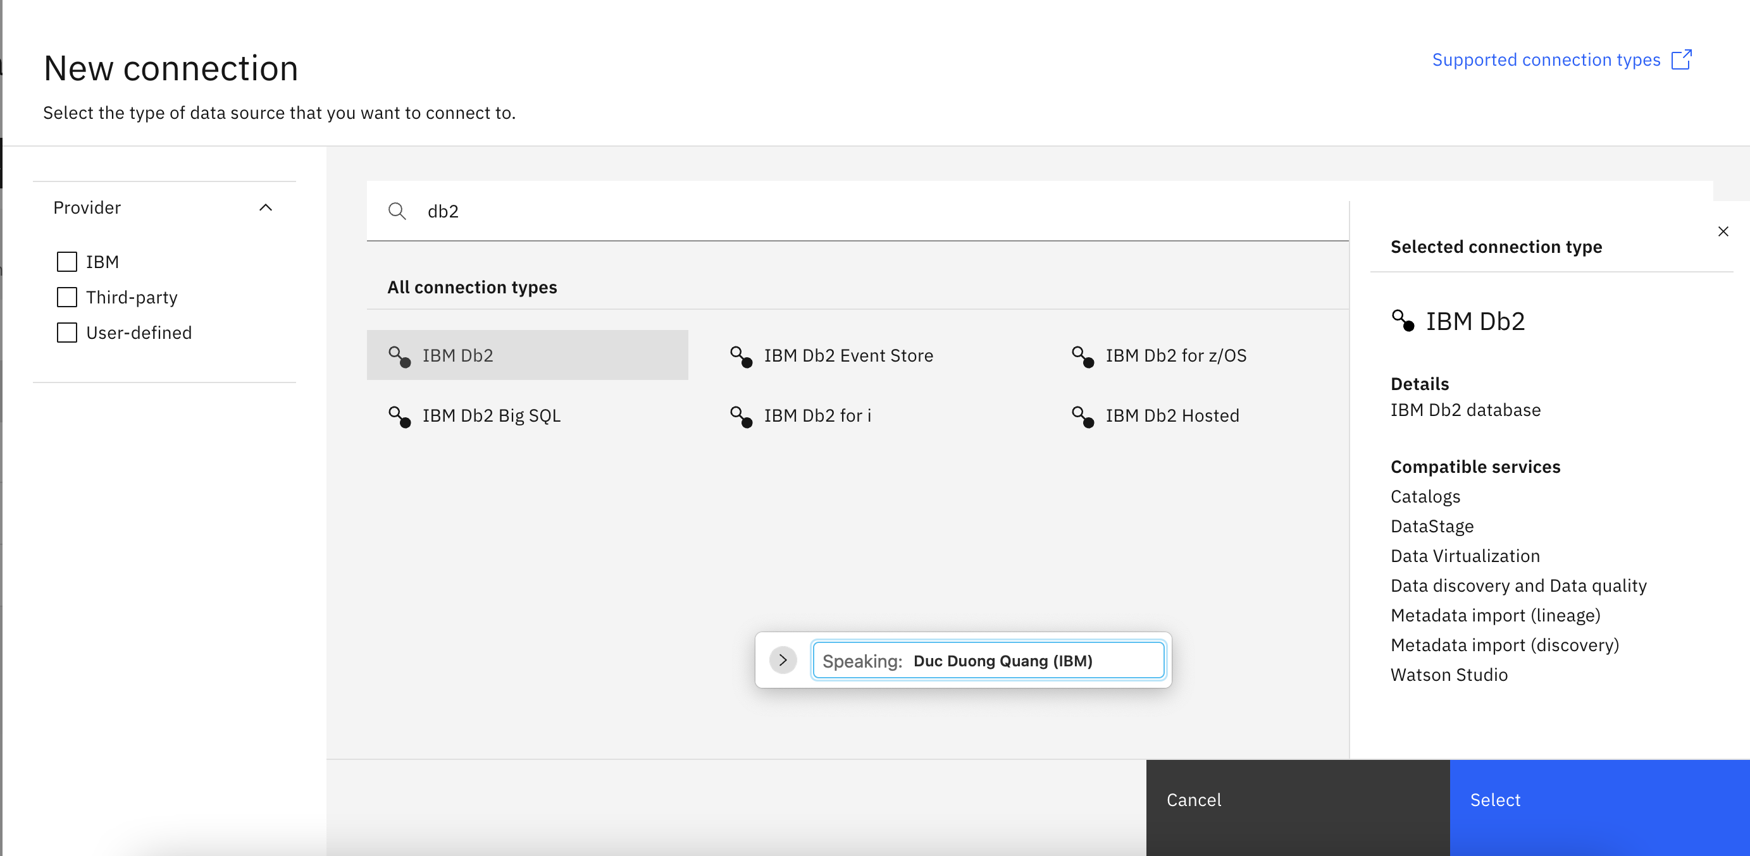

1. Complete the connection details based on the credentials you copied for your db2 instance .

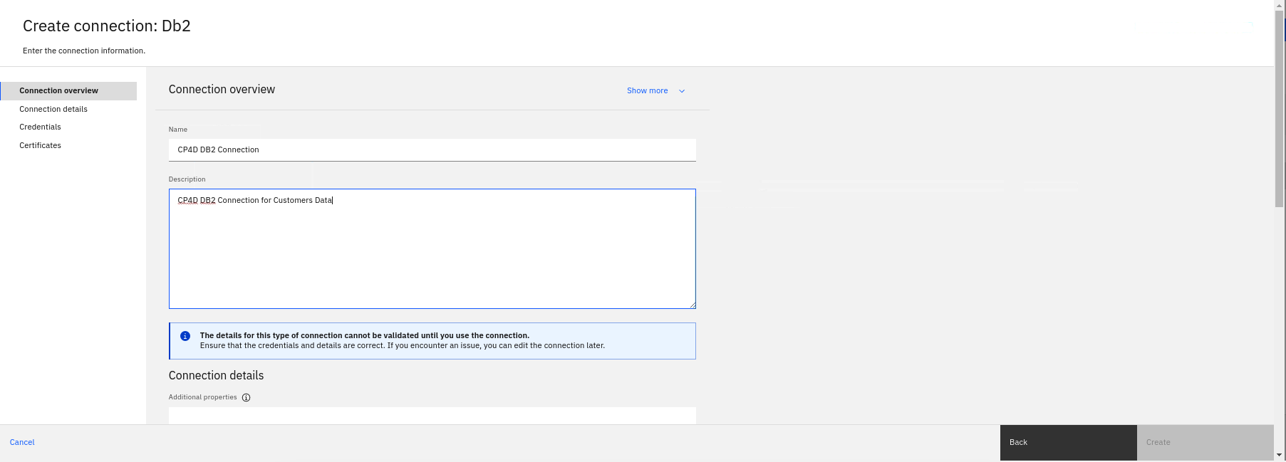

1. Enter Database Name, Host Name and Non SSL Port as we noted earlier. Select the Credential Setting as **Personal**.

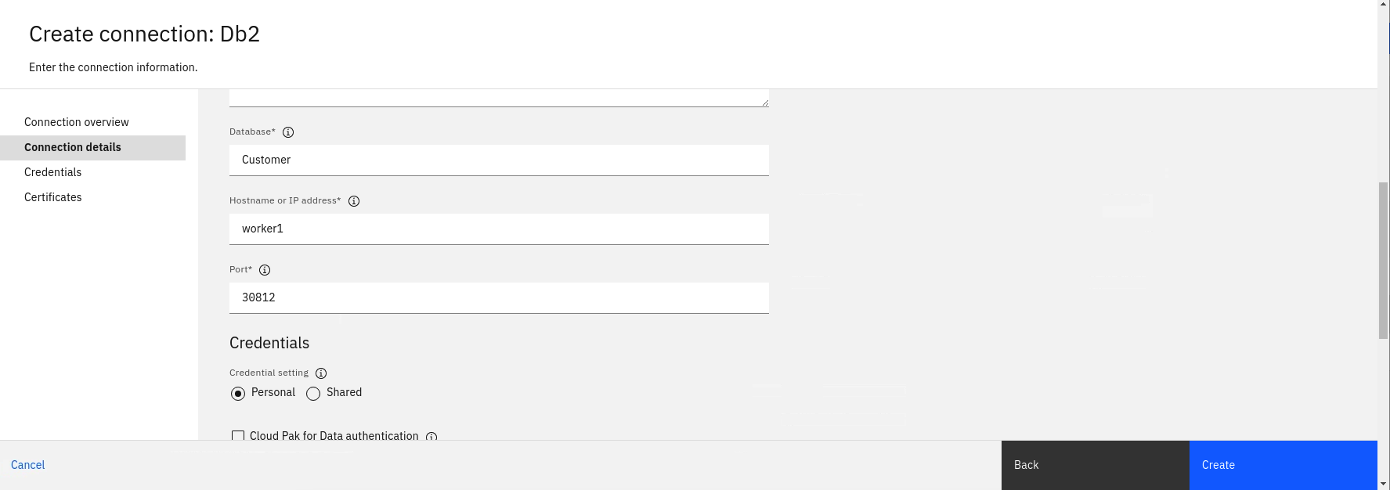

1. Enter **Personal** Credential of **admin** User. Click **Create**.

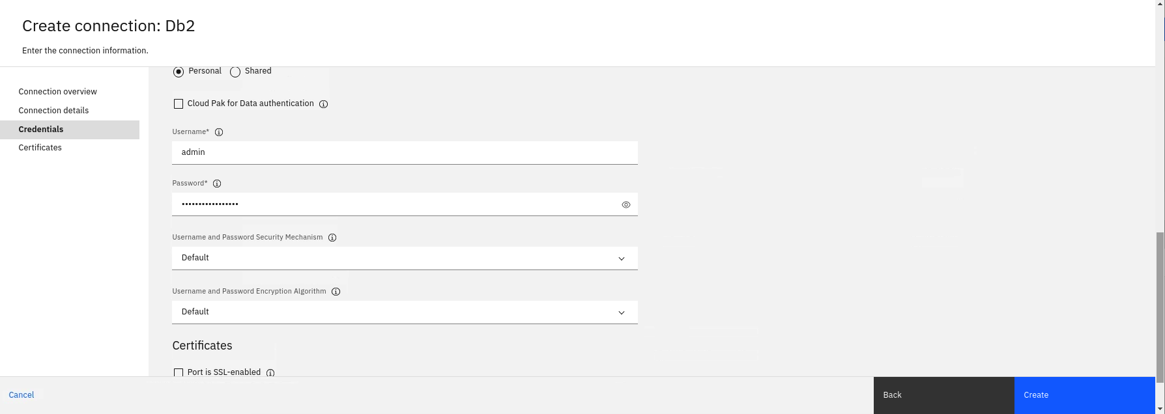

1. Click **Skip**

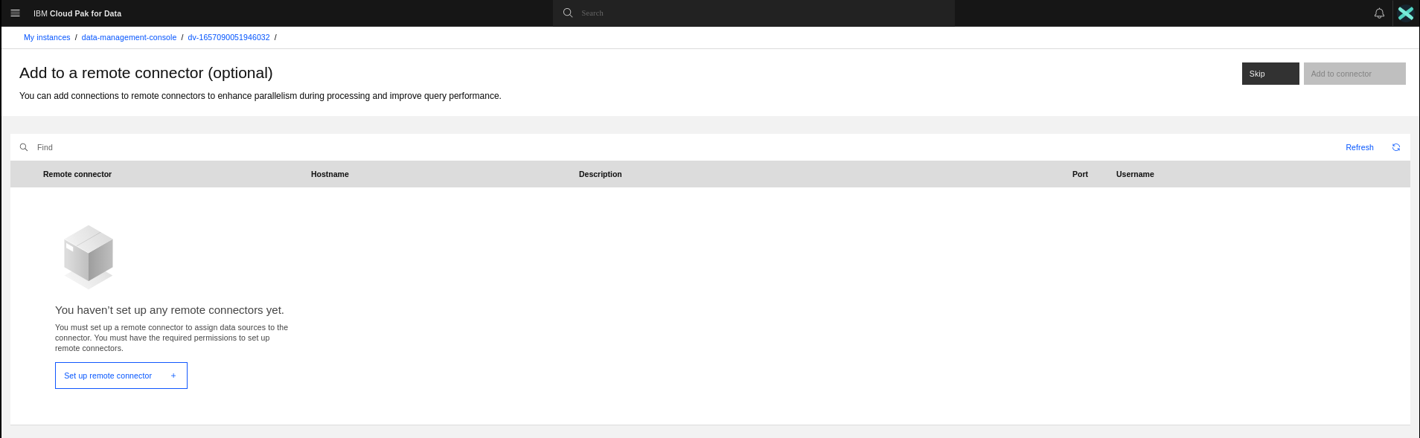

1. The DB2 Data Source will be added as a Data Virtualization Source.

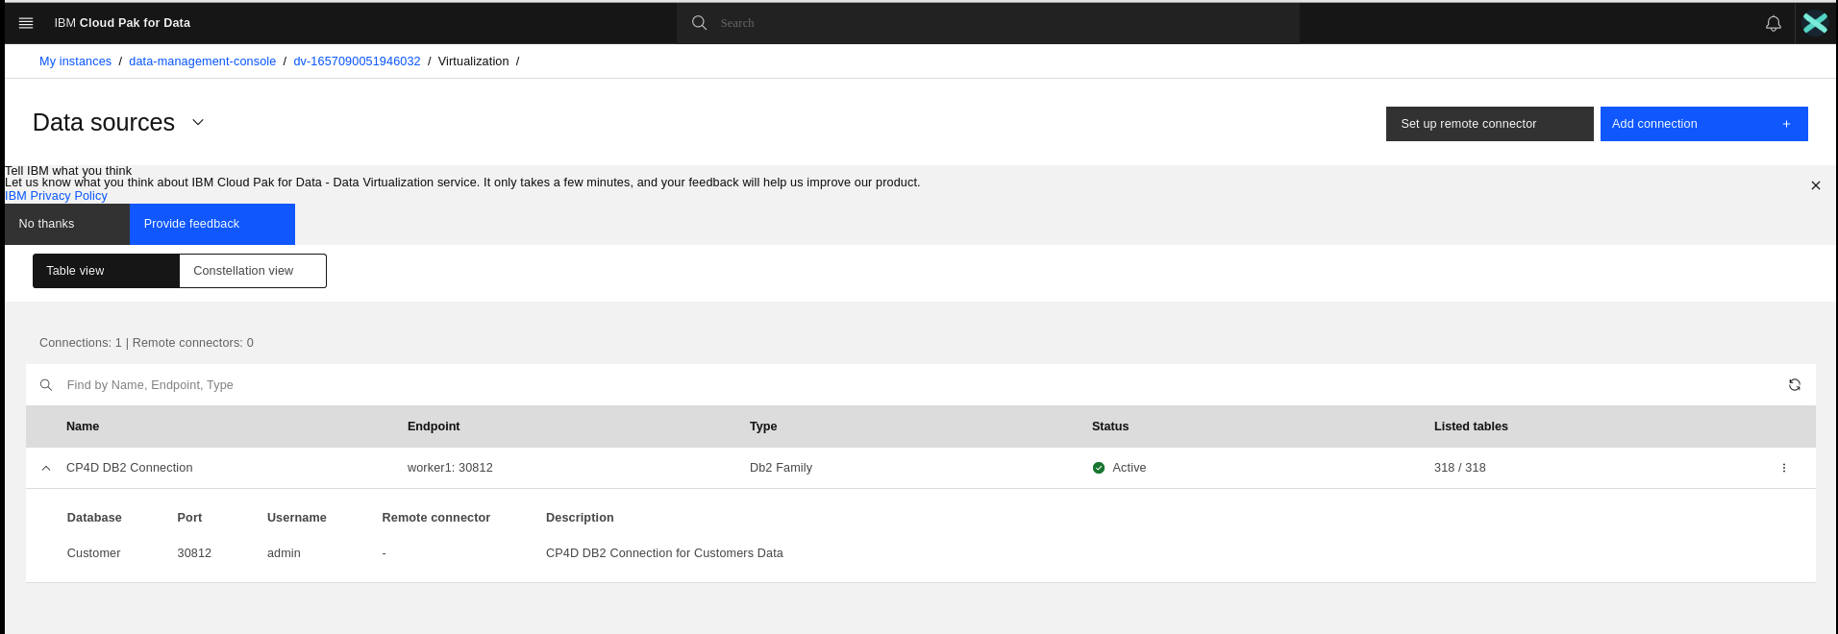

### **Task 3: Add a connection to a PostgreSQL data source**

For the purpose of Validating the Data Virtualization from Multiple Types of Data Sources, We have prepared a **PostgreSQL DB** as well with the *Sales.csv* data uploaded in table named *Sales_Rep*. Use below steps and given credentials to use the data from this PostgreSQL Data Source.

1. From the main navigation menu , select **Data** > **Platform Connections**. The list of configured Data sources displays.
2. Click  **New connection**.

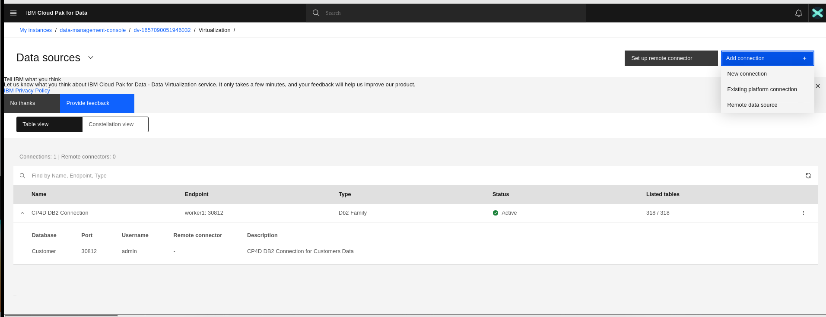

1. Select **PostgreSQL** and click **Select**.

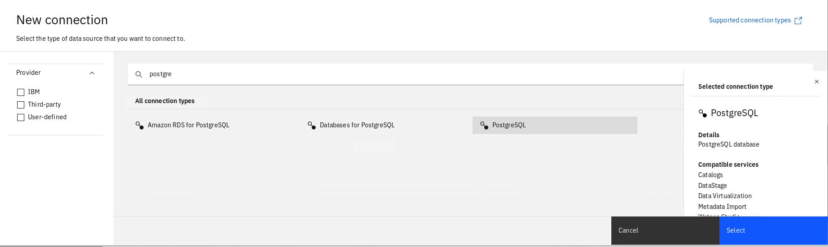

1. Enter the Connection Name and Description.

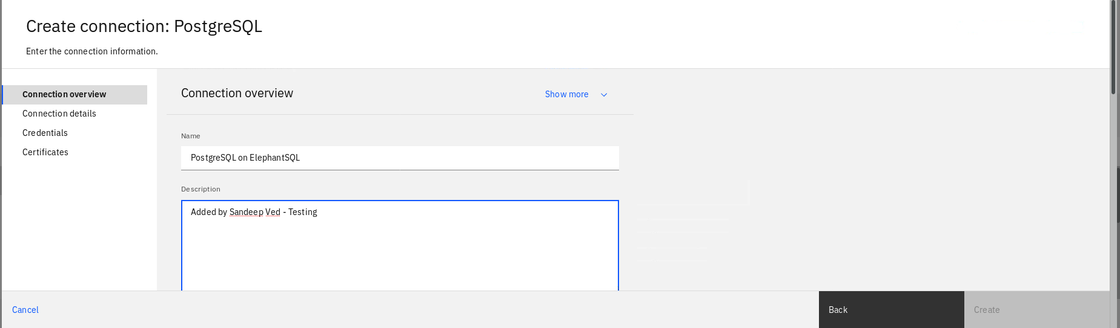

1. Enter the Connection Details and Credentials as below. Click **Next.**

* Database Name: vlyawtap
* Host Name: tiny.db.elephantsql.com
* Port: 5432
* Credential: Personal
* User Name: vlyawtap
* Password: fXt4TyCB_W0d0LCaCaPF7MbLKWLpti60

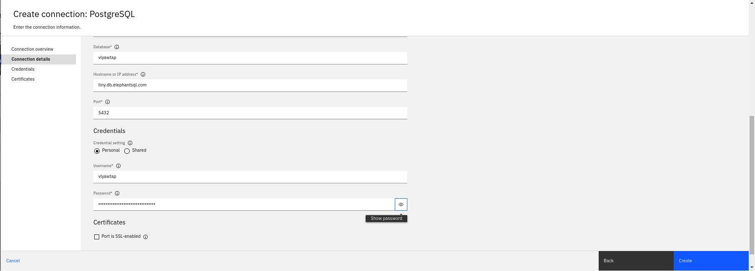

1. Click **Skip.**

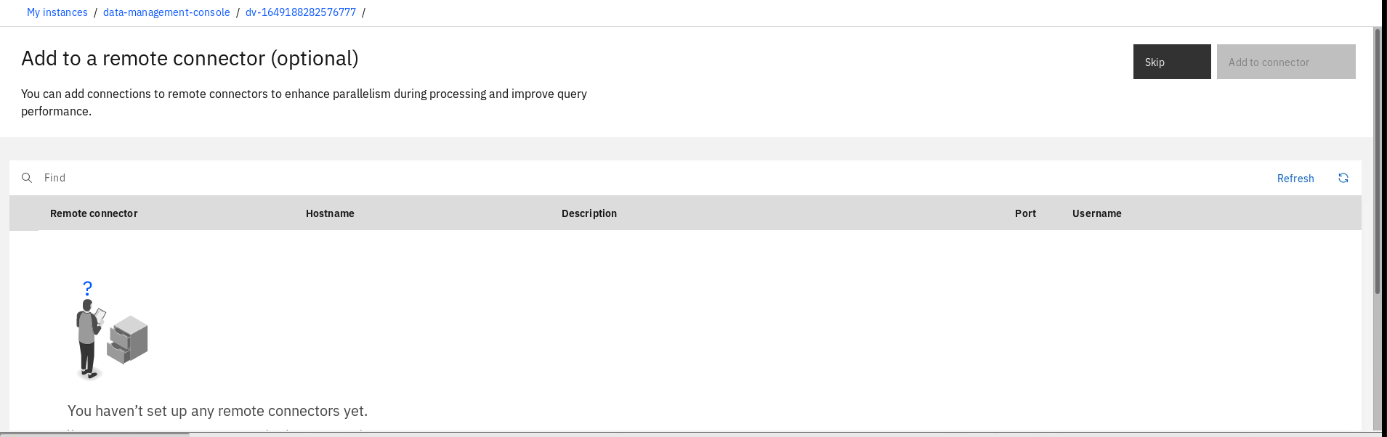

1. The new data source will be added.

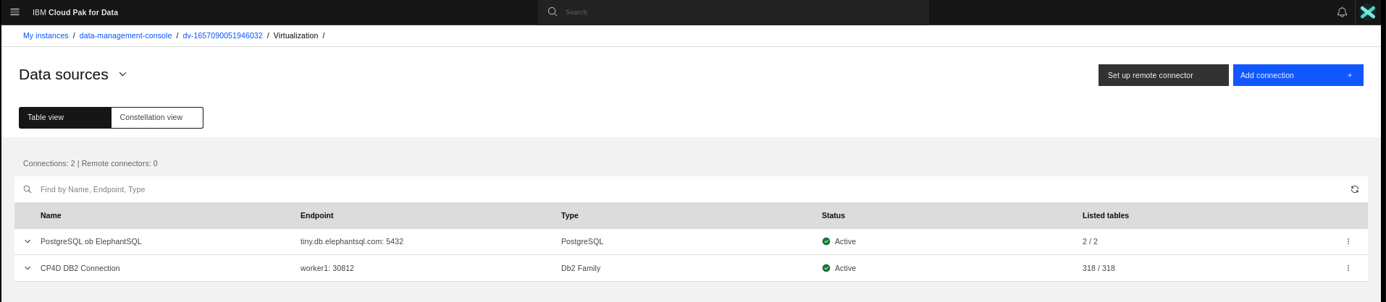

### **Task 4: Add tables to your virtualized data**

With the connection defined, you can virtualize data from that data source.

1. From the Data sources menu, select **Virtualization > Virtualized Data**.

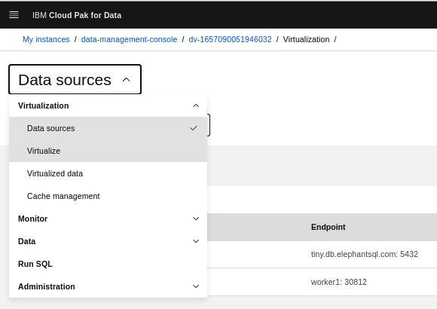

1. Click on **Add Virtual Objects.**

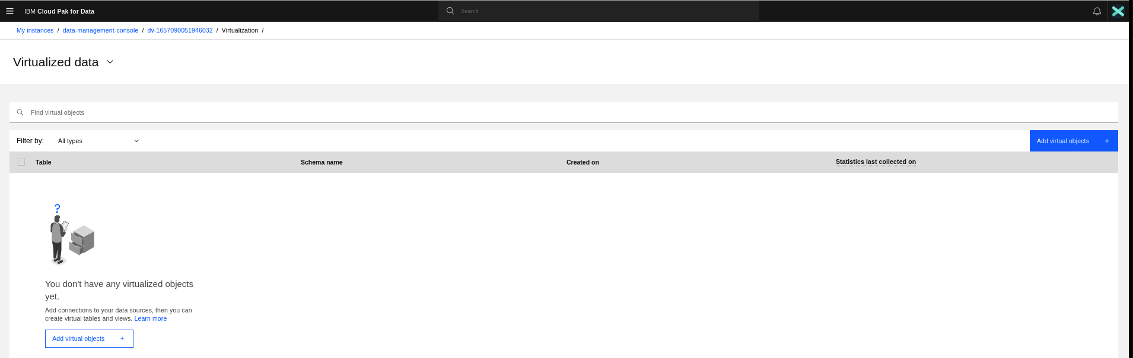

1. You will see the available connections from where data can be virtualized.

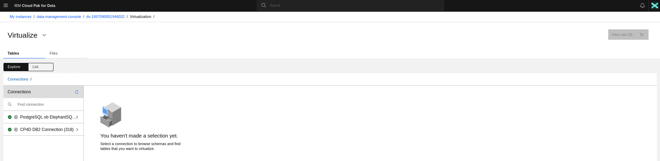

1. Select CP4D DB2 Connection -> IBMADMIN -> CUSTOMERS Table and click **Add to cart.**

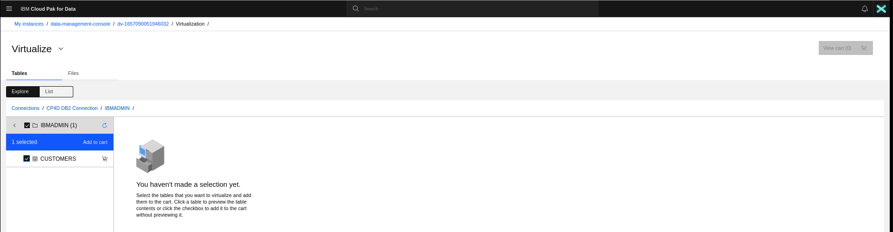

1. Click on **Connections** link again.

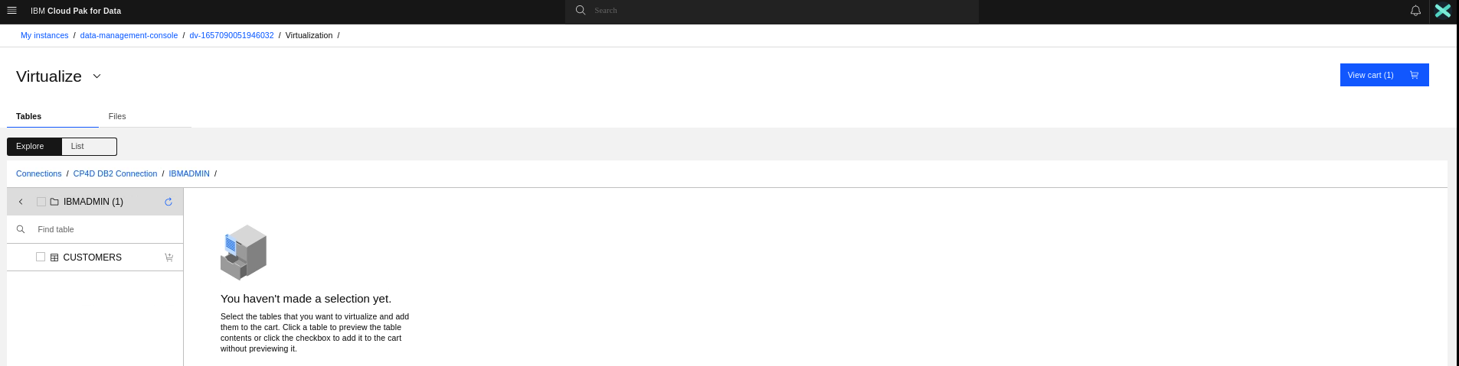

1. Select **PostgreSQL on ElephantSQL -> sample ->**  **sales_rep** tables from the list, and click **Add to cart**.

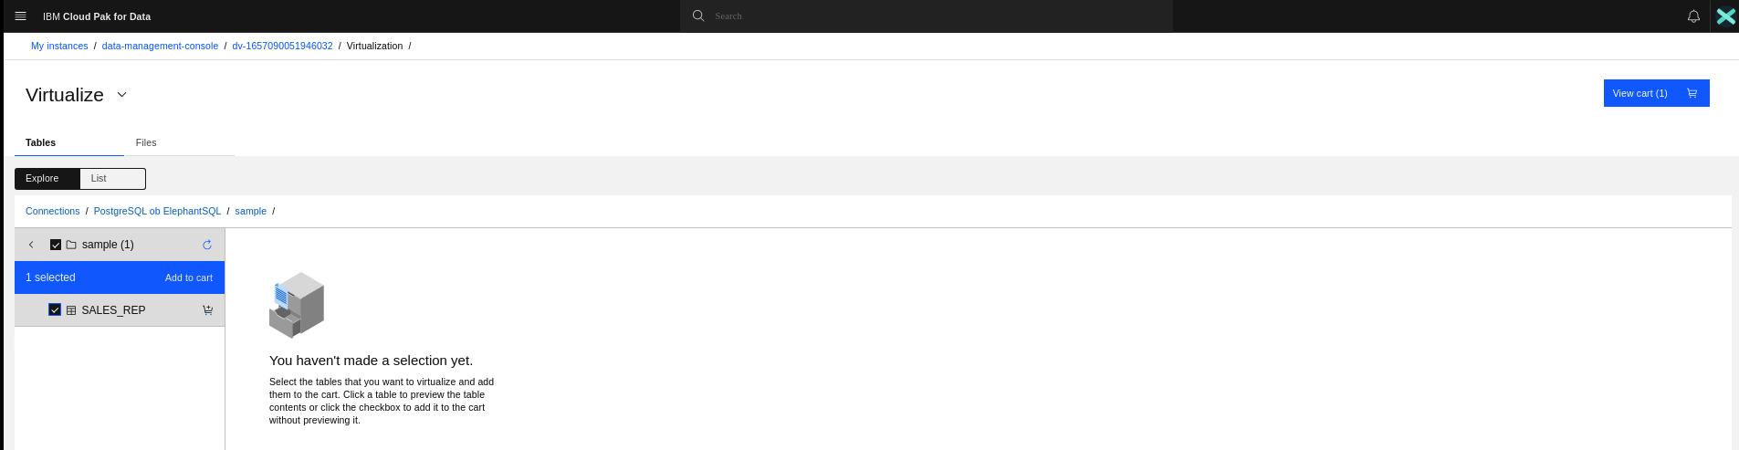

1. Click **View cart**.

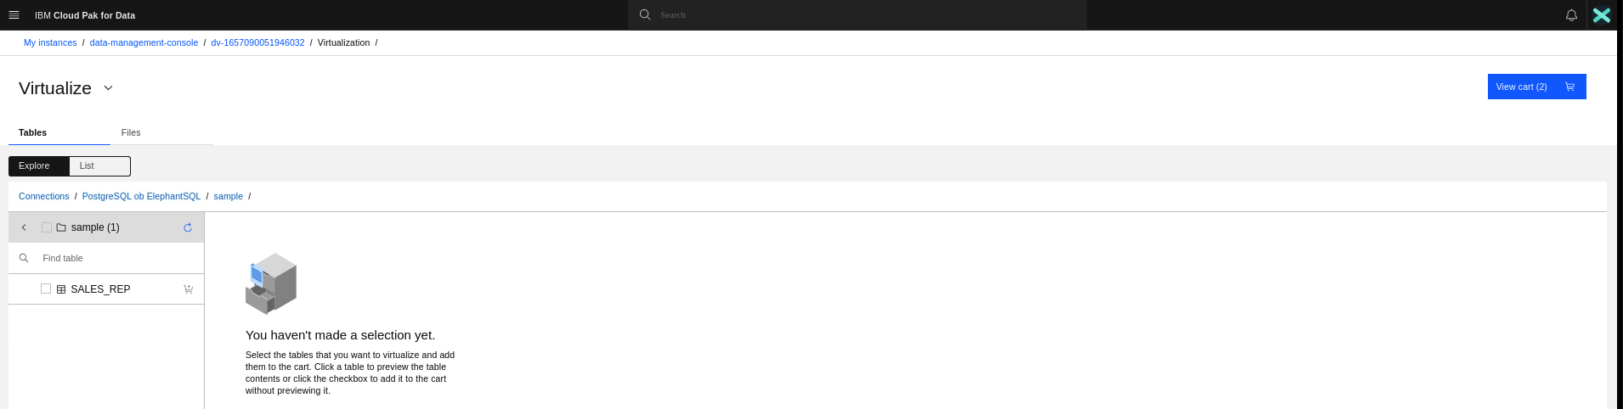

1. Select Assign to **Virtualized data** to add these two tables to your list of virtualized data. Click **Virtualize**.

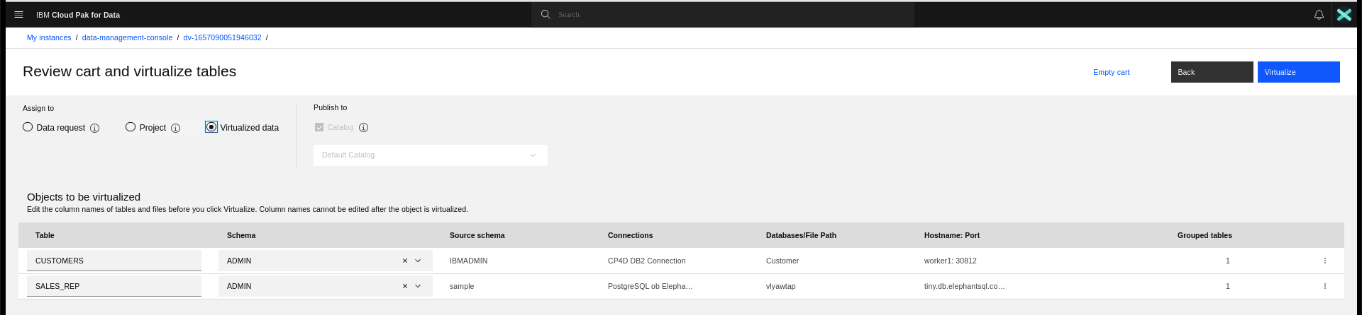

1. Click **Confirm**.

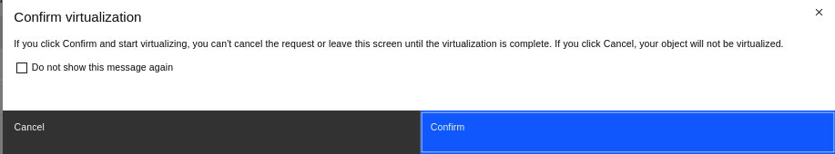

1. Click **Go to virtualized data**.

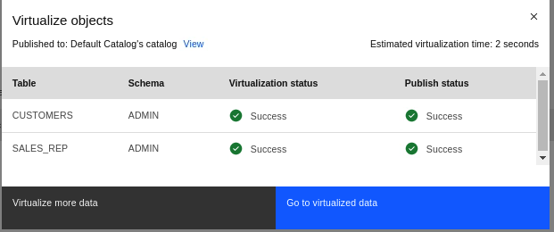

1. You can see the  **virtualized data**.

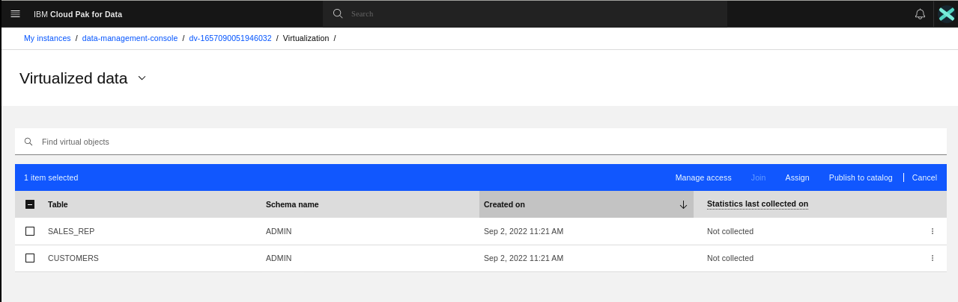

### **Task 5: Join and Publish virtualized data to project**

Next, join two tables to create a virtualized asset and publish that to a catalog and project.

1. On the Virtualized data screen, select the **customers** and **sales_rep** tables from the list, and click **Join**.

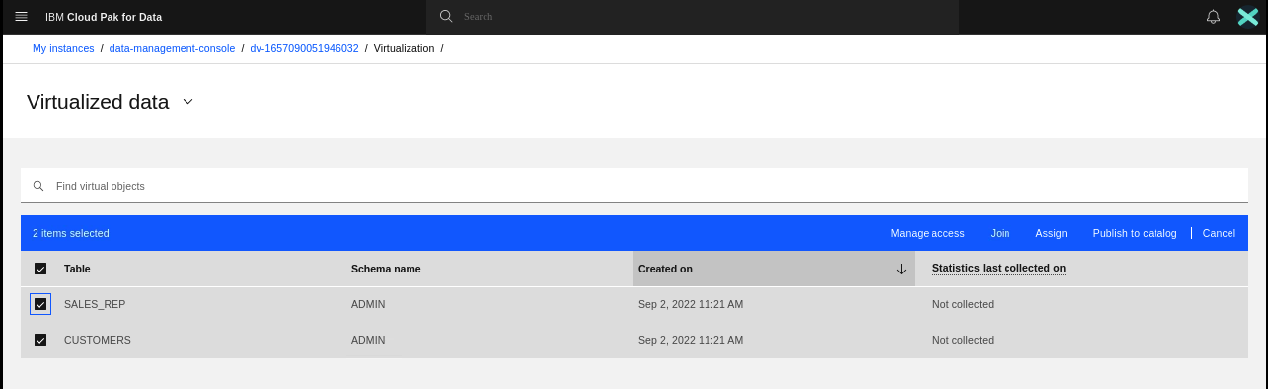

1. Connect the **SALESREP_ID** columns in the two tables. Click the link **Open in SQL Editor** to see the actual query used to join the tables and create the view.

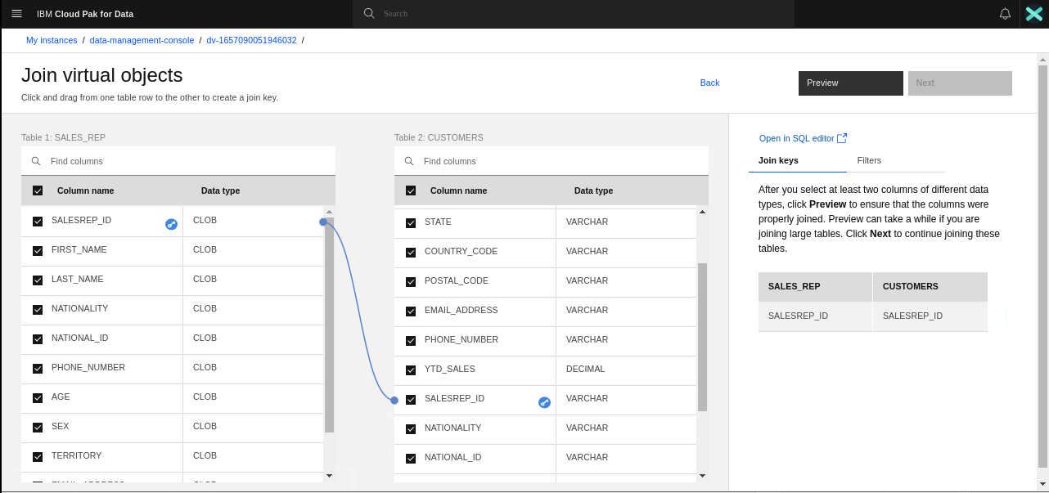

1. Click **Continue**.

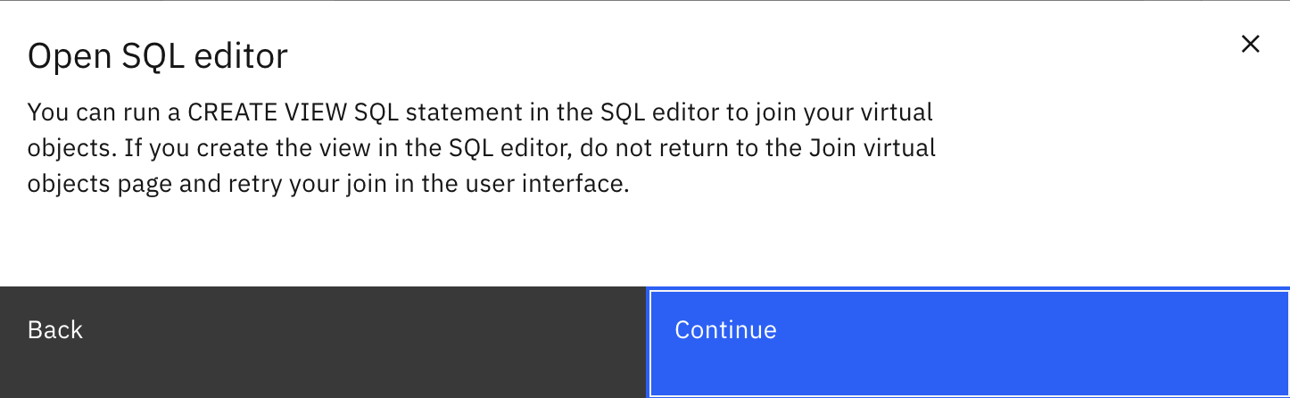

1. If any Query Customization is required, then we can change here and click on **Run All** button. For now, Click **Back.** Click **Preview** on the Previous screen to see the join data preview.

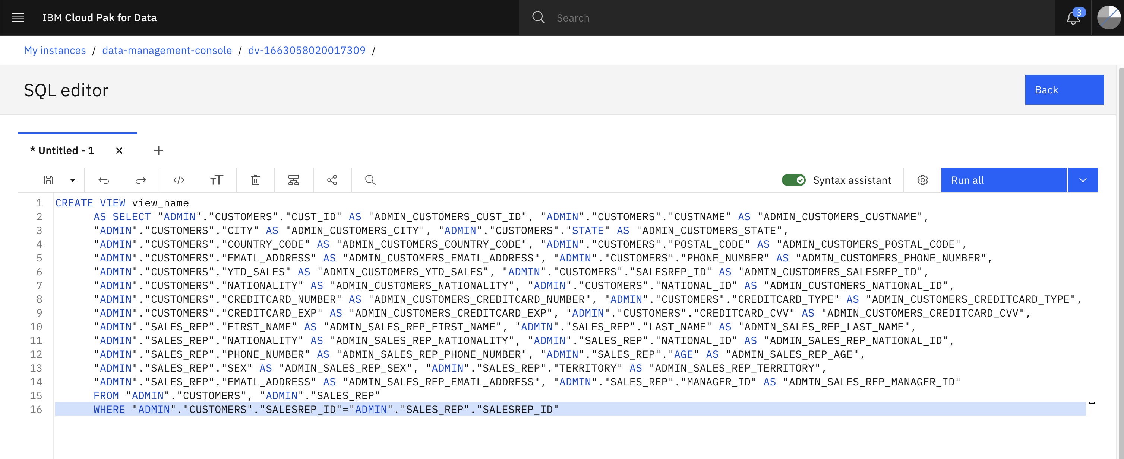

1. Close the Preview Popup.

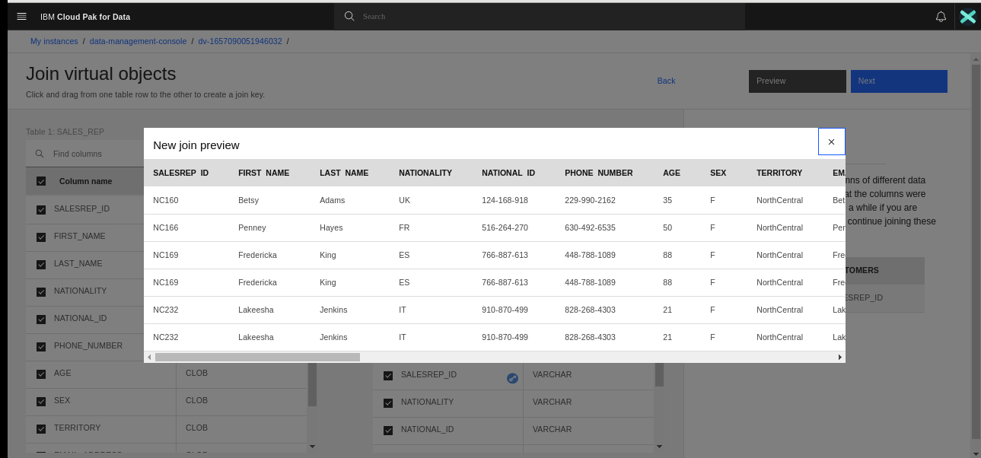

1. **Filters** tab can be used to filter some of the data from this view. For now leave it as default and click **Next**.

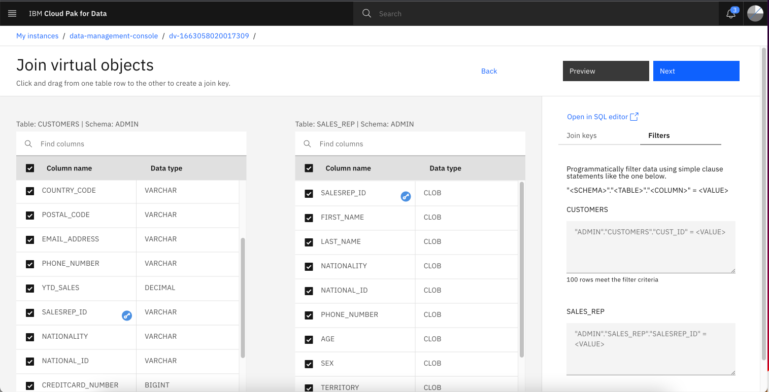

1. Review the joined table, and click **Next**.

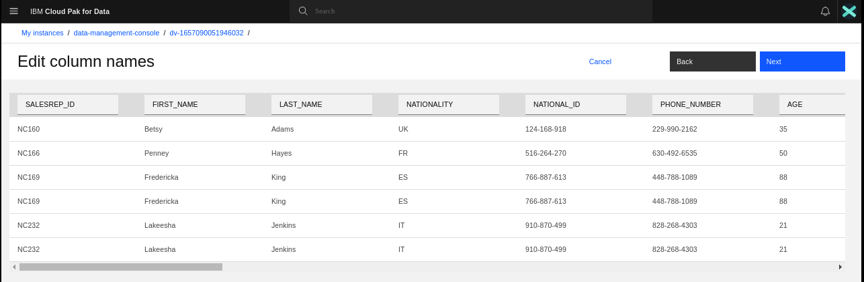

1. For the view name, type joined_customers_sales_table. Select a project from the list that was created earlier, eg. Data Virtualization Project. Click **Create view**.

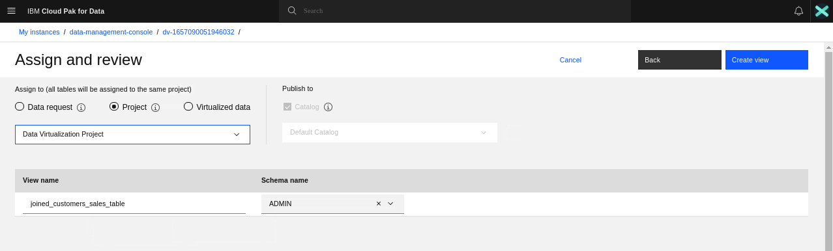

1. When the process completes, Click **Go to Virtualized Data.**

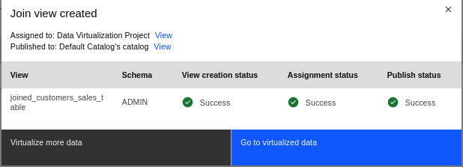

1. Navigate to Projects -> Data Virtualization Project to view the project to preview the virtualized data.

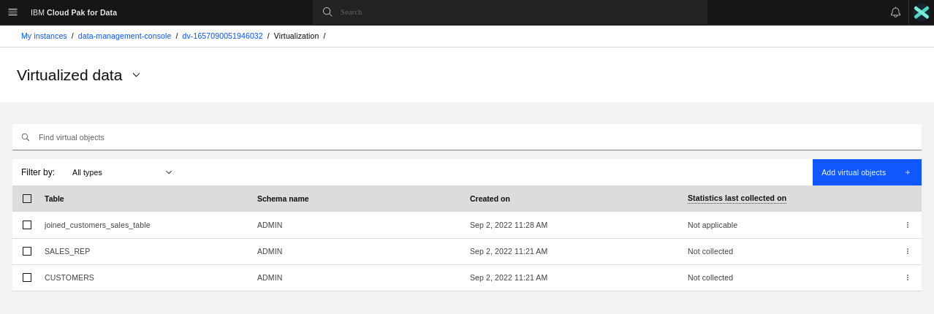

1. Click on the project created earlier.

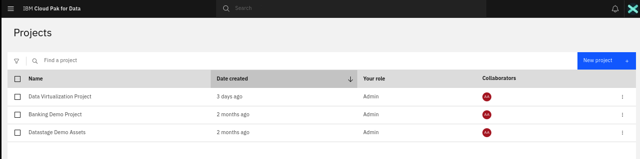

1. Navigate to **Assets** Tab. You will see the virtual view and the connect object to the Data Virtualization Service.
2. Normally, You will need a Credential or API key to view the data in the project. This credential can be saved in the connection object so that it’s not prompted again and again. Click on the Connection object eg. DSXXXXXX.

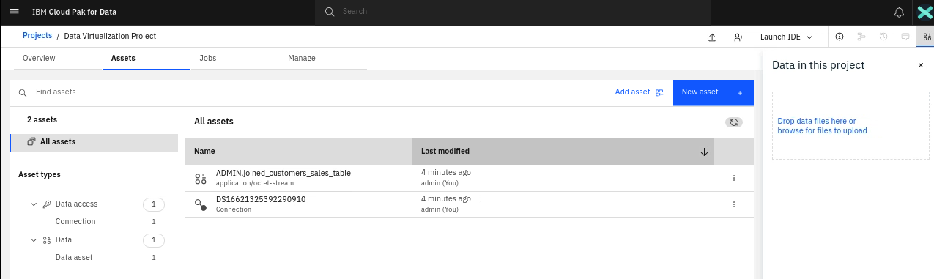

1. Click on **Credentials** in the left navigation pane menu.

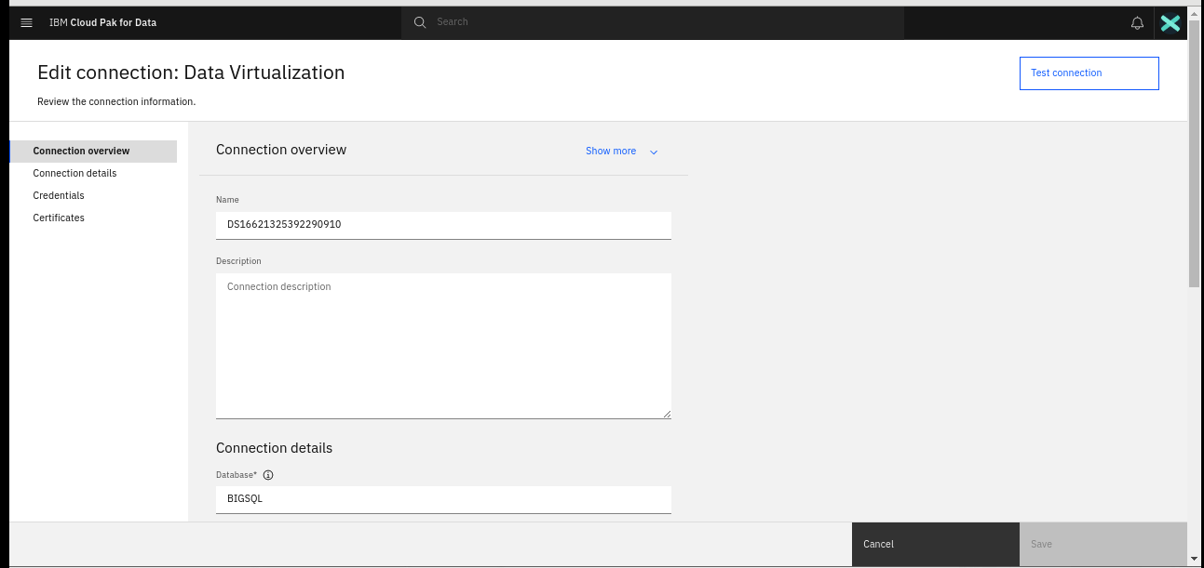

1. Select one of the Authentication Method as the personal connection.

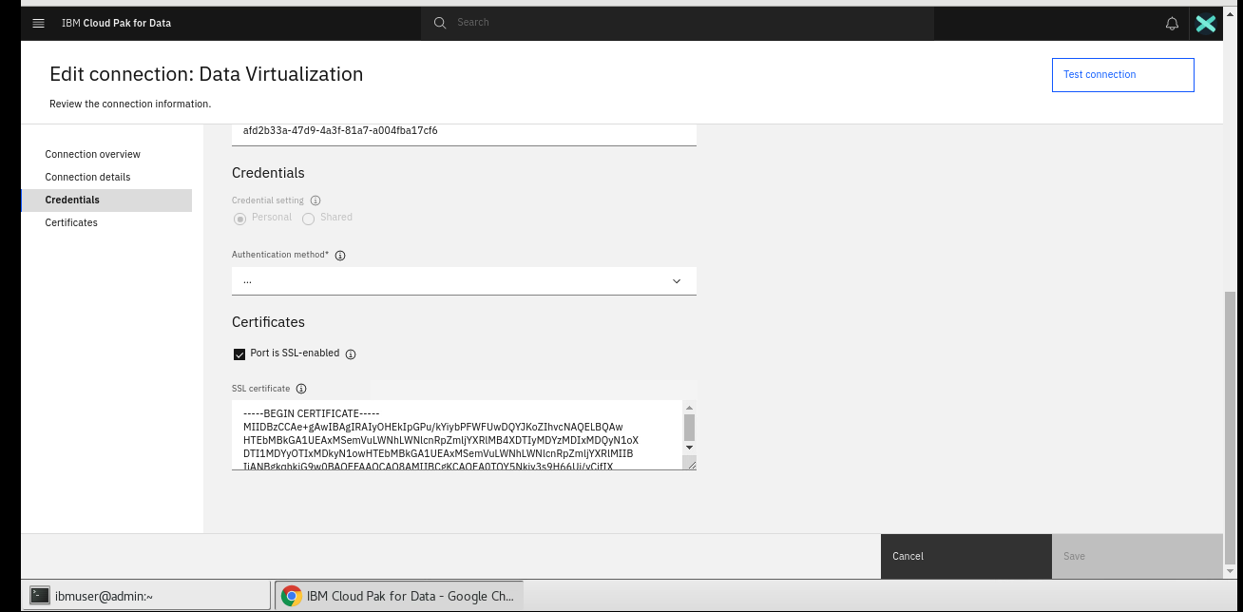

1. Chose User Name and Password.

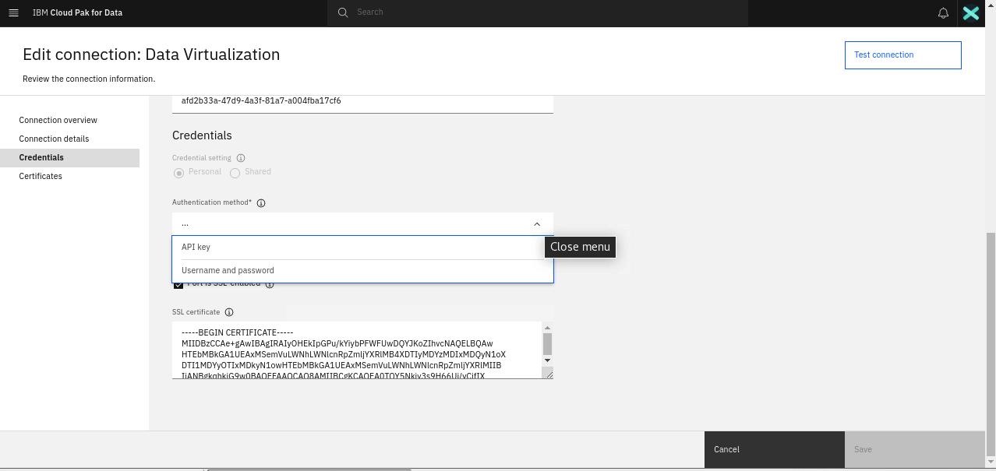

1. Enter the CP4D credentials and click on **Test Connection**. It should be successful. Click **Save** to save the credential information in the connection.

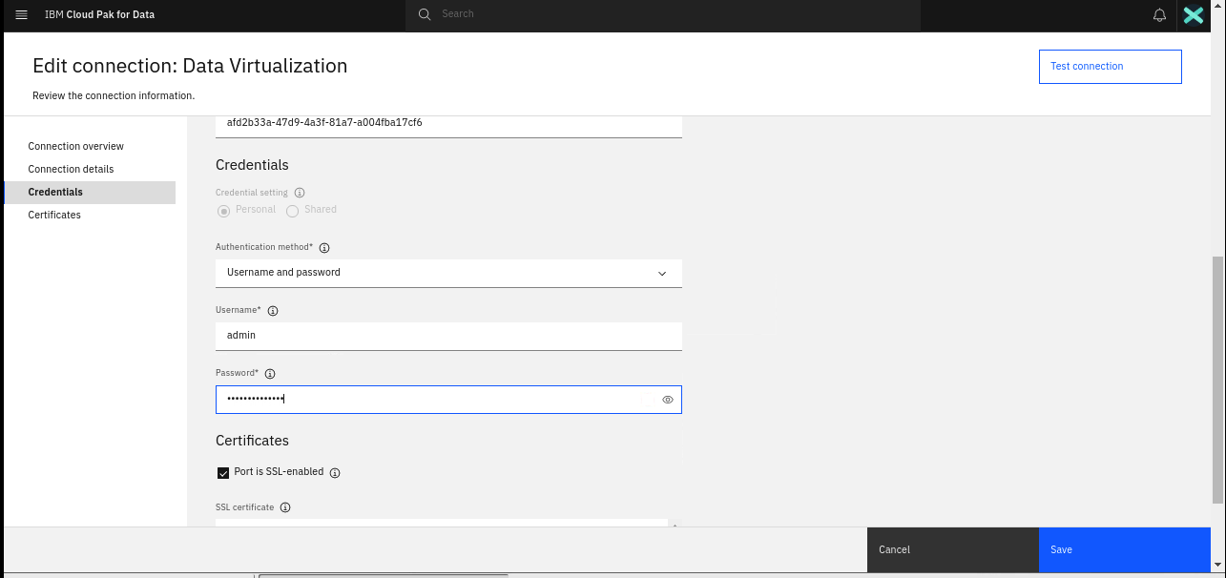



1. Now Click on the Virtualized Data Asset ADMIN.joined_customers_sales_table.

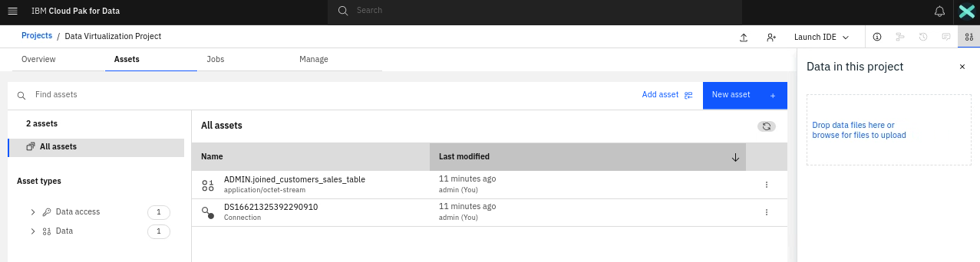

1. You should be able to preview the data without being prompted for credentials.

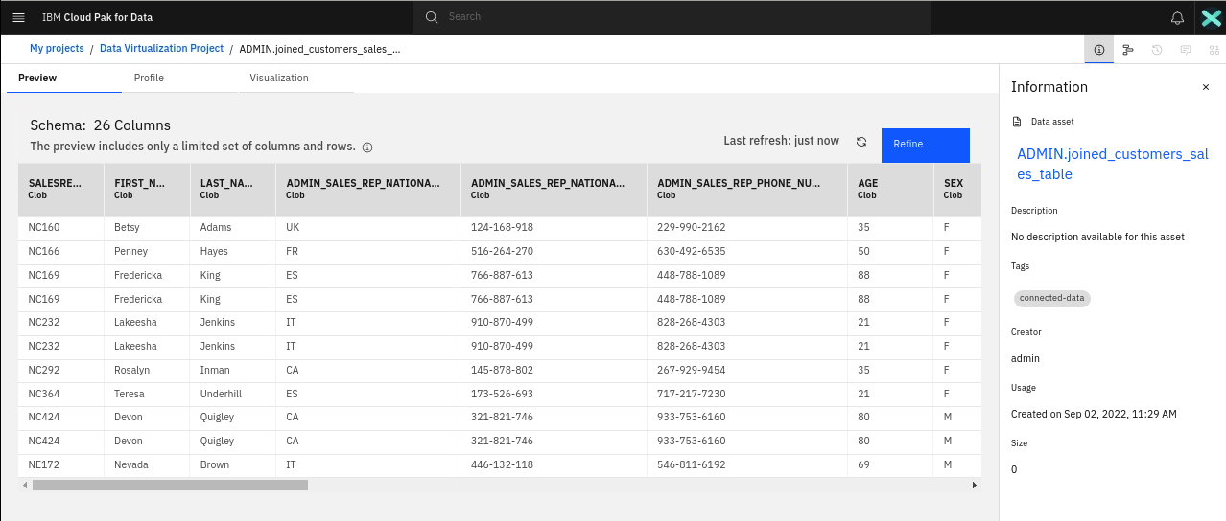

1. Optionally you can click on **Refine** button to explore or refine this data using **Watson Data Refinery**. The part of virtualized data can be saved as CSV file in the project using the Data Refinery Jobs.

## Next steps

Now your virtual data is ready to be used. For example, you can these tasks:

### **Analyze the data in a notebook**

1. Under the Data Virtualization Project, In **Assets** Tab, Click on **New Asset +** to add a notebook Asset.



1. Click on **Jupyter notebook Editor.**

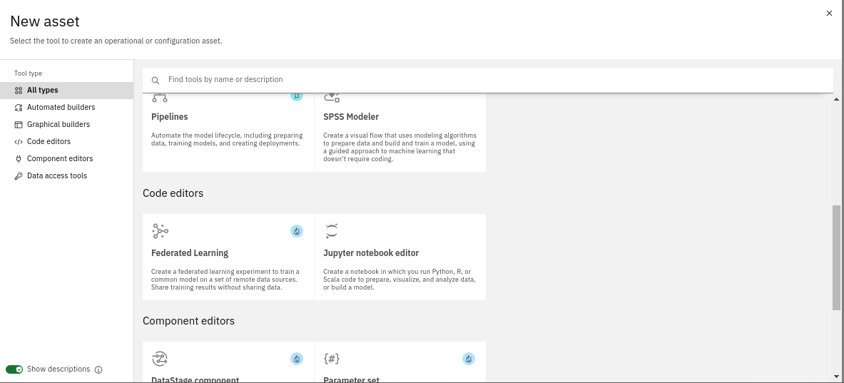

1. Enter the Notebook Name and Credentials and Click **Create**.

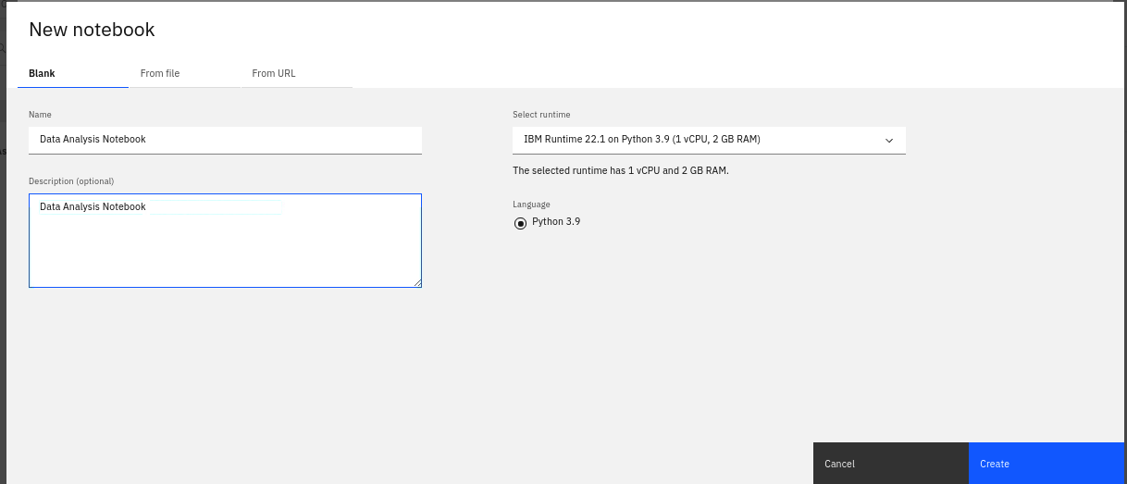

1. Click on  icon to View the Find and Add Data.

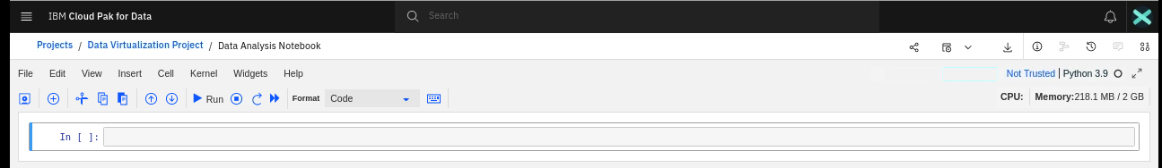

1. Under the Files tab, Click **Insert to Code -> pandas Data Frame** For the Virtual Table in the project.

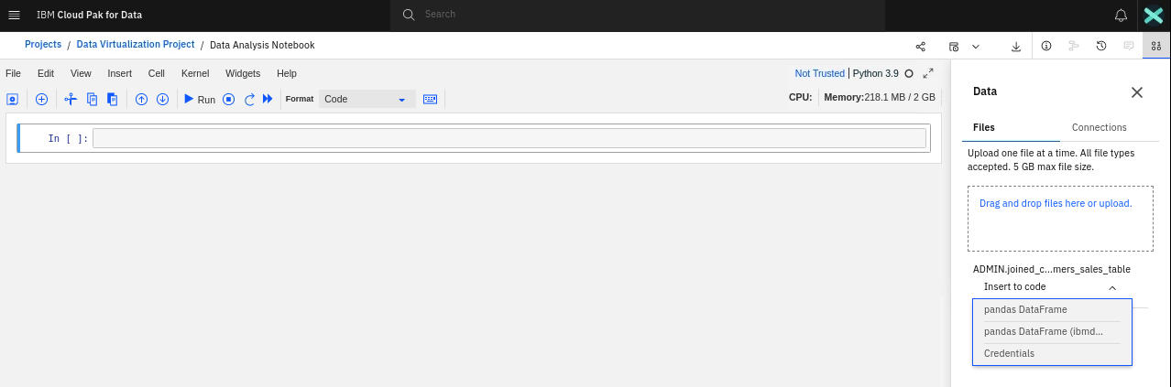

1. The code will be added automatically. Click Run button in the toolbar to execute the code.

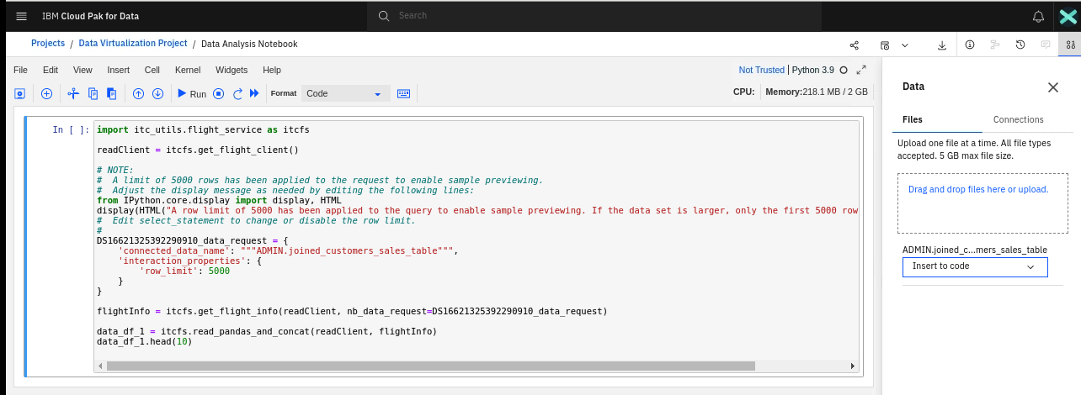

1. You should be able to access the virtualized data in the Watson Studio Notebook.

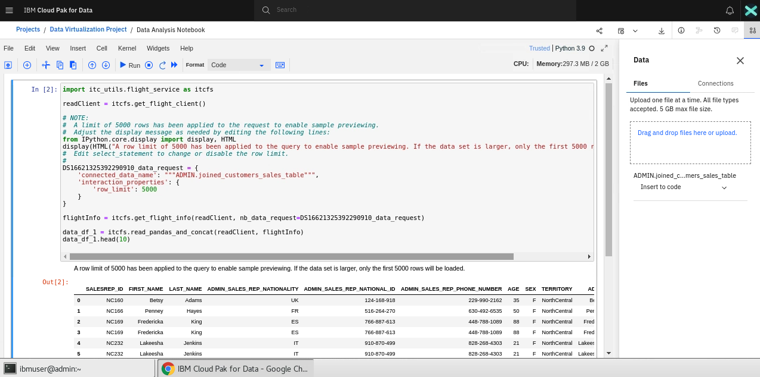

### **Visualize the data with a dashboard**

1. Under the Data Virtualization Project, In **Assets** Tab, Click on **New Asset +** to add a new Dashboard.

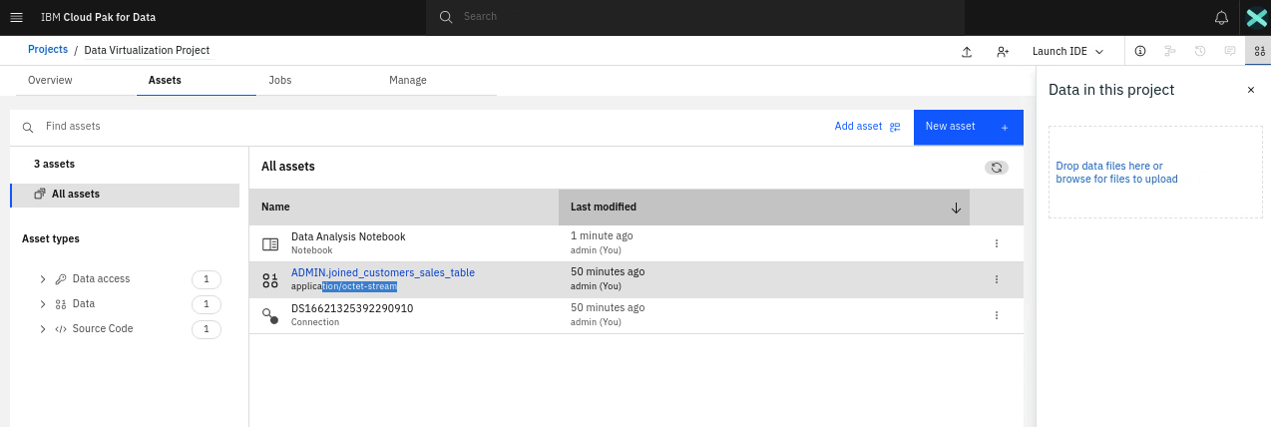

1. Click on **Dashboard Editor.**

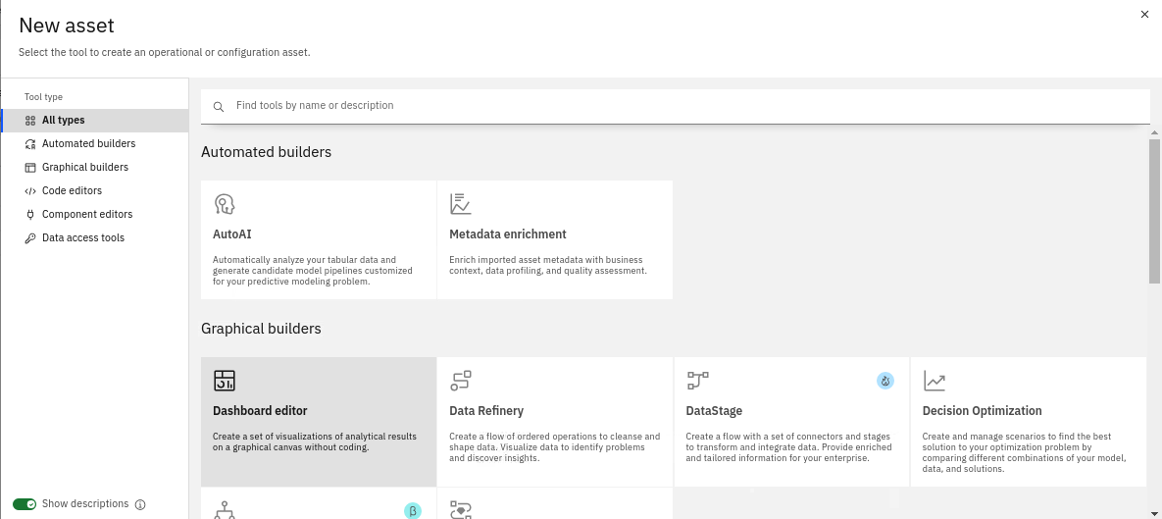

1. Enter the name and description and click Create.

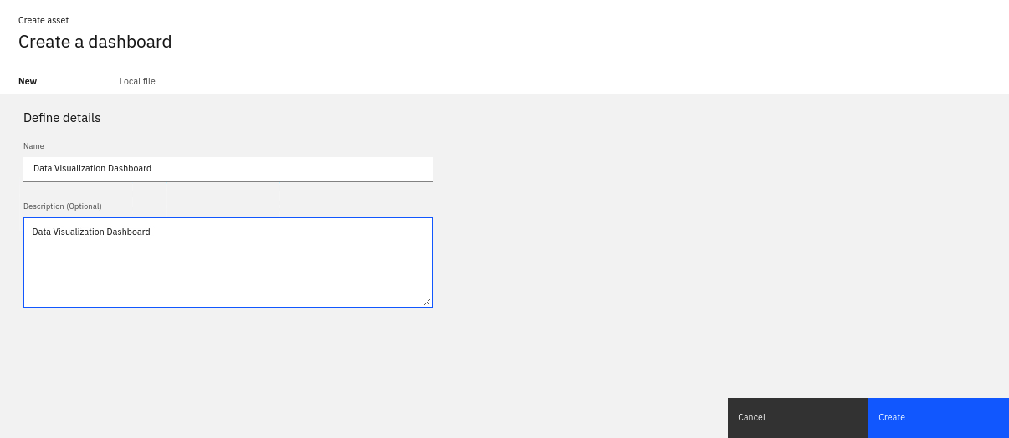

1. Click Create to create an empty tabbed Dashboard.

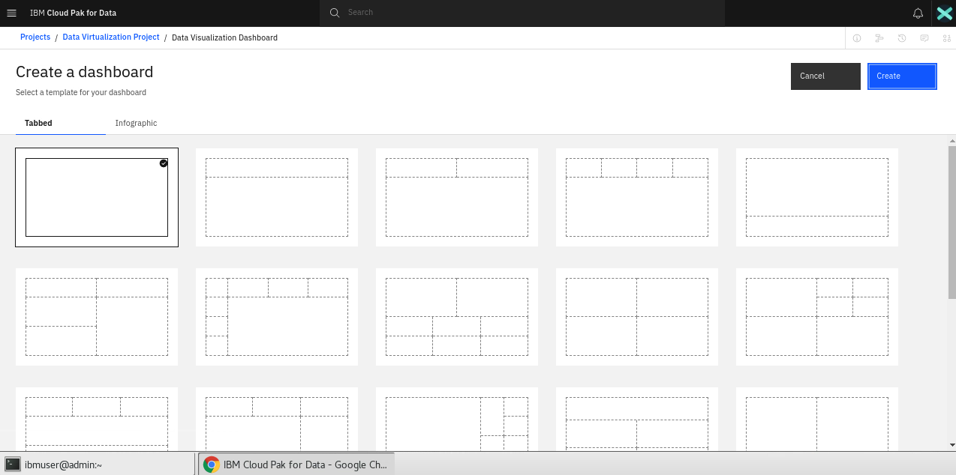

1. Click **Select a source +** button in the Data Pane to select a data source.

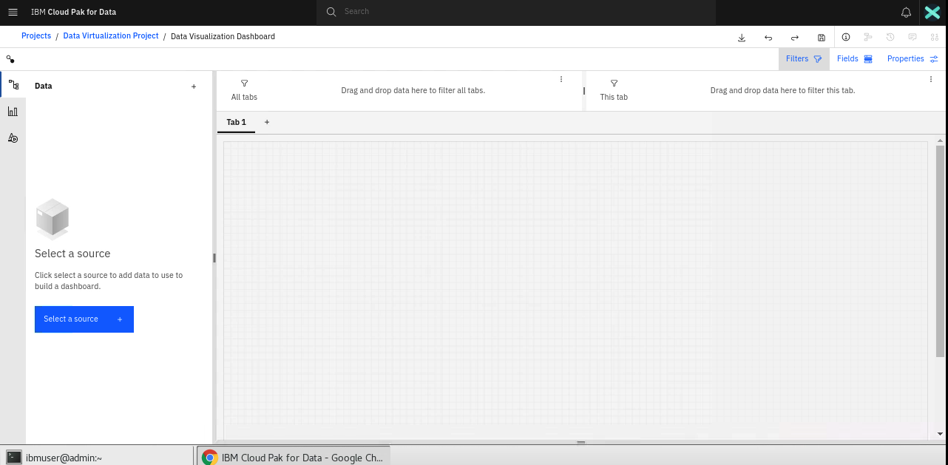

1. Select the Virtual Table. Click **Select**.

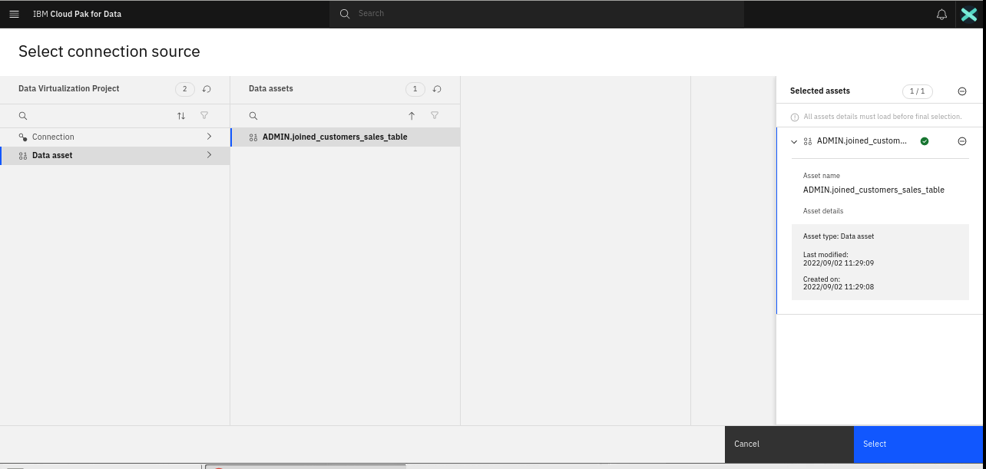

1. The Data source will be added successfully. Click on **Visualization** Tab to see the types of Visualization to be used.

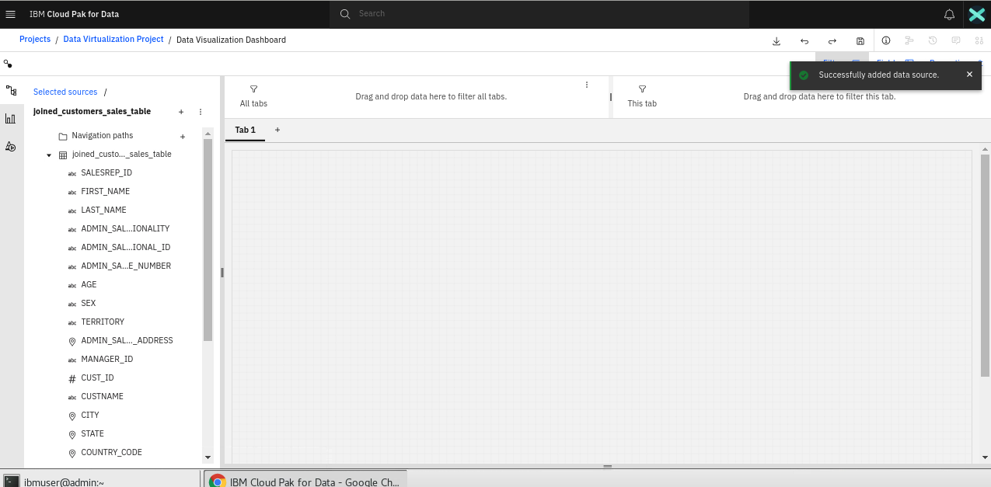

1. Click on the required visualization to add it to the dashboard.

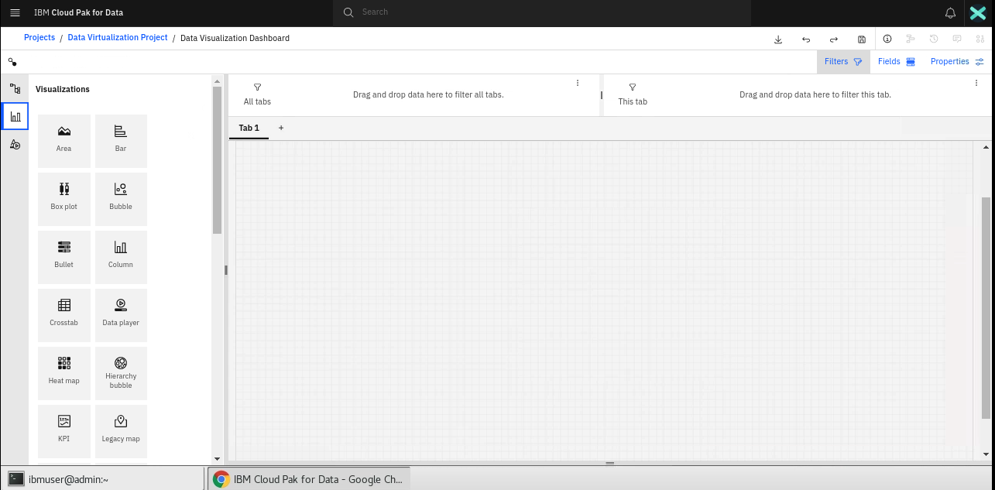

1. Configure the chart to show the required visualization. Eg. X Axis/Y Axis fields. Alternatively, New charts can also be created by directly dragging and dropping a field from the virtual table to the dashboard.

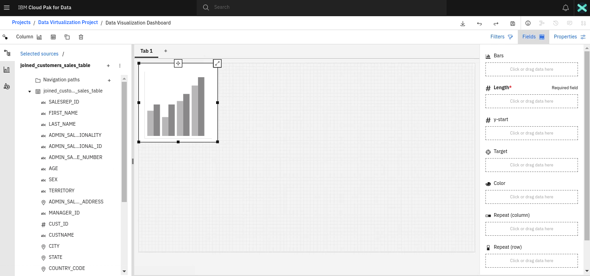

## Appendix

Below steps are for reference only.

### **DB2 Instance Provisioning**

1. If you have a Db2 service listed, then there is no need to provision another instance. Otherwise, follow these steps to procure a DB2 instance.
2. Under the services selection page, select **DB2**. Note that the service status is Available. For rest, the status is enabled.

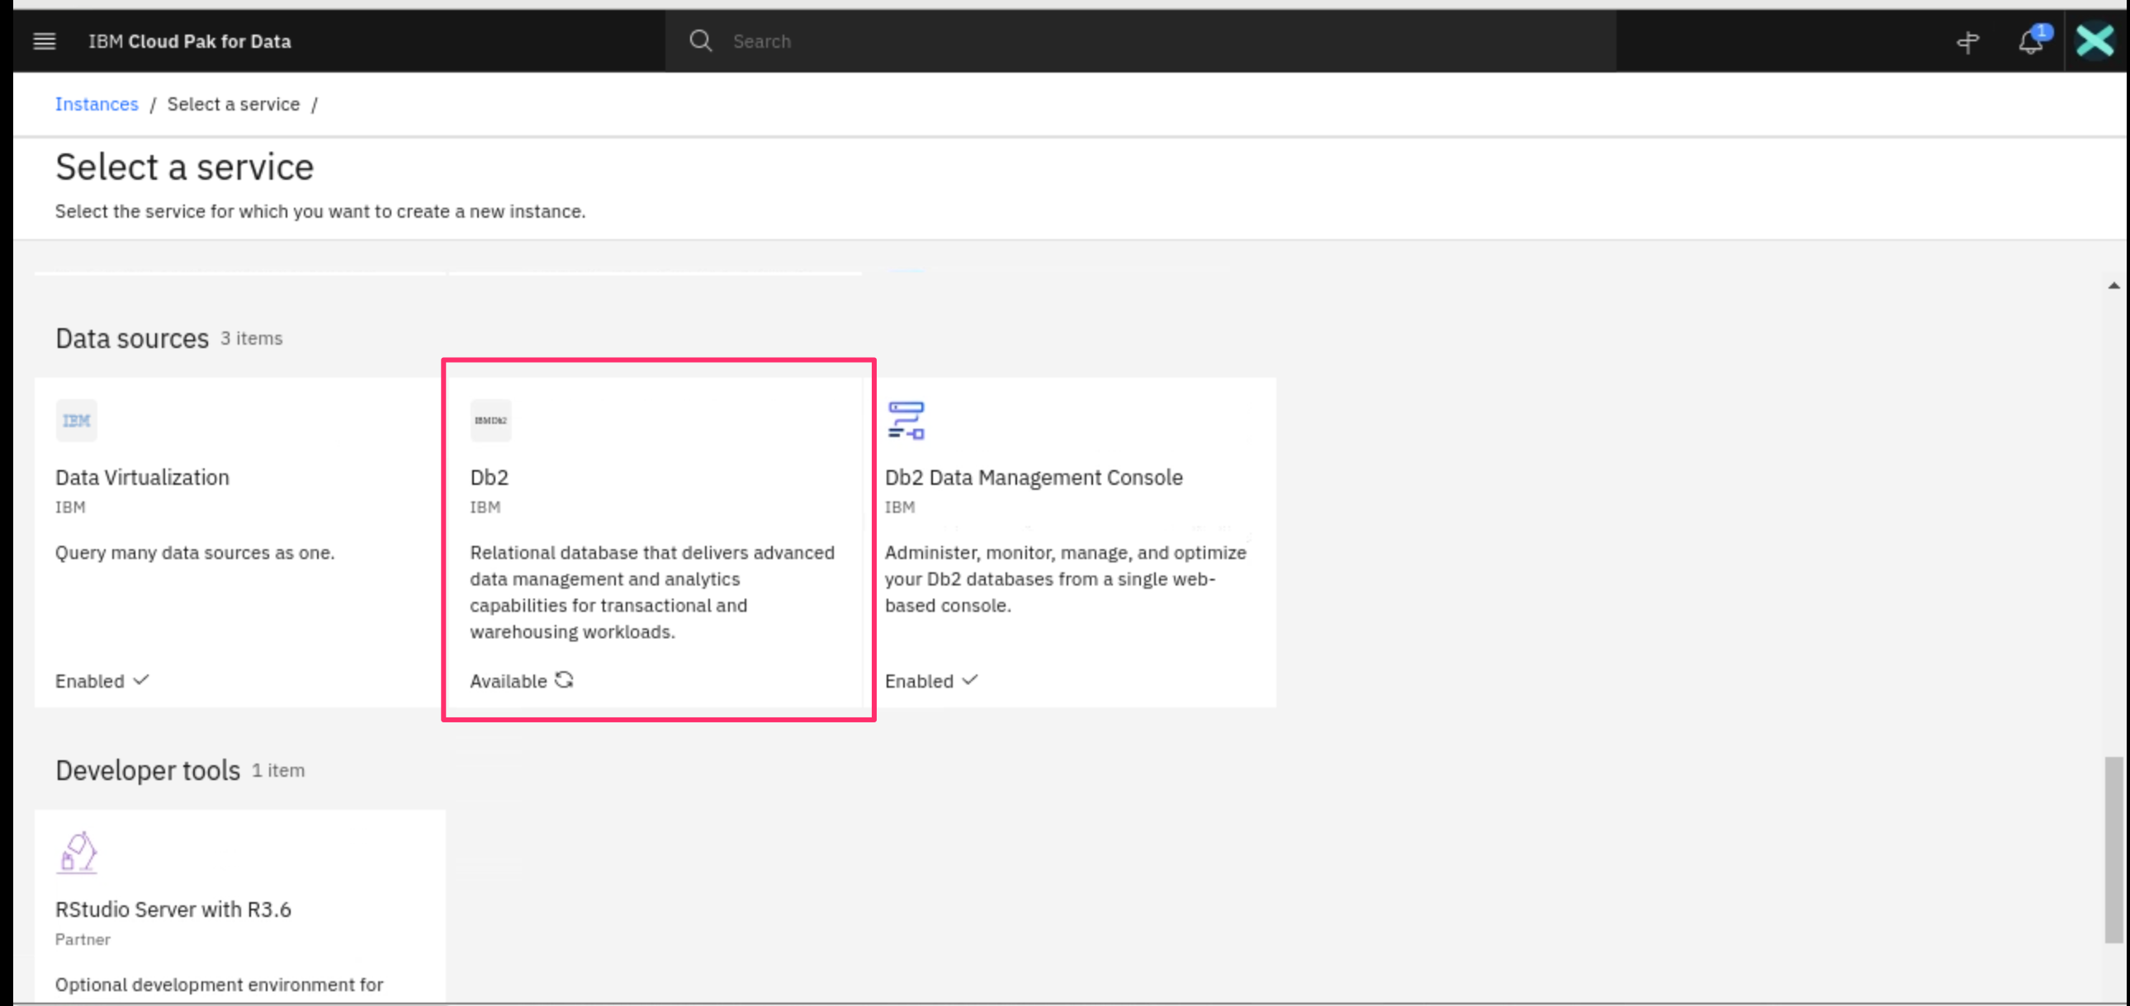

1. Click **New Instance**.

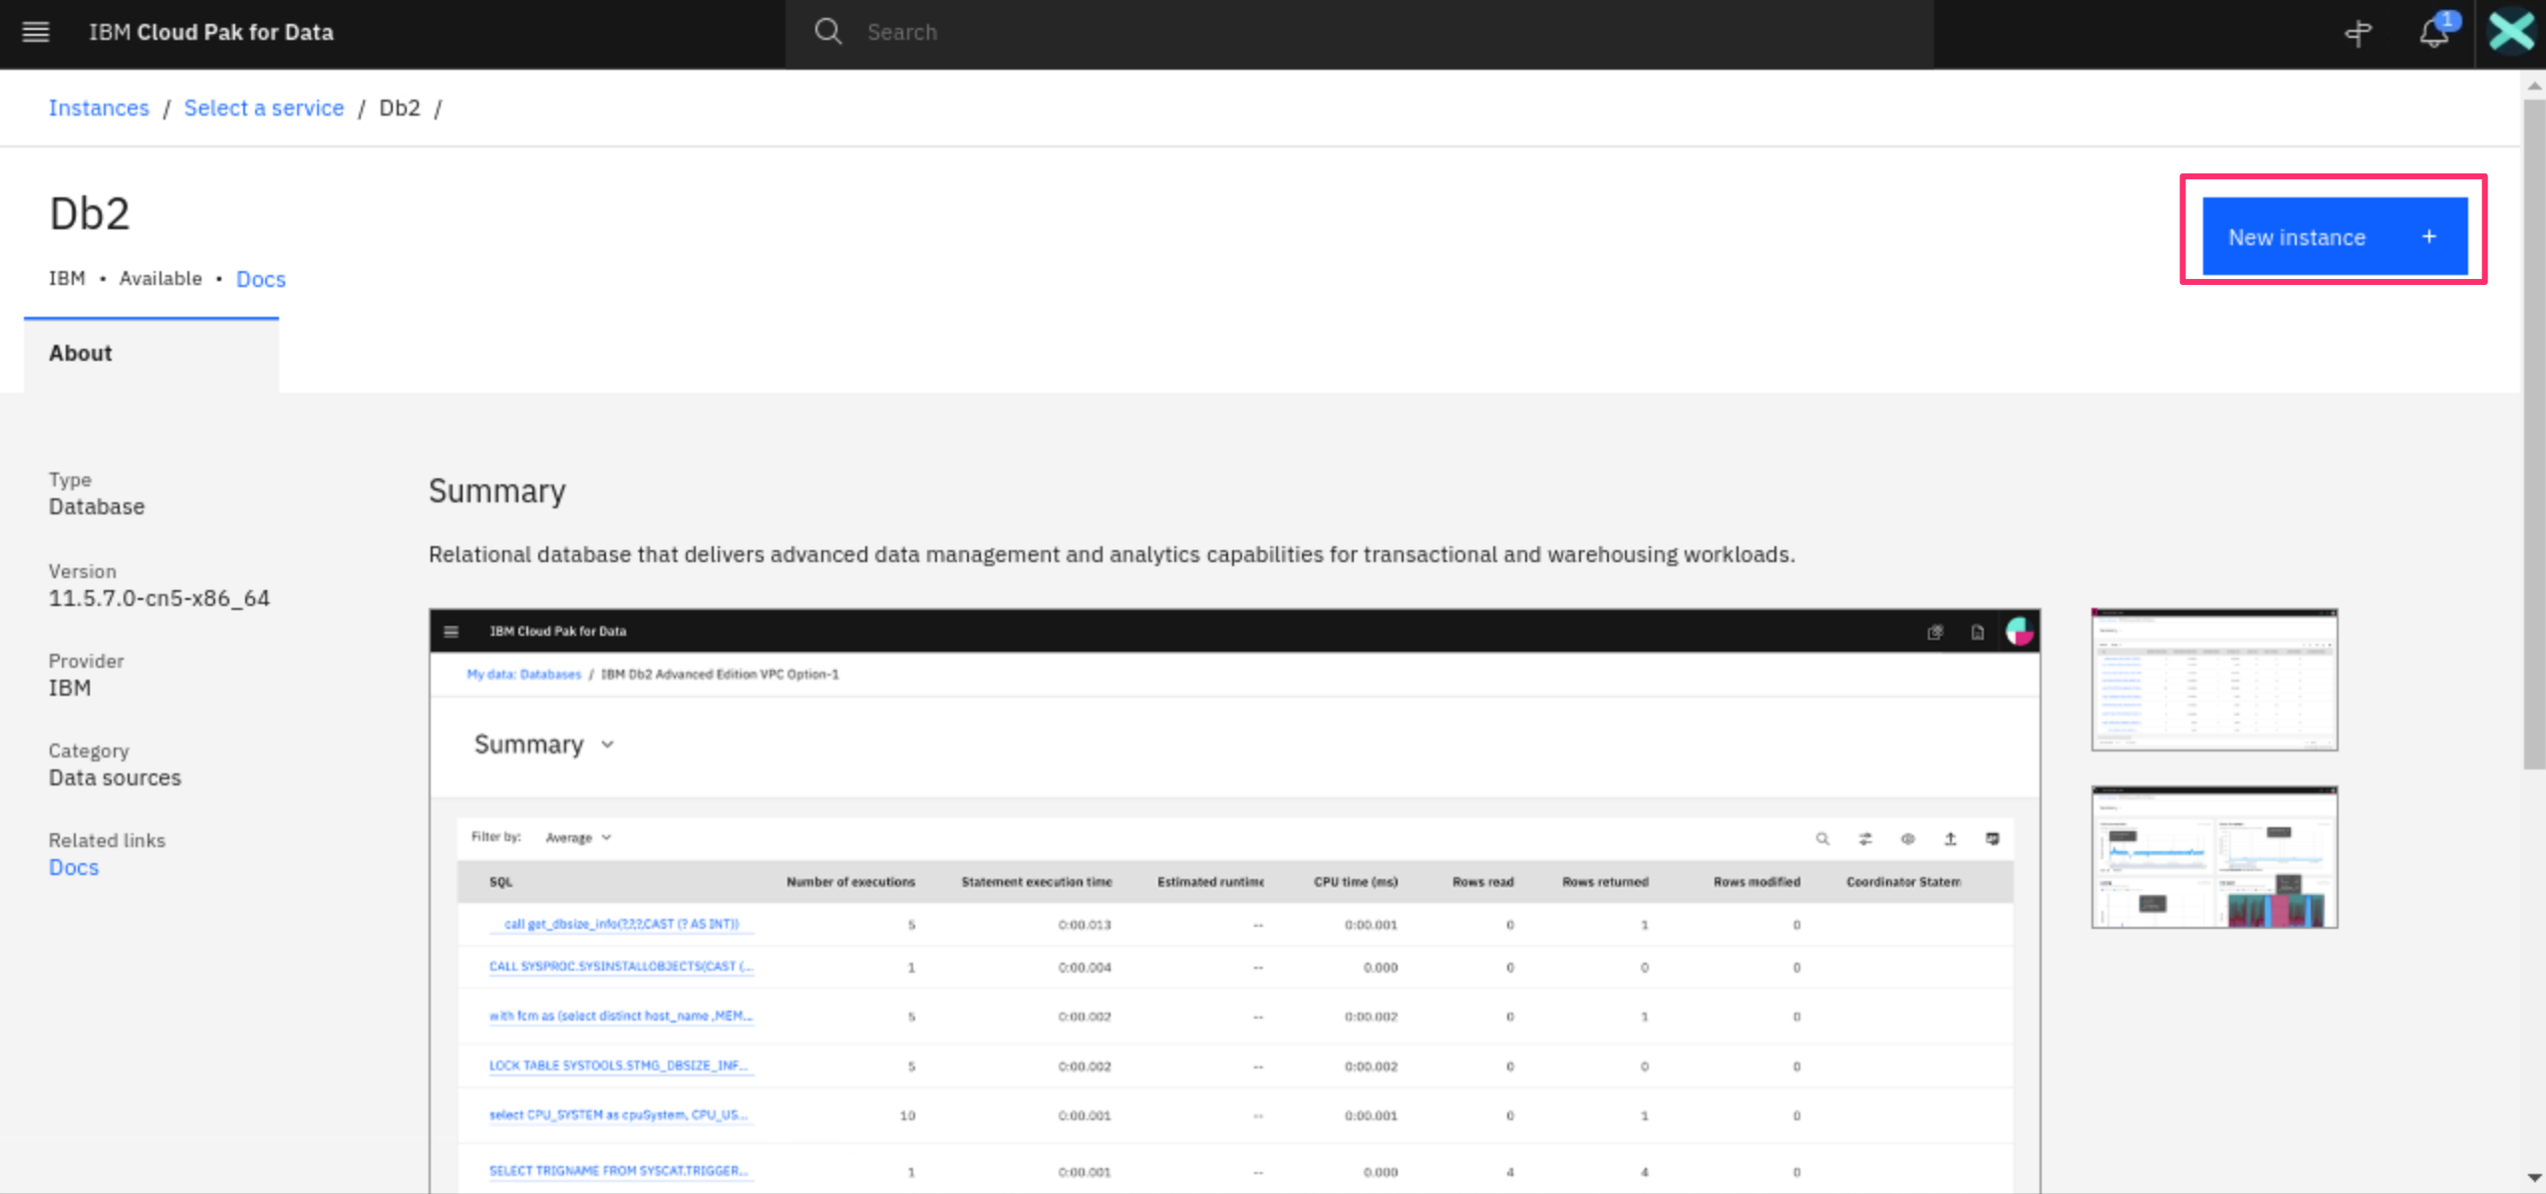

1. Provide the DB Details like DB Name (Max 8 Chars). Scroll Down.

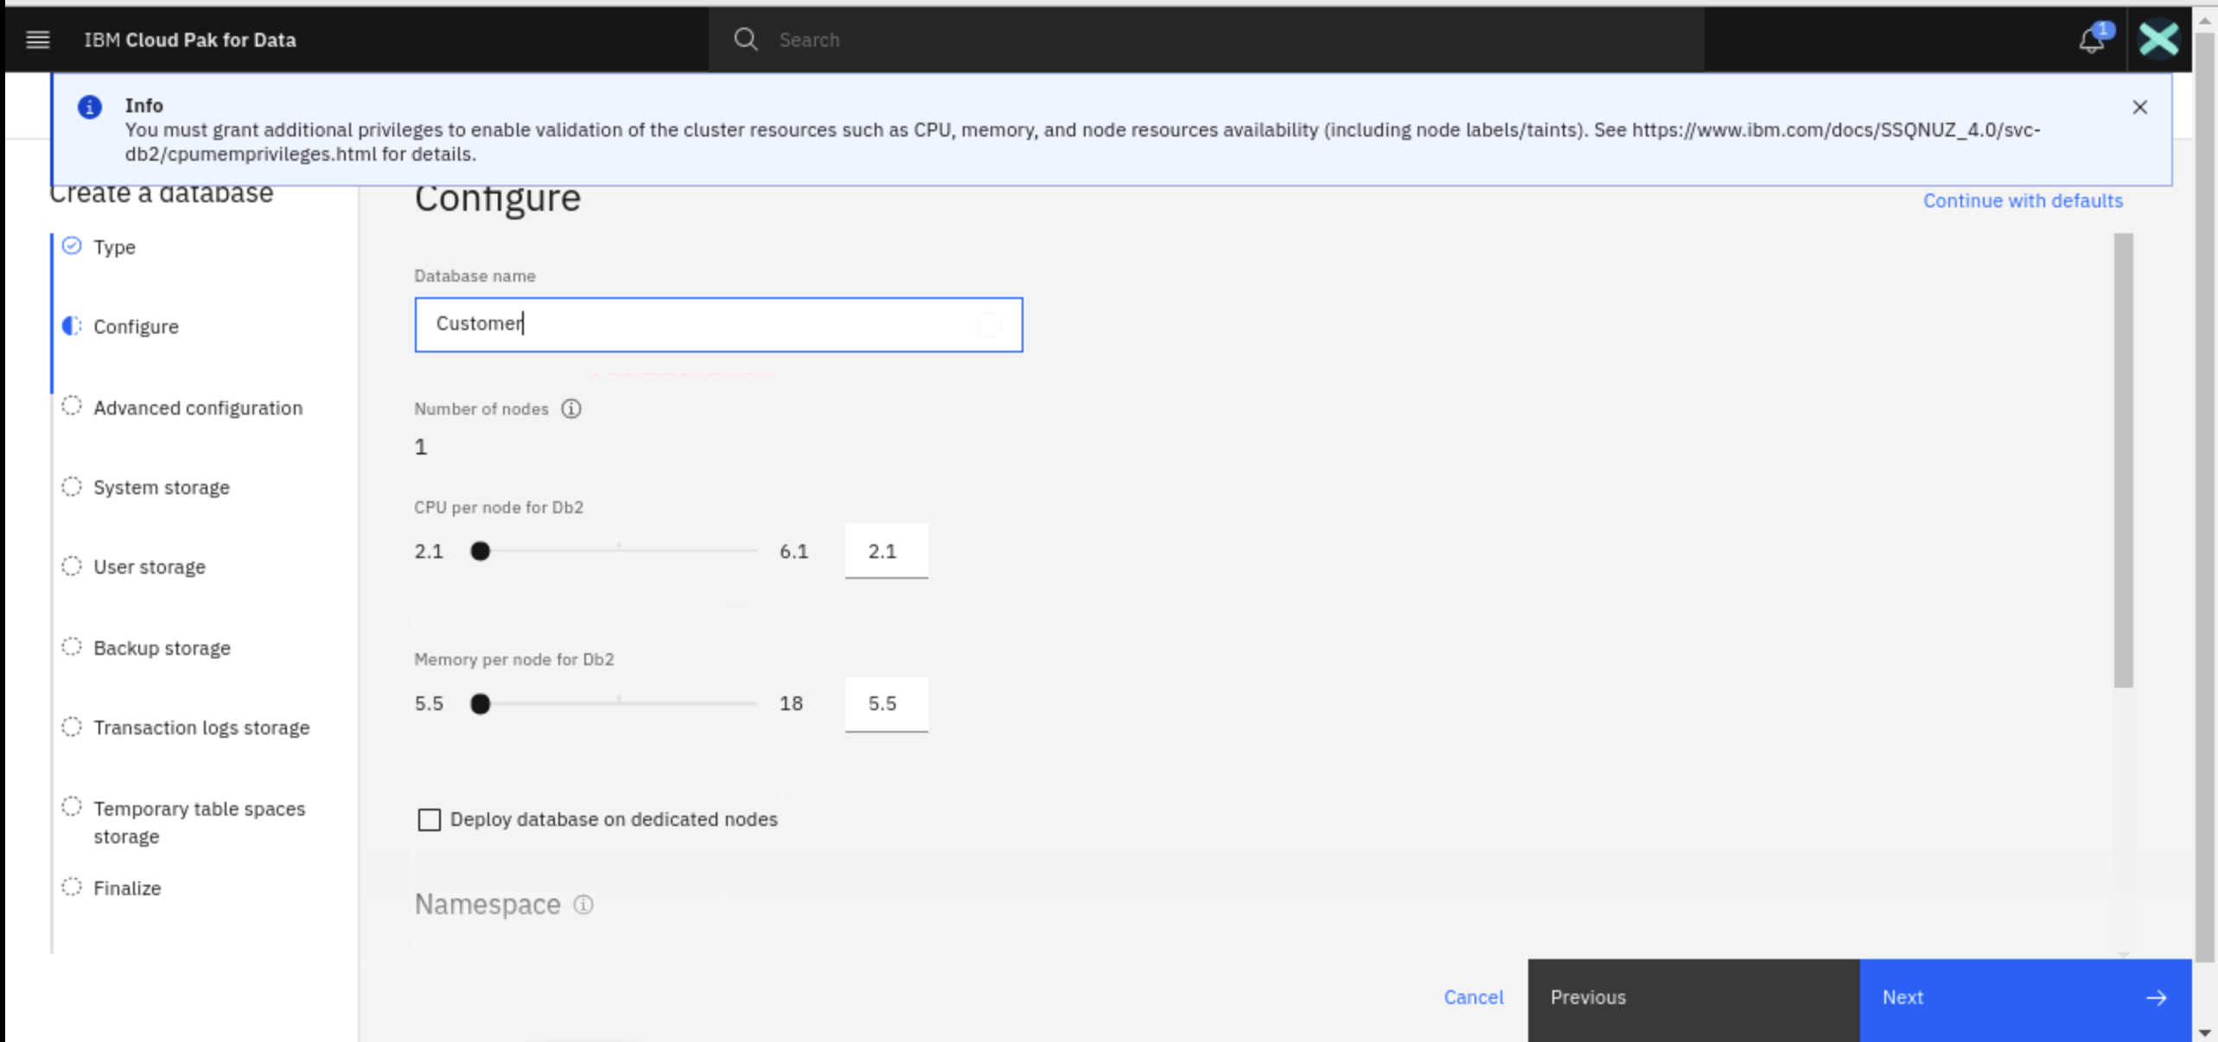

1. Select **Single Location for all Data** Option and click **Next**.

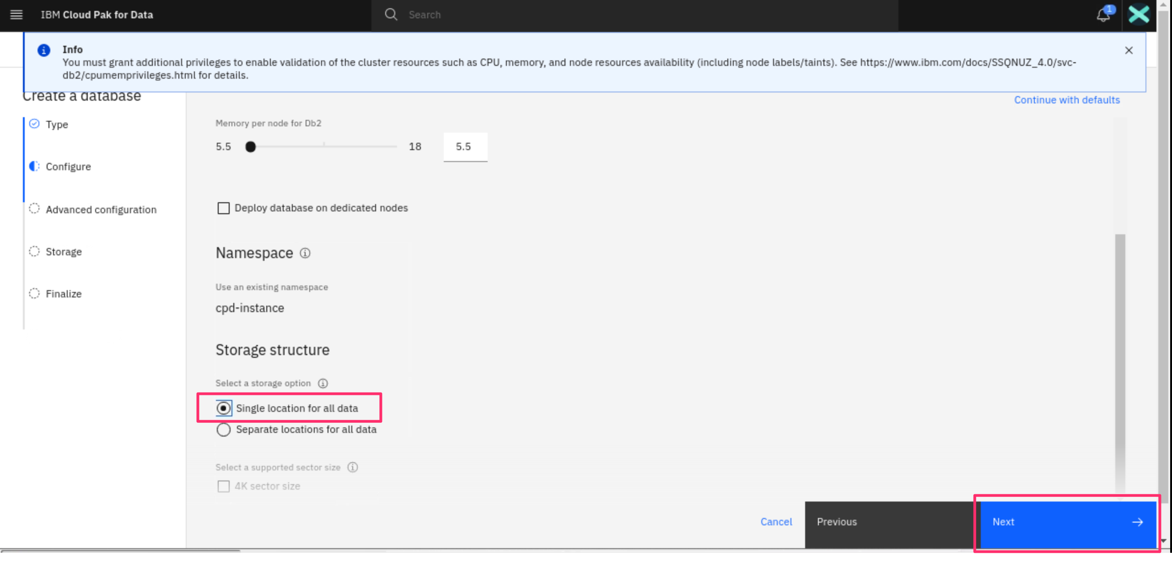

1. Click **Next** on the advanced configuration.

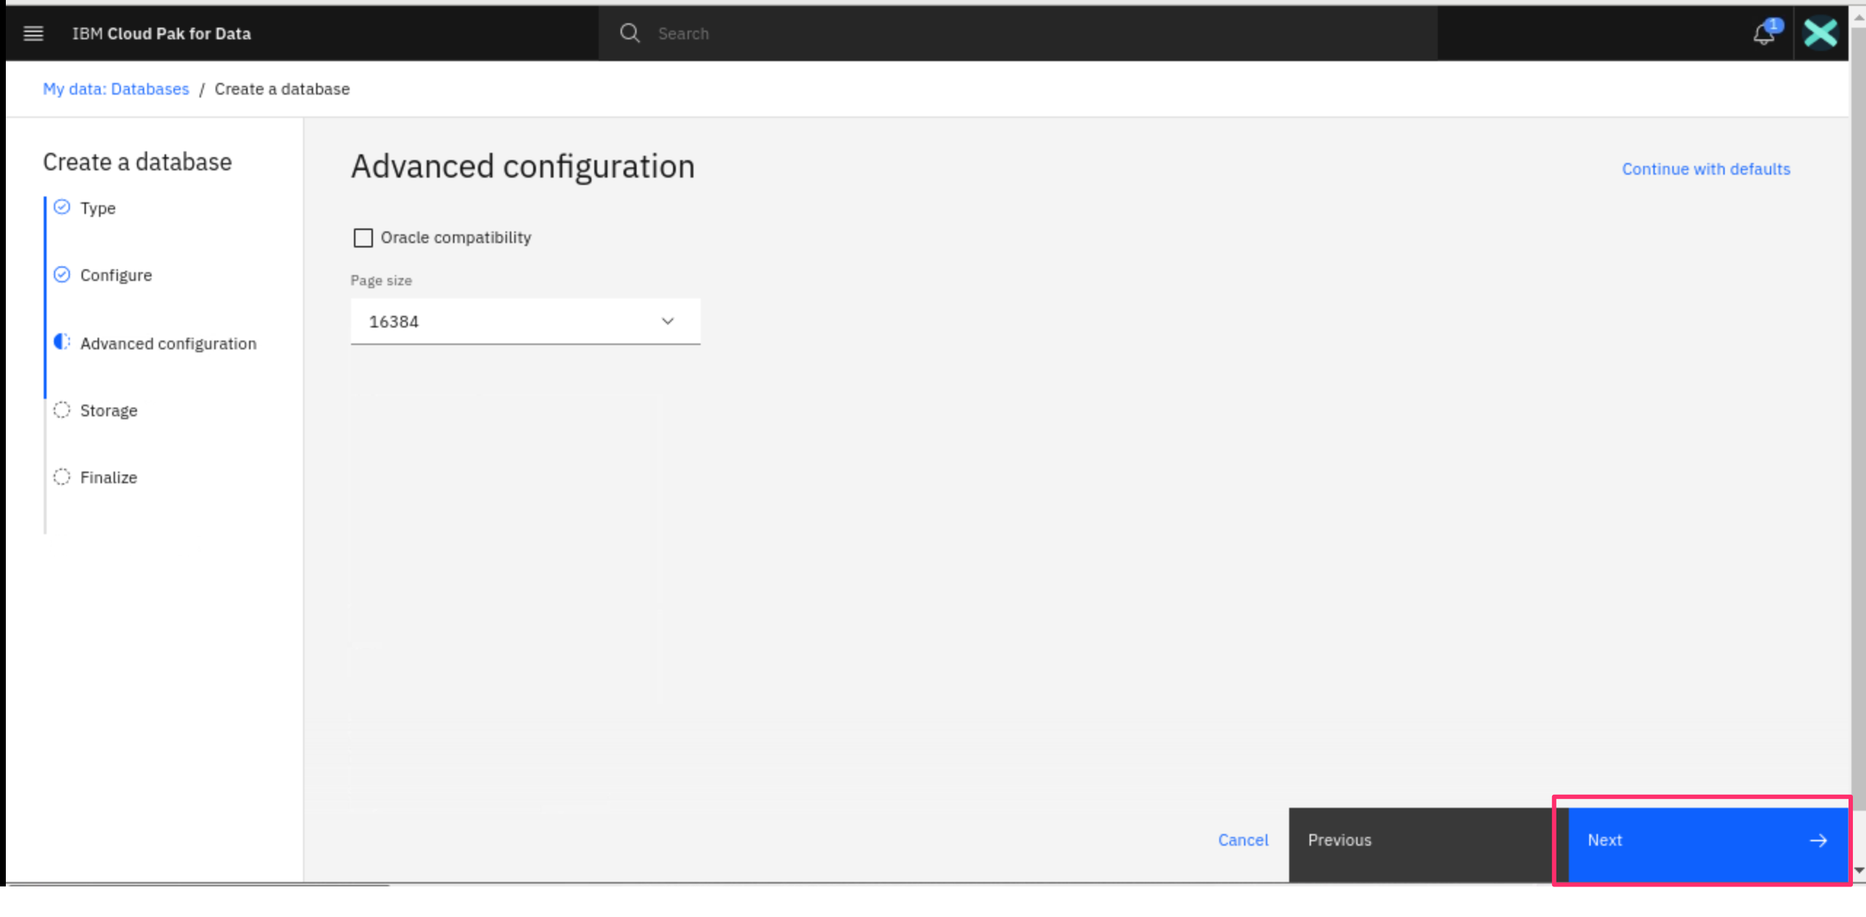

1. Configure the Storage Size as **10 GiB** and Click **Next.**

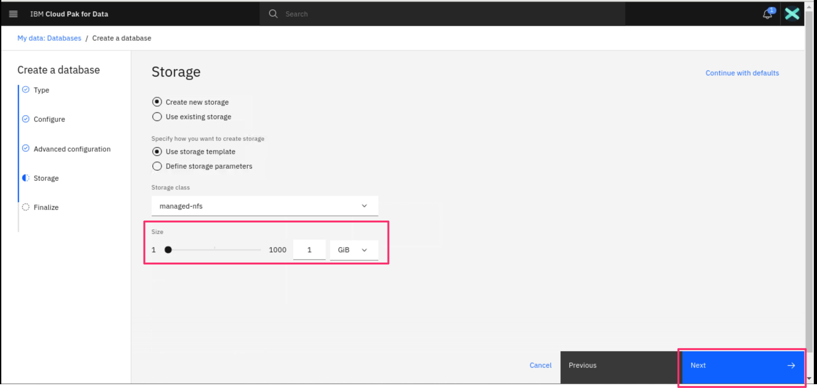

1. Click **Create** on the summary screen.

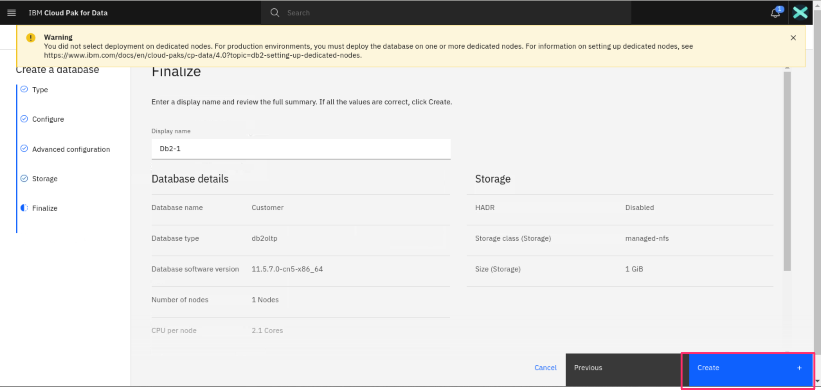

1. It will start provisioning the service.

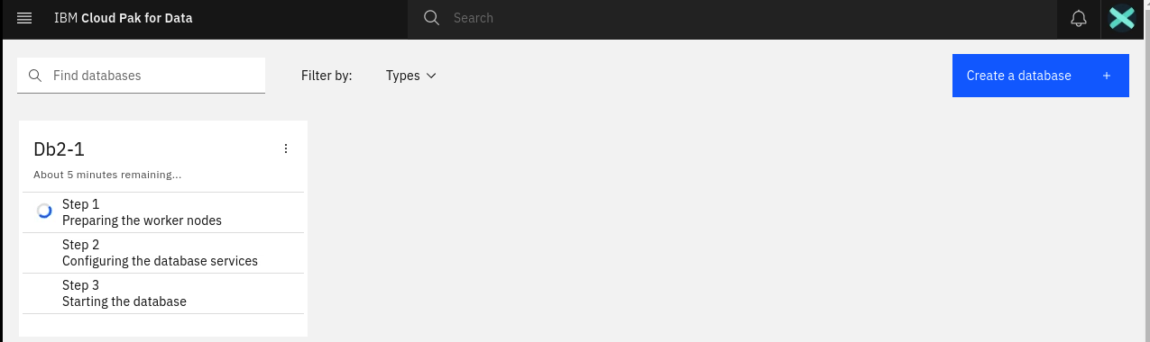

1. The service will be provisioned in 10-20 min depends on the configuration chosen.

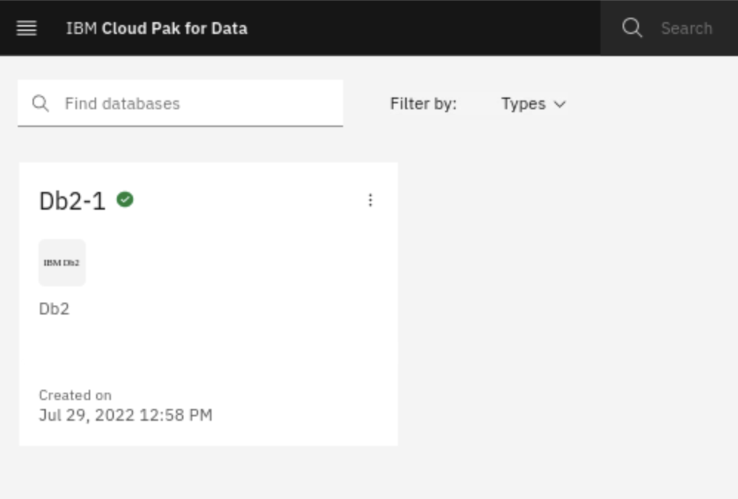

1. Verify that the services are provisioned on your Service instances page.

